Basics of Research for Healthcare Professionals

Research Simplified: A Healthcare Professional's Guide.

Dr Ashfaque Talpur
Professor Parveen Ali

Table of Contents:

Idea for presentation:
Arc with extension to table and boxes where term and its definitions are given, as above:


Chapter 1: An Introduction to Research
Research is a systematic exploration of issues to understand complexities and find practical solutions.

Chapter 2: Research question

In healthcare settings, a research question is a specific inquiry and often develops from practice to which research seeks to provide an answer.

Chapter 3: Literature Review
A literature review is a systematic and structured approach to the search and evaluation of the range of information that may be published on any given topic.

Chapter 4: Research Design
A research design is an outline of the study that explains how research questions will be answered.

Chapter 5: Ethics and Integrity
Research ethics are moral principles that govern how you should conduct research, to protect the dignity, rights and welfare of research participants.

Chapter 6: Data Collection
Data collection is a systematic process of gathering and measuring information from different sources of interest.

Chapter 7: Data Analysis
Data analysis is a systematic process of critically analyzing and interpreting data to get a sense of it.

Chapter 8: Evidence-Based Practice
EBP is a method/system of ensuring that decisions about patients are based on the best available evidence.

Chapter 9: Research Proposal
A research proposal is a structured, formal document which provides a blueprint of the intended study, detailing research aims, methods, costing, ethics and timeframe.

Chapter 1. An Introduction to Research

Research supports practitioners in providing the best possible and most effective care to the people they serve. Available evidence suggests that research-active healthcare organisations have lower mortality rates, increased treatment options and better patient satisfaction than those that are not. This chapter aims to provide an introduction to research, the research process and explain the importance of research. it will also provide an overview of the subsequent chapters.

Research refers to the systematic exploration of issues to understand complexities and find practical solutions. It aims to develop generalizable or transferable new knowledge with the goal of improving practices (National Institute for Health and Care Research, 2022).

Research is a carefully planned and systematic process. It's like exploring uncharted territory to discover new things and find better ways of doing things. In simple terms, research helps us figure out complex issues and come up with practical solutions. The goal is to create knowledge that can be used to improve how things are done, especially in healthcare.

Research is a bit like detective work. It's about investigating problems, looking for clues, and finding answers. When healthcare professionals, like nurses and midwives, do research, they're trying to make sure they're doing the best job they can for their patients. Imagine it's like having a treasure map that guides you to provide the best care possible.

In this chapter, we'll dive into the world of research. We'll explore why research is important, how it helps us make healthcare better, and what the research process looks like. By the end of this chapter, you'll have a clearer picture of what research is all about, and you'll be ready to journey further into the world of healthcare research.

Why should we be involved in Research?
Nurses, midwives, and other healthcare professionals are responsible for giving high-quality care to their patients. Research helps us do just that. It's like having a toolbox full of tools that make our job easier and better. Here's why being involved in research is so important:

Evidence-Based Care: Research gives us the evidence we need to make informed decisions about how to care for patients. It's like having a reliable guide that tells us what works best.

Cost-Effective Care: Research helps us use our resources wisely. It's like making sure we have the right ingredients for a recipe, so we don't waste anything.

Safety and Quality: Research helps us make healthcare safer and better. It's like having a safety net to catch any problems before they happen.

Innovation and Technology: Research drives innovation and new technology. It's like getting the latest and greatest tools to do our job.

Patient Experience and Outcomes: Research ensures that patients have the best possible experience and outcomes. It's like making sure every journey ends with a smile.

Knowledge and Skills: Research helps us grow and learn. It's like having a library of books that we can keep adding to.

Research process

Think of the research process as a roadmap. It's like having a step-by-step guide to help us navigate through the research journey. In reality, it's not always a straight line; sometimes, we go in circles or take detours. But having a roadmap helps us stay on track (/see Figure 1)
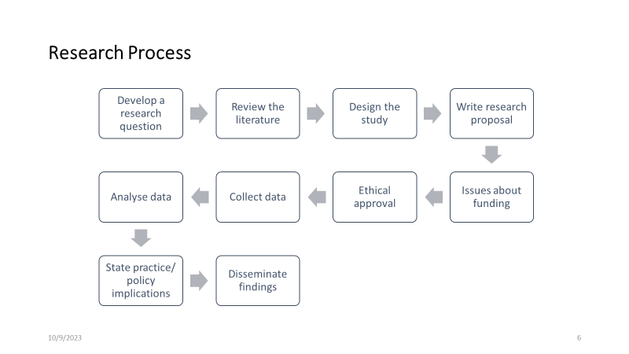

This booklet is designed to be your trusty guide on this research journey. It's meant for healthcare professionals working in different settings, and it covers a wide range of topics, from asking research questions to finding answers.

By the end of this booklet, you'll have a good grasp of what research is, why it's essential, and how you can be a part of it. We'll use the research process as our compass to explore each aspect of research more deeply. Our goal is to make research less daunting and more accessible, so you can use it to provide top-notch care to your patients and contribute to the world of healthcare knowledge. Let's embark on this research adventure together.

We will use the research process as mentioned above, as a guide to delve deeper into each aspect. Ultimately, this booklet is envisioned as a valuable tool to empower nurses/healthcare professionals, irrespective of their experience or specialisation, to harness the power of research to provide the highest quality care to their patients and contribute to the ongoing advancement of the nursing/their profession. By demystifying research and offering practical guidance, it seeks to inspire nurses to become confident and proficient consumers and contributors to the ever-evolving body of nursing knowledge.

Chapter 2. Research Question

We ask questions to learn more about things. In our daily personal and professional lives, we come across many questions. As healthcare professionals, we encounter questions from various sources: our patients, who seek to understand their health issues, our colleagues, who want to provide the best care, and ourselves, as we reflect on our practice and seek ways to improve.

Asking a question and converting it into a good research question is the first and foremost step of the research process. Developing a research question in itself is a process that starts with the selection of a broad research topic. After choosing the topic of one’s interest, the researcher goes through the initial literature search to find out what research has already been done and what literature already exists on the topic. This helps the researcher to further refine the research question to ensure it is appropriate for a scientific inquiry. So choosing a topic is the initial step.

A research question is a precise, clear, focused and operational question formulated by researchers at the beginning of the study.
A research question is:
  - A statement that identifies the phenomenon to be studied
  - Can be investigated using the process of scientific inquiry
  - Helps solve a problem, add to the theory, or improve practice
  - Needs to be usable, current, and clear
  - Provides answers that will explain, describe, identify, predict or qualify
Remember, the development of a research question is a process of thinking, reading, reflecting, discussing with colleagues and mentors, reading and refining.

Where do research questions come from?
Research questions can arise from a wide variety of sources.

Personal encounters: clinical observations, such as those concerning the behaviours of a patient and family in crisis and how the nurse might intervene to improve their coping.

Personal Knowledge: Personal knowledge is formed through direct involvement in various situations and events within one's practice. As described by Moule et al. (2017, page 26), this individual knowledge is shaped by personal experiences.

Available evidence: Literature review helps in the identification of gaps in the current knowledge and also helps identify or develop a specific research question.

Customs and tradition: Traditional practices can be conveyed through observed practice, role modelling, written documents, books, journal articles and often from ‘experienced’ practitioners. Exploring or interrogating such customs and traditions can help develop new research questions

Other sources: There could be other sources of questions which include discussion with colleagues, feedback from customers, unanticipated events (e.g., COVID-19 Pandemic) research work in itself etc

Criteria for a good research question
When thinking about research questions, the following characteristics should be considered:
- Is the question too broad or too narrow?
- Do you have resources to explore the topic (consider budget, time and expertise)
- Is it focused, clear and researchable?
- Is it relevant, significant and potentially contributing to practice/evidence?
- Is it justified and supported by established theory, and research and linked to other variables of interest?
- Does it hold the prospect of being able to make an original contribution, no matter how small?
- Can it be explored ethically?

You may have seen that not all studies have research questions. Some have hypotheses, some have aims or objectives and some have research questions. Sometimes, all three are presented in a study. It is important to note that you don't need to have all three in one paper and that all of these pretty much serve the same purpose. See the table below to understand and distinguish between various terms

Table. Clarifying terms (Hadrian whether to keep table or something else)

Term | Description | Example
Research problem | An enigmatic or troubling condition or concern or specific issue or gap in knowledge that the researcher would like to explore. | Recent data shows a rise in the number of medical incidents and staff sickness reports.  Stress can impact healthcare workers' performance and health. "Reducing healthcare worker stress through targeted interventions and support to mitigate its adverse effects on well-being and performance."
Statement of Purpose | A clear and concise description of the problem and the proposed methods of addressing it (problem). | The purpose of the study is to investigate the link between lack of sleep and stress at work, among healthcare workers.
Research question | A research question is a specific enquiry of exactly what issues the researcher intends to answer. | Does sleeping more than 6 hours per night reduce workplace stress for healthcare workers?
Hypothesis | A statement about the expected or predictive relationship between two or more variables. It must specify the variables, the population being studied and the predicted outcome of the hypothesis | Healthcare providers who obtain over 6 hours of sleep per night experience lower levels of work-related stress compared to their counterparts who sleep fewer than 6 hours per night.
Aims/Objectives | A purpose statement explains the major aim, intent, or roadmap of the study. It should be a single sentence, include the purpose of the study, include the central phenomenon, use qualitative words, e.g. explore, understand, discover, note the participants (if any) and state the research site | To assess the impact of mobility-promoting interventions on patient recovery, functional independence, and overall healthcare outcomes within a specific healthcare environment.

Research Questions in Qualitative and Quantitative Research

Qualitative and quantitative questions differ in their nature, purpose, and the type of data they seek to collect. Here are the key differences between the two:

Qualitative Research Question | Quantitative Research Question
Often used to explore a phenomenon (research problem) or experience. | Often used to investigate cause and effect relationships
State what you are attempting to ‘discover’, ‘generate’, ‘explore’, ‘identify’ or ‘describe | State what you are attempting to ‘investigate’, ‘compare’, ‘identify’
Usually start with What and How | Usually start with What, Why, and How
Example: To explore the experiences of victims of domestic violence with suicidal ideation. | Example: To compare suicidal risk between women experience domestic violence and women perpetrate spouse abuse?

Chapter 3. Literature Review

A literature review is an organised and comprehensive summary of existing research on a particular topic. The purpose of a literature review is to provide an overview of the existing research on a topic, identify any gaps in the current research, and draw conclusions and implications for future research. It is a critical process that helps synthesise existing research and identify any potential flaws or limitations in the research. A literature review is essential in any research project, as it helps to provide context, identify potential research gaps, and inform the overall research project.
A literature review requires a critical evaluation of the material; this is why it is called a literature review rather than a literature report. It is a process of reviewing the literature, as well as a form of writing.
To illustrate the difference between reporting and reviewing, think about television or film review articles. These articles include content such as a brief synopsis of the key points of the film or programme plus the critic’s own evaluation. Similarly, the two main objectives of a literature review are firstly the content covering existing research, theories and evidence, and secondly your own critical evaluation and discussion of this content.
Usually, a literature review forms a section or part of a dissertation, research project or long essay. However, it can also be set and assessed as a standalone piece of work.

Definition (in box):
To Review has been defined as: “To View, inspect, or examine a second time or again”.
It is a crucial stage in the research process to establish what is already known about the topic so that unintentional replication can be avoided (green to go).

Why do we need to write a literature review?
There are several reasons to write a literature review, depending on your research plans. Some reasons include:
- To find out what's already known about your topic. It helps readers understand the background of your study.
- To show readers the size and depth of the topic you're studying.
- To spot gaps in the research, where more study is needed. This helps you refine your research question and focus on a specific part of the topic.
- To explain why your study is important.
- To learn from past studies' methods and approaches, both successful and unsuccessful.
- To analyse and judge the quality and relevance of the studies you're reviewing. This helps you refine your research methods and questions.
- Literature reviews help you create a theoretical framework for your research, giving it a conceptual foundation.
- To avoid doing research that's already been done. This way, you build on existing knowledge instead of repeating it.

Type of Literature Review
There are various types of literature reviews and these include:
· Literature review
· critical review
· scoping review
· systematic review
· meta-analysis
· meta ethnography
· realist review
· Review of reviews
Literature reviews or narrative reviews
Literature, or narrative, reviews provide an overview of what is known about a particular topic. They evaluate the material, rather than simply restating it, but the methods used to do this are not usually prespecified and they are not described in detail in the review. The search might be comprehensive but it does not aim to be exhaustive. Literature reviews are often topic-based and can take the form of a discussion. Literature reviews lack precision and replicability and can present their findings in the context of what has come before. Often, this sort of synthesis does not attempt to control for the author’s own bias. The results or conclusions of a literature review are likely to be presented in a narrative format rather than statistical methods.
Critical review
A critical review (sometimes called a critique, critical commentary, critical appraisal, critical analysis) is a detailed commentary on and critical evaluation of a text. The aim of the critical review is to demonstrate that the reviewer has a commanding understanding of the literature to the point where they can extrapolate hypotheses on the topic of review. This type of review goes beyond the level of detailed description of the existing literature.
While conducting a critical review, the reviewer identifies the most significant research in the field and evaluates the literature based on its contribution to the field (as opposed to a formal quality assessment). This review type is usually narrative or conceptual.
Scoping review
Scoping reviews are exploratory and typically address a broad question, compared to a systematic review that typically has a more targeted question.
Researchers conduct scoping reviews to assess the extent of the available evidence, to organize it into groups and to highlight gaps. If a scoping review finds no studies, this might help researchers to decide that a systematic review is likely to be of limited value and that resources could be better directed elsewhere.

Rapid Review
Rapid reviews aim to produce a rigorous synthesis quickly (due to time constraints/urgency), based on a pre-defined research question. The review process for rapid reviews is the same as for a more traditional systematic review: the emphasis is on a replicable pre-specified search, and screening methods that minimize the risk of bias, although potentially isn’t as stringent as a formal systematic review.
The process operates within pre-specified limits (for example, by restricting searches to articles published during a specific timeframe) and is usually run by a multidisciplinary team with expertise in systematic review methods.

Systematic review.
Systematic review attempts to collate all empirical evidence that fit pre-specified eligibility criteria in order to answer a specific clearly formulated research question. It uses explicit and reproducible systematic methods that are selected with a view to minimising bias, thus providing more reliable findings from which conclusions can be drawn and decisions made.
The process starts with a research question and a protocol or research plan. A review team searches for studies to answer the question using a highly sensitive search strategy. The retrieved studies are then screened for eligibility using pre-specified inclusion and exclusion criteria (this is done by at least two people working independently). Next, the reviewers extract the relevant data and assess the quality of the included studies. Finally, the review team synthesises the extracted study data and presents the results.

A systematic review may contain meta-analyses (statistical analysis). A systematic review which is continually updated, incorporating relevant new evidence as it becomes available is often known as a living systematic review.

Meta-analysis.
A meta-analysis is a systematic approach to combining the results of multiple studies. It is a statistical technique used to combine the results from multiple different studies in order to assess a single overall effect. Meta-analyses can be used to analyse data from randomized controlled trials, observational studies, or both. Meta-analyses are often used to assess the effectiveness of a certain treatment or intervention and can help provide better clarity on the effects of a particular intervention than individual studies alone.

Meta-ethnography.
Meta-ethnography is a qualitative research methodology that is used to synthesize multiple qualitative studies. This methodology involves meta-analysis of qualitative data from multiple sources in order to compare, contrast, and integrate the data from the different sources. A meta-ethnography is typically used to look for patterns, relationships, and themes that span the different studies. It can also be used to identify gaps in the research, to highlight areas for further research, and to develop new theories.

Realist review.
A realist review is an approach to the synthesis of qualitative and quantitative evidence. It is a type of review that focuses on understanding underlying mechanisms and processes that may explain why an intervention or policy works in certain contexts. The review helps to identify and explain the factors that are responsible for a particular outcome, as well as how different interventions might work in different contexts. Realist reviews can be used to identify strategies that have been successful in similar contexts in order to inform future interventions.

Review of reviews.
A review of reviews is a systematic method of systematically summarizing the findings of existing reviews and synthesizing them into a single report. It is a form of evidence synthesis that can help to identify gaps in evidence, identify trends in the literature, and identify areas for further research. The review of reviews allows for a more comprehensive assessment of the existing evidence and can be used to inform future research.
Umbrella Reviews or Overview of Reviews.
An umbrella review is a review of multiple systematic reviews. The process uses explicit and systematic methods to search for, and identify, systematic reviews on related research questions in the same topic area. The purpose of an umbrella review is to synthesize the results of the systematic reviews across important outcomes.
I suggest use the following
Reproduced from Grant, M. J. and Booth, A. (2009), A typology of reviews: an analysis of 14 review types and associated methodologies. Health Information & Libraries Journal, 26: 91–108. doi:10.1111/j.1471-1842.2009.00848.x
Label | Description | Search | Appraisal | Synthesis | Analysis
Critical review | Aims to demonstrate writer has extensively researched literature and critically evaluated its quality. Goes beyond mere description to include degree of analysis and conceptual innovation. Typically results in hypothesis or mode | Seeks to identify most significant items in the field | No formal quality assessment. Attempts to evaluate according to contribution | Typically narrative, perhaps conceptual or chronological | Significant component: seeks to identify conceptual contribution to embody existing or derive new theory
Literature review | Generic term: published materials that provide examination of recent or current literature. Can cover wide range of subjects at various levels of completeness and comprehensiveness. May include research findings | May or may not include comprehensive searching | May or may not include quality assessment | Typically narrative | Analysis may be chronological, conceptual, thematic, etc.
Mapping review/ systematic map | Map out and categorize existing literature from which to commission further reviews and/or primary research by identifying gaps in research literature | Completeness of searching determined by time/scope constraints | No formal quality assessment | May be graphical and tabular | Characterizes quantity and quality of literature, perhaps by study design and other key features. May identify need for primary or secondary research
Meta-analysis | Technique that statistically combines the results of quantitative studies to provide a more precise effect of the results | Aims for exhaustive, comprehensive searching. May use funnel plot to assess completeness | Quality assessment may determine inclusion/ exclusion and/or sensitivity analyses | Graphical and tabular with narrative commentary | Numerical analysis of measures of effect assuming absence of heterogeneity
Mixed studies review/mixed methods review | Refers to any combination of methods where one significant component is a literature review (usually systematic). Within a review context it refers to a combination of review approaches for example combining quantitative with qualitative research or outcome with process studies | Requires either very sensitive search to retrieve all studies or separately conceived quantitative and qualitative strategies | Requires either a generic appraisal instrument or separate appraisal processes with corresponding checklists | Typically both components will be presented as narrative and in tables. May also employ graphical means of integrating quantitative and qualitative studies | Analysis may characterise both literatures and look for correlations between characteristics or use gap analysis to identify aspects absent in one literature but missing in the other
Overview | Generic term: summary of the [medical] literature that attempts to survey the literature and describe its characteristics | May or may not include comprehensive searching (depends whether systematic overview or not) | May or may not include quality assessment (depends whether systematic overview or not) | Synthesis depends on whether systematic or not. Typically narrative but may include tabular features | Analysis may be chronological, conceptual, thematic, etc.
Qualitative systematic review/qualitative evidence synthesis | Method for integrating or comparing the findings from qualitative studies. It looks for ‘themes’ or ‘constructs’ that lie in or across individual qualitative studies | May employ selective or purposive sampling | Quality assessment typically used to mediate messages not for inclusion/exclusion | Qualitative, narrative synthesis | Thematic analysis, may include conceptual models
Rapid review | Assessment of what is already known about a policy or practice issue, by using systematic review methods to search and critically appraise existing research | Completeness of searching determined by time constraints | Time-limited formal quality assessment | Typically narrative and tabular | Quantities of literature and overall quality/direction of effect of literature
Scoping review | Preliminary assessment of potential size and scope of available research literature. Aims to identify nature and extent of research evidence (usually including ongoing research) | Completeness of searching determined by time/scope constraints. May include research in progress | No formal quality assessment | Typically tabular with some narrative commentary | Characterizes quantity and quality of literature, perhaps by study design and other key features. Attempts to specify a viable review
State-of-the-art review | Tend to address more current matters in contrast to other combined retrospective and current approaches. May offer new perspectives | Aims for comprehensive searching of current literature | No formal quality assessment | Typically narrative, may have tabular accompaniment | Current state of knowledge and priorities for future investigation and research
Systematic review | Seeks to systematically search for, appraise and synthesis research evidence, often adhering to guidelines on the conduct of a review | Aims for exhaustive, comprehensive searching | Quality assessment may determine inclusion/exclusion | Typically narrative with tabular accompaniment | What is known; recommendations for practice. What remains unknown; uncertainty around findings, recommendations for future research
Systematic search and review | Combines strengths of critical review with a comprehensive search process. Typically addresses broad questions to produce ‘best evidence synthesis’ | Aims for exhaustive, comprehensive searching | May or may not include quality assessment | Minimal narrative, tabular summary of studies | What is known; recommendations for practice. Limitations
Systematized review | Attempt to include elements of systematic review process while stopping short of systematic review. Typically conducted as postgraduate student assignment | May or may not include comprehensive searching | May or may not include quality assessment | Typically narrative with tabular accompaniment | What is known; uncertainty around findings; limitations of methodology
Umbrella review | Specifically refers to review compiling evidence from multiple reviews into one accessible and usable document. Focuses on broad condition or problem for which there are competing interventions and highlights reviews that address these interventions and their results | Identification of component reviews, but no search for primary studies | Quality assessment of studies within component reviews and/or of reviews themselves | Graphical and tabular with narrative commentary | What is known; recommendations for practice. What remains unknown; recommendations for future research

Process of Literature Review
This diagram provides a visual representation of the sequential steps involved in conducting a literature review. It serves as a useful reference for anyone engaged in the literature review process.

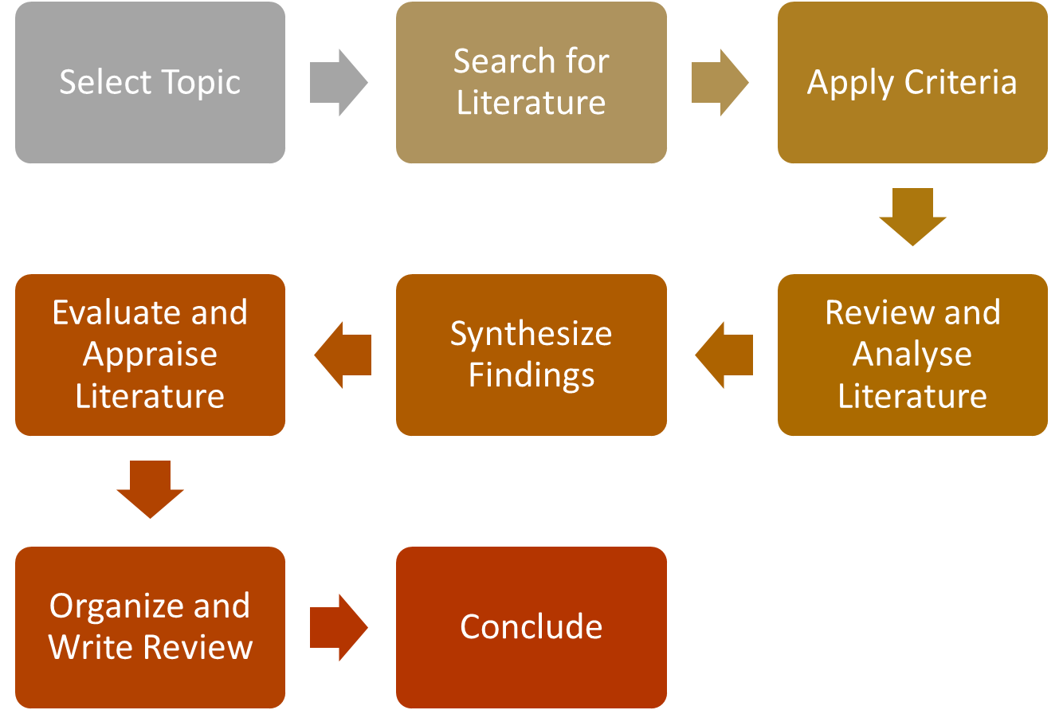

- Select Topic: Choose a research topic relevant to your field of study or practice.
- Conduct a comprehensive search of relevant literature using databases, journals, and other sources.
- Apply Criteria: Define inclusion and exclusion criteria to select the most relevant sources.
- Review and Analyze Literature: Read and critically assess the selected literature to understand the key findings and methodologies.
- Synthesise Findings: Identify common themes, trends, and patterns in the literature.
- Evaluate and Appraise Literature: Assess the quality and reliability of the studies and acknowledge strengths and weaknesses.
- Organise and Write Review: Structure your review with clear headings, and write a comprehensive, organised document.
- Conclude: Summarise the key takeaways and implications of the literature review.

Stages in Literature Searching

Developing Review Question

Developing a research question for a literature review is a crucial step in the process. A well-crafted question guides your literature search and shapes the focus of your review. Here's how to develop a research question and an overview of different types of question development frameworks:

Steps to Develop a Research Question
- Choose a Broad Topic: Start with a general topic that interests you or is relevant to your field. It should be broad enough to provide a range of literature but not too broad to be unmanageable.
- Review Existing Literature: Before finalising your question, conduct some preliminary research to familiarise yourself with the existing literature. This will help you identify gaps and refine your focus.
- Determine the Key Elements: Identify the key elements or concepts within your topic. What are the essential components of the subject you want to explore?
- Formulate the Question: Your research question should be clear, concise, and specific. It should focus on a particular aspect of the topic. Consider using question words like "what," "how," "why," "to what extent," or "in what way."
- Consider the Scope: Ensure that your question isn't too broad or too narrow. It should be manageable within the scope of your literature review.
- Evaluate the Relevance: Ask yourself whether the question is relevant to your field and research goals. It should contribute to the existing body of knowledge.
- Test the Feasibility: Make sure that you can find enough literature to answer your question. If you can't locate relevant sources, consider revising your question.
- Refine and Revise: It's common to refine and revise your question as you progress in your literature review. Don't be afraid to adapt it based on your findings and emerging insights.

Question Development Framework

Asking a specific and focused question is a challenging task and to make this easy there are various frameworks that have been proposed to help practitioners develop a specific, focused and answerable question. The most widely used framework, in this respect, is PICO. This framework is commonly used in healthcare and clinical research. It stands for Patient/Population, Intervention, Comparison, and Outcome.
PICOT: It is a similar framework but with an added dimension of Time; It stands for Patient/Population, Intervention, Comparison, Outcome, and Time. It helps structure questions related to healthcare interventions, treatments, and outcomes.

PICO - To guide the development of your research question

 | Term | Description | Example
P | Population or Problem | Identifying if research has a focused question. E.g., Disease status, or current medication.  Who is the patient?  What is the problem? | People with Back Pain
I | Intervention or Issue | Stating clearly management strategy. E.g., treatment  What is the intervention being considered? | Analgesic and Exercise
C | Comparison or Context | What are other alternatives/controls considered? | Bed rest
O | Outcome | The desired outcome or patient consequence. E.g., eliminating symptoms  What will you get (outcome) after the intervention? | No back pain

There are other frameworks that can be used to help formulate research questions. The important point to remember is that these frameworks are only a guide - they can help the researcher shape the question but will not provide ideas in justification for a good review question. The other two commonly used question development frameworks are SPIDER and SPICE.
SPIDER: This framework is often used in healthcare research and social sciences to develop well-structured and focused research questions for systematic reviews, scoping reviews, or other types of research. It stands for Sample of Setting, Phenomenon of Interest (research problem), Design, Evaluation, and Research type.
SPICE: This framework is useful in social science research. It stands for Setting, Perspective, Intervention, Comparison, and Evaluation. It's particularly helpful when exploring complex social issues and policies.

These are exemplified below.

Quantitative/Qualitative |  |  |  |  | Mainly Qualitative
SPIDER |  | PICOS |  | Example | SPICE
S | Sample | P | Population | Overweight children | S | Settings | Hospitals
P+I | Phenomenon of Interest | I | Intervention | Diet | P | Perspective | cancer patients
D | Design | C | Comparison | Exercise | I | Intervention/ Interest/ Exposure | dog therapy
E | Evaluation | O | Outcome | Lower BMI | C | Comparison | music therapy
R | Research Type | S | Study Type | Qualitative or Quantitative | E | Evaluation | feeling of stress and loneliness
Does the dietary intake of overweight children when compared to their level of physical exercise, have a significant impact on reducing their Body Mass Index (BMI)? |  |  |  |  | "Among cancer patients in a hospital, does dog therapy or music therapy have a greater impact in reducing feelings of stress and loneliness?

Another model is called ECLIPSE that is mainly used to develop questions related to health policy and management. The framework refers to Expectation, Client group, Location, Impact/ Intervention, Professional, Service/ Study Design and Evaluation.

Try and use these frameworks to develop your review question. Find a template here to use

As already suggested, before starting a search of the literature, you need to determine what you are trying to find out about and what level of information is needed.

Search for Literature
Once you have developed a specific and answerable question, the next step is to find appropriate evidence to answer that question. Finding appropriate evidence can become a very complicated and a cumbersome task if you do not follow a systematic process. A process with smaller steps to enable you to identify the appropriate number of articles/ research studies that you can evaluate. To do this, you need to follow a few steps and these include:
- Develop a search strategy: This means identifying various search terms that you think will help you find appropriate evidence. It is about thinking about alternative spellings and synonyms for each component of your PICO to ensure maximum search results.

- Use Boolean Operators: When searching in databases or search engines, employ Boolean operators like "AND," "OR," and "NOT" to combine or exclude keywords. This can help you refine your search.

Boolean operator | Search examples | How it works | Results. following is example. draw obesiy and exercise
AND | Obesity and exercise | AND Searches for two terms and hence narrows the search.  When you use AND - It will retrieve results that have both words. | 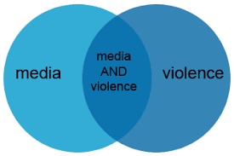
OR | Hospital OR Healthcare | OR Searches for two or more terms and hence expands the search.  When you use OR - It will retrieve results that have either word.  It is useful for capturing synonymous. | picture. Hospital OR healthcare
NOT | Practitioners  NOT  Doctors | NOT Excludes a term or terms from search and hence narrows the search.  When you use NOT - it will only retrieve result of primary term (s). | picture. Practitioners NOT Doctors

- Utilise Filters and Advanced Search Options: Many databases provide advanced search options and filters. You can use these to narrow down your results by date, type of publication, language, and more.
- Identify Appropriate Databases: Databases are structured collections of information, and they are often the first place to start your search. These can be subject-specific databases, such as PubMed for medical research, IEEE Xplore for engineering, or PsycINFO for psychology. General databases like Google Scholar, JSTOR, or Scopus are also commonly used for broader searches. You use these databases to input search terms, keywords, or phrases related to your research topic.

Sources of literature:
Four common approaches to finding evidence that fits with your inclusion criteria

Searching approaches | Description
Electronic Searching | This involves using databases, search engines, and online resources to find academic articles, papers, and research on a specific topic.  Internet-accessible online bibliographical databases are valuable sources of general references
Reference List | This involves Checking the citations within relevant articles to discover other studies and sources related to your research
Hand Searching relevant literature | This involves physically going through printed journals, books, and documents in libraries or archives to find relevant literature
Author Searching | This inovolves seeking out authors who have a substantial publication record in the area of your interest

Apply Inclusion and exclusion Criteria
- Develop Inclusion criteria: These are the characteristics or attributes that a study or source must possess to be considered for inclusion in your review. These criteria are typically aligned with your research question and are used to select studies that are directly relevant to your topic. Inclusion criteria can include elements such as study design (e.g., randomised controlled trials, cohort studies), population characteristics (e.g., age, gender, specific health condition), intervention or exposure of interest, outcomes, and publication types (e.g., peer-reviewed articles, conference abstracts).For example, if you are conducting a review on the effectiveness of a specific medication in treating a particular medical condition, your inclusion criteria might specify that you will include only randomised controlled trials (study design), involving adult patients (population), receiving the specific medication as an intervention, and reporting relevant clinical outcomes.
- Develop Exclusion Criteria: Exclusion criteria outline the characteristics or attributes that disqualify a study or source from being included in your review. These criteria help you filter out studies that do not meet your research objectives or may introduce bias. Exclusion criteria can include the opposite of your inclusion criteria. For example, you may exclude studies with certain study designs (e.g., case reports, editorials), populations (e.g., paediatric patients for an adult-focused study), interventions (e.g., studies involving different medications), or outcomes (e.g., studies not reporting relevant data).

Summary of Inclusion and exclusion Criteria
Inclusion criteria | Exclusion Criteria
- Primary research relating to xyz  - English and Spanish languages only  - Published including grey literature  - Between 2010 and 2020 | - Primary research..  - Non-English/Spanish  - Unpublished, papers under review or proposals  - Published pre 2010 and after 2020

Conducting a comprehensive search is a critical foundation for a literature review or any research study, as it ensures that you are aware of the existing body of knowledge and can build on previous research. It's a systematic and methodical process that demands patience, critical thinking, and attention to detail. There are some important points that you should keep in mind throughout the process and these are:
- Keep Records: As you find relevant sources, make sure to keep records of them. This might involve creating a bibliography, using citation management software, or simply keeping a detailed list of the sources you've found.
- Review and Refine Search: Periodically review your search results and refine your search strategy as needed. You may discover additional keywords or subject headings as you delve deeper into the literature.
- Search Iteratively: Conduct multiple searches with different combinations of keywords and databases. This iterative process helps ensure that you locate a comprehensive set of relevant literature.
What is Primsa flow Chart?

"PRISMA helps researchers ensure that they report all their search and paper selection details transparently in various types of reviews. The Prisma flow chart provides a visual summary of the steps reviewers took to find and decide whether to include published data in the review."
Figure. Prisma Chart

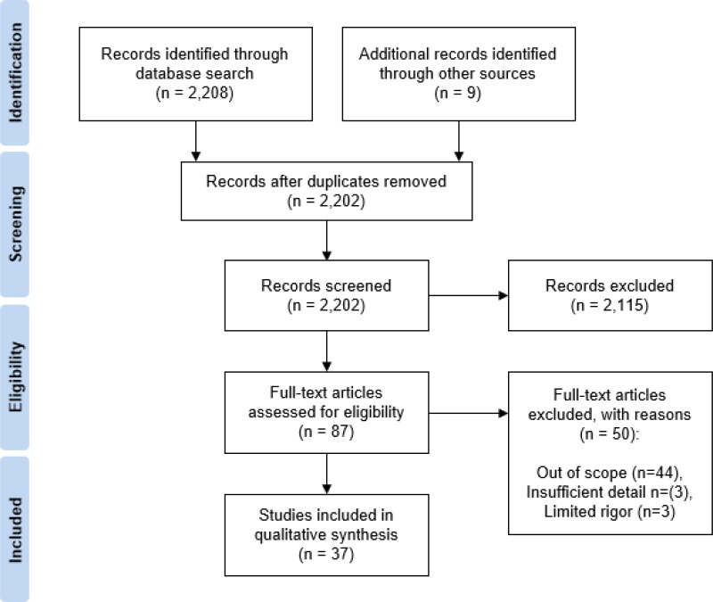

Review and Analyze Literature:

Up until now you have learned to develop a specific research question and then to identify relevant research studies. Now you have got a pile of research articles on the table in front of you. But do you actually know how to read a research article? Is it the same as a magazine article? What are the various components of a research article? How to make sense of it. All of these questions are very important. If you don’t know the components of a research article, you will not be able to appraise that article effectively.

Usual component of a research article/ Format of a research article

Research articles in the healthcare field typically consist of several key components. These components are structured to provide a clear and comprehensive understanding of the research, its methods, results, and implications. The specific format can vary slightly between different journals, but the core components often include:
Title: The title should be concise and clearly reflect the main topic of the research.
Abstract: A brief summary of the research, including the research question, methods, key findings, and conclusions. It provides a quick overview of the article.
Introduction: This section sets the stage for the research by providing background information, context, and a clear statement of the research question or hypothesis.
Literature Review: A review of relevant literature that provides the theoretical and empirical basis for the research. It identifies gaps in existing knowledge.
Methods: A detailed description of the research methods, including study design, data collection procedures, study participants, and statistical or analytical methods used.
Results: Presentation of the research findings, often through text, tables, figures, or graphs. This section should be clear and organised, allowing readers to understand the results easily.
Discussion: An interpretation of the results, including their significance and relevance. This section also addresses limitations and suggests areas for further research.
Conclusion: A concise summary of the key findings and their implications for the healthcare field.
Recommendations: If applicable, suggestions for practical applications or policy recommendations based on the research.A section where authors can acknowledge individuals or organizations that contributed to the research.
References: A comprehensive list of all sources cited in the article, following a specific citation style (e.g., APA, MLA, Chicago).
Appendices: Supplementary materials that provide additional details on methods, data, or analysis. These are often included if they would be too extensive to include in the main body of the article.
Additionally, some articles may include other components like a "Methods" section that is divided into subsections (e.g., participants, data collection, data analysis) or a "Conflict of Interest" statement to disclose any potential conflicts.
The specific structure and requirements may vary from one journal to another. These components collectively serve to present the research in a clear, transparent, and structured manner, allowing readers to understand, assess, and potentially build upon the research findings.
It is also important to remember that research articles and their parts or components vary depending on the study reported in the article. For instance, an article reporting the findings of a qualitative study will be written in a different way than one reporting a quantitative study. An article reporting in a systematic review will be different from presenting information about screening tests.

Analytical/Critical reading triggers critical thinking
Analytical reading is an active cognitive process that involves developing the ability to think critically. It encompasses mental activities such as focusing, categorising, choosing, and assessing. Engaging in analytical reading not only leads to a deeper comprehension of the subject matter but also supports researchers in honing and retaining their analytical reading abilities.

Table. The EEECA Model of Analytical reading
Examine | The topic from more than one perspective
Evaluate | Critique the topic, thereby making a judgement about it
Establish | Relationships and show how they are related
Compare | And contrast the ideas - similarities and differences
Argue | For and against something to try to persuade the reader to agree

Critically Appraising Literature

Part 2. Appraising Literature

Critical appraisal means thoroughly and carefully evaluating research to figure out if it's trustworthy and how useful it is in a specific situation. It's like a detailed review of a research study to see what's good and not so good in the research paper.

So, now you have developed a research question, found the evidence and read the research article. Is that enough? Now you need to make sense of the research article. Not in terms of the components or parts of a research article, but to understand the findings of the study reported in the article. You need to be able to make a judgement about the quality of the study presented in the article. You need to decide if the findings are valid and reliable.
You will be able to make these judgments only if you are able to critically appraise the article.

So what is critical Appraisal?
Critical appraisal is a systematic process, a central process of evidence-based practice, which helps the reader to determine:
- If the study presented in the research paper addresses a clear and focused question.
- If the methods used to answer the question were valid
- Are the results/ findings of the study valid, informative and important?
- Can these findings be applied in a practice setting?
Basically, the process of critical appraisal helps the reader determine the quality of the research evidence in an attempt to see its applicability in a given practice situation.

Why there is a need for critical appraisal?

- Not all published research is scientifically sound. The majority of published articles are not of appropriate quality and therefore cannot be used to inform practice
- To weigh up evidence to see how useful it is in decision making
- To determine and balance benefits and strengths of research against its flaws and weaknesses
- All health care professionals should have an ability and skill to critically appraise evidence
- It is important to remember that studies that do not state methods fully overstate the benefits of treatments. In addition, studies funded by a pharmaceutical company are more likely to give results that are favourable to the company than independent studies.

Principles of Critical Appraisal?

There are some principles of appraising and these can be summarised as:
- Read and critique the entire study
- Examine the organisation and presentation of the research report
- Examine the significance of the problem
- Identify strengths and weaknesses of the study objectively and realistically
- Provide specific examples of the strengths and weaknesses
- Provide a rationale for your critique
- Suggest modifications for future studies
- Discuss feasibility of replication of the study
- Discuss usefulness of findings for practice

Critical appraisal tools
There are many critical appraisal tools available that can be used to evaluate various types of research.
Using tools for critical appraisal, one can determine whether the evidence is derived from impartial, methodologically sound, and rigorous research.

Table 3.3 provides a list of some common critical appraisal tools used in health and social care research.

Table. Common Critical Appraisal Tools
Tool | Description | Sub-type
CASP (Critical Appraisal Skills Programme) | The CASP (Critical Appraisal Skills Programme) checklist is a tool used in evidence-based medicine and research to assess the quality of studies, particularly in the fields of healthcare and social sciences. | - CASP- Randomised Controlled Trial (RCT)  - CASP - Qualitative Studies  - CASP - Cohort studies
CEBM (Centre for Evidence Based Medicine) | The Centre for Evidence-Based Medicine (CEBM) is an organization, typically associated with universities or healthcare institutions, that promotes and conducts research in the field of evidence-based medicine. | - Systematic review  - Randomised Controlled Trial (RCT)  - Qualitative studies
JBI (Joanna Briggs Institute) | The Joanna Briggs Institute (JBI) checklist is a tool developed and used by the Joanna Briggs Institute, an international research organization known for its work in evidence-based healthcare. The JBI checklist is designed to assist researchers and healthcare professionals in critically appraising and synthesizing research studies and evidence, particularly in the fields of healthcare and nursing. | - Economic Evaluations  - Prevalence Studies  - Qualitative studies
PEDro | The PEDro (Physiotherapy Evidence Database) critical appraisal checklist is a widely used tool designed to assess the quality and methodological rigor of clinical research studies in the field of physiotherapy and related healthcare disciplines. | PEDro Scale
MMAT (Mixed Methods Appraisal Tool) | Mixed methods research involves the integration of both qualitative and quantitative research approaches within a single study to provide a comprehensive understanding of a research question or issue. | MMAT Tool

Part 3 Synthesising literature

The literature synthesis stage of a literature review is where you make sense of all the articles and studies you've gathered. It's like putting together pieces of a puzzle to create a clear picture of what's known about your topic. As nurses and healthcare professionals, this step is crucial for understanding the latest research and its practical applications in your field. Here's how to do it:
Organise Your Sources: Start by organising the articles and studies you've found. You can use software or tools like reference managers to help with this. Create categories or themes that relate to your topic, making it easier to group similar findings together.
Read Carefully: Read each article carefully and take notes. Highlight key findings, important statistics, and the author's conclusions. Note any differences or contradictions in the studies.
Identify Patterns: Look for patterns or trends in the literature. Do multiple studies support similar conclusions, or are there mixed findings? Identify any gaps in the research where more investigation is needed.
Compare and Contrast: Compare and contrast the studies and analyse the methodology used in each research piece. Are there differences in sample size, demographics, or methods that could explain variations in the results?
Extract Key Insights: Extract key insights from the literature. These are the main takeaways that are relevant to your research question or topic. Think about how these insights might be applied in your healthcare practice.
Synthesise Information: Write a summary of the literature, combining the key findings and insights from various sources. This should provide a clear, comprehensive view of the current state of knowledge in your area of interest.
Discuss Implications: Consider the practical implications of the research for your nursing or healthcare practice. How can the findings be applied to patient care, policies, or procedures? What questions or issues still need further exploration?
Identify Future Directions: Highlight areas where more research is needed or suggest potential future studies that could address existing gaps in the literature.
Write Your Review: Finally, write your literature review, structuring it with an introduction, a discussion of the reviewed literature, and a conclusion that summarizes the key findings and their relevance to your field.
Remember, the literature synthesis stage is all about connecting the dots and creating a clear, evidence-based understanding of your topic. This knowledge will not only benefit your own practice but can also contribute to the advancement of healthcare as a whole,

Part 4. Reporting Literature

The literature reporting stage in a literature review is where you share your findings with your fellow nurses and healthcare professionals. Here's how to effectively report your literature review:
Introduction: Start with an engaging introduction that explains the purpose of your review and why it's important for healthcare professionals.
Methods: Briefly describe the methods you used for your literature review, such as search criteria, databases, and inclusion/exclusion criteria.
Review Structure: Clearly outline the structure of your review, mentioning how you've organised the literature (e.g., by themes, chronology, or other categories).
Key Findings: Present the key findings and insights from the literature. Summarise what the existing research says about your topic.
Implications for Practice: Discuss the practical implications of the literature for healthcare professionals. How can this information be applied to improve patient care, policies, or healthcare practices?
Challenges and Gaps: Mention any challenges or limitations you encountered during your review. Highlight gaps in the research where further investigation is needed.
Recommendations: Provide recommendations for healthcare professionals based on the literature. What actions or changes in practice should be considered?
Conclusion: Summarise the main takeaways from your literature review and emphasise, the relevance of this knowledge for nurses and healthcare professionals.
References: List all the sources you've reviewed in a proper format, such as APA or MLA, so that your peers can access the original studies.
Appendices (if necessary): Include any supplementary materials, like tables or charts, that can help illustrate your findings.
Remember, the goal of the literature reporting stage is to communicate the valuable insights you've gathered from the research to your healthcare colleagues in a clear and concise manner. This information can be a valuable resource for evidence-based practice and decision-making in healthcare.

End

Chapter 4. Research Design

Can you envision navigating through the streets of London without a map or navigator? Most likely, you cannot. In the same vein, conducting research without a well-thought-out research design would be both challenging and inevitable. If research is to be meaningful and beneficial, meticulous planning is essential. This planning process, and the resulting 'blueprint,' is referred to as the research design. In the realm of research, the research design serves as a guiding map that researchers follow to achieve their research aims and objectives.

Purpose of Research Design:
Some of the key purposes of research design are:
- To provide a structure for answering a specific research question
- To aid in the solution of the research question and to maintain control
- The research design involves designs for the following aspects of the study:
  - What will be research aims and objectives?
  - How to integrate theoretical and methodological approaches to it?
  - What will be the research participants, settings and location?
  - Will there be an intervention?
  - What type of comparison will be made?
  - what procedures will be used to control extraneous variables?
  - When and how many times will data be collected from research subjects?
  - In what settings will the study take place?
  - When will the research project be completed (timeline)?

Developing Research Design
The issues around the concept of research design are crucial, as they determine the nature of a piece of research. The research design must be determined at the beginning of the research process as it then sets the scene for the work that will be undertaken by the researcher.

Types of Research Design:
Different research designs are used by researchers that help them answer their research problems. However, broadly at a higher level, there are two major approaches/designs to research: qualitative and quantitative.

Qualitative Research:

Qualitative research involves collecting and analysing data to gain an understanding of individuals' social reality, including understanding their attitudes, beliefs and motivations.

Qualitative researchers engage with study participants in their natural social settings to gain a holistic picture of their life experiences. Qualitative researchers may be required to engage over some time with research settings to familiarise themselves with social, cultural and other contextual variables and to build rapport with research participants. We will discuss the need for prolonged engagement in quantitative research later in the book.

Qualitative research is a valuable approach to understanding the complexities of human behaviour, experiences, and social phenomena. However, like any research method, it comes with its own set of advantages and disadvantages:

Advantages | Disadvantages
Qualitative research generates in-depth, rich, and detailed data that can provide a nuanced understanding of a subject or phenomenon | Qualitative research is inherently subjective, as it relies on the interpretation of researchers. Bias can be introduced during data collection and analysis.
It is well-suited for exploring new topics, generating hypotheses, or investigating complex, little-understood issues. | The small, non-random samples in qualitative studies may limit the generalizability of findings to broader populations
Qualitative research allows researchers to gather insights within the context in which the behavior or phenomenon occurs, providing a deeper understanding of the environment. | Qualitative research is often more time-consuming and resource-intensive than quantitative methods due to data collection, transcription, and in-depth analysis.
Researchers have flexibility in data collection methods, allowing them to adapt to evolving research questions or unexpected insights during the study. | Qualitative research is often more time-consuming and resource-intensive than quantitative methods due to data collection, transcription, and in-depth analysis.
This approach emphasises the participants' perspectives, giving a voice to the people being studied and allowing for a more comprehensive understanding of their experiences. | Analyzing qualitative data can be complex and labour-intensive, as it often involves coding, categorizing, and synthesizing large amounts of text.
Qualitative research can capture the full complexity of a situation by examining multiple variables, interactions, and contributing factors. | Replicating qualitative research can be challenging, as it is challenging to capture the same context and nuances in different settings.
The findings can inform practical applications, such as program development, policy changes, and improved healthcare practices. | Ensuring the privacy and confidentiality of participants can be challenging, especially in sensitive or controversial topics.

In summary, qualitative research is a powerful tool for exploring complex, context-dependent phenomena and understanding the lived experiences of individuals. However, it has limitations, including subjectivity, limited generalizability, and the resource-intensive nature of data collection and analysis. Researchers should carefully consider the advantages and disadvantages of qualitative research when choosing their research approach.

Types of Qualitative Research

Qualitative research encompasses a wide range of methodologies and approaches designed to explore and understand human experiences, behaviours, and social phenomena. Here are some common types of qualitative research used in nursing and health:

Phenomenology: Focuses on exploring the lived experiences of individuals, often patients or healthcare providers, to understand the essence of a particular phenomenon or condition.
Grounded Theory Research: Aims to develop theories or models grounded in data, typically used to explore and explain social processes and interactions within healthcare contexts.
Ethnographic Research: Involves deep immersion in a particular healthcare culture, such as a hospital or clinic, to understand the behaviours, practices, and values of healthcare professionals and patients.
Case Study Research: Examines a specific case or instance within healthcare, providing an in-depth analysis of a particular situation or intervention.
Narrative Research: Involves the collection and analysis of personal stories, narratives, or accounts related to healthcare experiences to understand patient perspectives.
Action Research: Integrates research with practical action to address specific healthcare problems or challenges, often in a collaborative manner with healthcare professionals.

Researchers can select the method that best aligns with their research questions and goals to gain deeper insights into the issues relevant to the field of nursing and healthcare. Below we describe three main types in further detail.

Grounded Theory

Description | Key characteristics
GT is a structured, yet flexible approach, concerned with the generation of theory, which is ‘grounded’ in data that has been systematically collected and analysed.  - GT focuses on social experiences  - Contributes to the development of middle-range theories.  - GT theories are grounded in data  - GT is suited to research about which very little is known.  - GT is an appropriate approach to explore many health-related research questions. | There are the following key components of GT.  Theoretical sampling is  the process of data collection, and deciding what data to collect based on the theory and categories that emerge from your data.  Theoretical sensitivity facilitates insight into what is meaningful and of significance in the data for theory development. Professional background, knowledge and experience can help researchers are helpful in developing sensitivity to the research topic.  Theoretical saturation. It is the last component to be taken into account when integrating theory. It is described as the stage in which no new categories are created and all additional data is gathered within already established categories.  Coding is a process of systematically labelling, organising and categorising qualitative excerpts to identify themes and patterns.  Constant comparison is an analytic technique in which information obtained from data collection is constantly compared with emerging categories and concepts.  Memo writing. Memos are written records of a researcher's ideas, reflections, and thoughts on the research process. Memos offer a record of the researchers' analytical decisions and logistical information regarding their research activities.

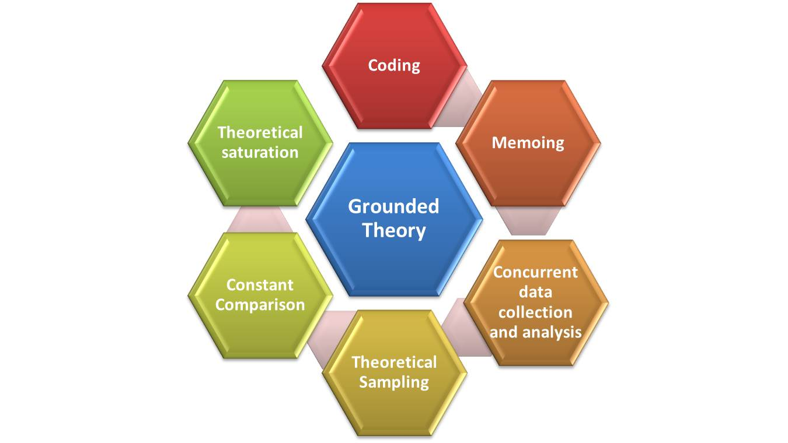

Phenomenology
Description | Key characteristics
Phenomenology is concerned with the lived experiences of humans and of the ways things present themselves to us in and through such experiences (Sokolowski 2000, 2). | Positionality refers to the researcher's acknowledgement and consideration of their own subjectivity, background, beliefs, and perspectives in the research process. Positionality influences the way a researcher approaches and interprets the data, and it is important to recognize and address these potential biases and preconceptions.  Reflexivity refers to the researcher's continuous process of self-awareness and self-reflection. To make sure that one's own prejudices, beliefs, and presumptions do not unnecessarily affect how participants' experiences are interpreted, it requires ongoing self-examination.  Bracketing is used by researchers to temporarily suspend or set aside their preconceptions and biases, allowing them to focus solely on the phenomena as experienced by participants.  Hermeneutic Circle: Phenomenological research involves an iterative process where the researcher continually moves between the parts and the whole, refining the analysis to gain a deeper understanding of the phenomenon.

Ethnography
Description | Key characteristics
Ethnography involves the in-depth study of a specific cultural group or community. Researchers immerse themselves in the field, often through participant observation and interviews, to understand the culture, behaviours, beliefs, and social dynamics of the group. Ethnography seeks to provide a holistic and context-rich perspective on the lives and experiences of the people within the studied community. | Participant Observation: Ethnographers actively participate in the social activities and events of the community they are studying. They observe and interact with community members, building relationships and trust over time.  Fieldwork: Ethnographic research typically involves fieldwork, which can last from several weeks to many years, depending on the research objectives. During fieldwork, researchers live among the people they are studying and immerse themselves in the culture.  Key informants: are integral to the success of ethnographic research, as they provide valuable insights and information about the culture, community, or social setting being studied. These individuals are typically well-informed, respected, and knowledgeable members of the community, and they serve as critical sources of information and guidance for ethnographers.

Quantitative Research

Quantitative research stems from the positivist paradigm. It is a formal, objective and systematic process in which numerical data are utilised to obtain information about the world. A quantitative researcher’s aim is to examine and describe relationships between various concepts or variables. The researcher may also aim to establish or explore cause-and-effect relationships between variables. for example, the relationship between alcohol (variable 1) and sleep deprivation (variable 2) in causing premature mortality (outcome). They do this by examining numerical data with the help of appropriate statistical procedures and programs.
In healthcare, you will note that quantitative research is often used to investigate or compare whether a new drug, treatment or therapeutic intervention is better than an existing one.

Quantitative research is identified as a preferred and more scientific method of investigation than qualitative research. However, both of these methods are useful in exploring various issues. Both of these methods complement each other and can be used at the same time to ensure robust research investigation.

Advantages:
- It is a systematic approach to prove or disapprove a hypothesis
- Quantitative research is a scientific process that helps in proving or disproving a hypothesis
- Data can be collected from a large number of participants with the help of questionnaires and/ or other data collection instruments
- The findings of quantitative research can be generalised more widely.
- It ensures greater objectivity as well as accuracy of results.
- The research process is very prescribed and therefore easier to follow when compared with qualitative research
- The risk of personal bias is minimal as the researcher keeps a distance from participants

Disadvantages
- It is often difficult to obtain and record information about the context in which phenomenon of interest occurs
- It is not possible to provide a detailed account of participants’ perception about issues under investigation.
- various types of bias can occur in quantitative data collection. For example, when completing a questionnaire, there is a risk of recall bias as the participant may not correctly recall information about their experience

Types of Quantitative Research

Like qualitative research, there are a number of types of quantitative research; here we will
focus on three main types.

Quantitative research in nursing and healthcare involves the systematic collection and analysis of numerical data to draw statistically significant conclusions. Here are some common types of quantitative research used in these fields:
Descriptive Research: Descriptive studies aim to provide a clear and comprehensive overview of a specific healthcare phenomenon or population. They do not attempt to manipulate variables but focus on presenting data as it naturally occurs.
Correlational Research: Correlational research investigates the relationship between two or more variables to determine if they are related. It helps identify associations or connections between healthcare factors, but it does not establish causation.
Cross-Sectional Research: In cross-sectional studies, data is collected at a single point in time from a group of participants. This type of research is often used to assess the prevalence of certain health conditions or behaviours in a population.
Longitudinal Research: Longitudinal studies track the same individuals or groups over an extended period. They are valuable for examining changes and trends in health and healthcare practices over time.
Experimental Research: Experimental research involves controlled interventions or treatments to assess the effects on health outcomes. This approach is crucial for establishing causation. RCTs are a good example. RCT is considered the gold standard in healthcare research. They involve randomly assigning participants to an experimental group receiving a treatment and a control group not receiving the treatment to determine the treatment's effectiveness.
Quasi-Experimental Research: Similar to experimental research, quasi-experimental studies include interventions but lack random assignment of participants to groups. This is often used when randomization is not feasible or ethical.
Observational Research: Observational studies involve researchers observing participants in natural settings without intervening. This method is useful for understanding patient behaviours and healthcare practices.
Case-Control Studies: These studies compare individuals with a specific condition or outcome (cases) to those without the condition (controls) to identify factors associated with the outcome, such as risk factors for a disease.
Cohort Studies: Cohort studies follow a group of individuals with a common characteristic or exposure over time to assess the development of health-related outcomes. They can be prospective (follow-up) or retrospective (looking back in time).
Quantitative research methods in nursing and healthcare provide valuable evidence for decision-making, policy development, and practice improvement. Researchers choose the most appropriate method based on their research questions and goals.

Randomized controlled trials

Description | key characteristics
A randomized controlled trial (RCT) is a type of scientific experiment, designed to assess the effectiveness of a particular intervention or treatment.  The randomised controlled trial (RCT) is considered the gold standard for assessing the efficacy of interventions because it is the most scientifically rigorous approach to hypothesis testing currently available.  In an RCT, participants are randomly assigned to one of two or more groups: an experimental group that receives the treatment being studied, and a control group that does not receive the treatment or receives a placebo or standard treatment for comparison. | Randomization: is a process of randomly allocating participants so that each participant has an equal chance of being assigned to any particular group.  This random assignment eliminates selection bias ensuring that the groups are similar in terms of potential confounding variables.  Blinding: In many RCTs, participants and researchers are "blinded" to the treatment assignment to prevent biases. Single-blind means participants don't know which group they're in, and double-blind means both participants and researchers are unaware.  Causality Inference:  RCTs are well-suited for establishing causation. By randomly assigning participants to different groups, researchers can confidently attribute observed differences in outcomes to the intervention being studied rather than pre-existing differences between participants.  Generalizability:  Well-designed RCTs provide findings that can be generalized to broader populations.

Cross-sectional Research study:

Description | Key characteristics
A cross-sectional research study is a type of observational research design that involves data collection from a specific sample or population at a single point in time. The primary goal of a cross-sectional study is to gather information about the characteristics, behaviours, or conditions of the study participants at that particular moment. The cross-sectional research design is often called a survey design (Bryman 2016). | Single Time Point:  Cross-sectional studies collect data from participants at a specific point in time, providing a snapshot of the population's characteristics, behaviours, or conditions at that moment.  Prevalence Estimates:  Cross-sectional studies are often used to estimate the prevalence of certain conditions, behaviours, or characteristics within a population at a specific point in time.  Limited Causality Inference:  Cross-sectional studies are limited in their ability to establish causal relationships between variables. The observed associations may be due to confounding factors, and the temporal sequence of events cannot be determined.  Survey Methods:  Data in cross-sectional studies are often collected through surveys, interviews, or other methods that can efficiently capture a wide range of information from a large number of participants.

Longitudinal Research Study:

Description | Key characteristics
Longitudinal research designs involve the collection of data at multiple time points over an extended duration. These designs serve as valuable tools for investigating temporal changes and determining the chronological order of events, a fundamental aspect when establishing causative relationships | Time Frame: studies are conducted over an extended period (months to years); this allows researchers to observe changes, developments, and trends.  Repeated Measurements: Participants are typically measured or observed multiple times at different intervals during the study. This may involve follow-up assessments, surveys, interviews, or other data collection methods at predetermined time points.  Temporal Sequence:  Longitudinal studies establish a temporal sequence, enabling researchers to infer causality.

Comparison of of qualitative and quantitative Research table:

Table.
See the tables below, and can these be merged into one good form?

Research in a Digital Age.

In healthcare institutes, digitalisation has a robust presence helping healthcare practitioners communicate better and enable patients to access services. Digital transformation has been noted to boost patient outcomes and improve the healthcare system. Today, we see smartphone apps, like Samsung Health, wearable devices, like Fitbit, and platforms that provide remote healthcare, like telehealth, are widely used examples of digital transformation in health. This (influence the way) has implications for the way we interact and collect data about or from our patients.

Digital technologies have transformed the way traditional research is conducted. Today, how we engage, interact or recruit research participants/patients is often determined by modern and available methods of technology. In research participant recruitment, for example, social media, internet platforms and digital advertising through a wide range of channels, like Facebook, Twitter, and Instagram are the most common and accessible way to reach out to the targeted populations. In data collection and generation, similarly, AI-supported tools are the easiest, most flexible and most effective platforms. We also see technology shifting social and natural research settings of engagement and interaction to virtual sites. Zoom, Google Meet, and MS Team are popular new social fields changing traditional ways of face-to-face interaction and data collection.

Merge the following two/three tables to make one good one

Comparison of qualitative and quantitative research Table 1.1
Qualitative approach | Quantitative Approach
Words | Numbers
Participants’ point of view | Reseracher’s point of view
Meaning | behaviour
Contextual understanding | generalisation
Rich, deep data | hard , reliable data
unstructured | structured
process | static
micro | macro
Natural settings | Artificial settings
Theory emergent | Theory testing
Researcher close | Researcher distant
Page 17 Liamputtong
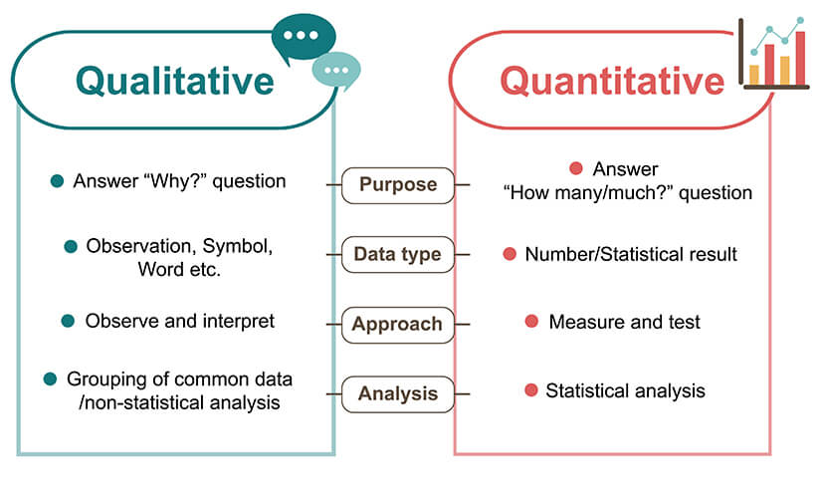

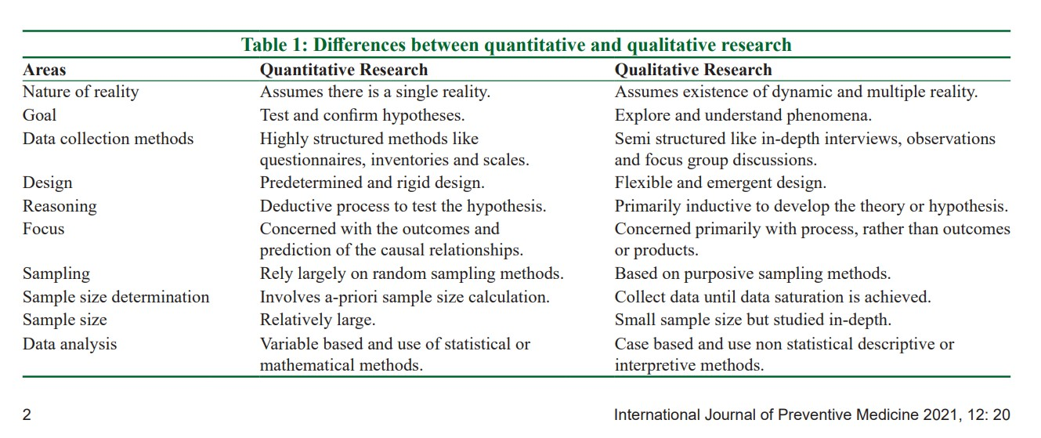

Chapter End.

Chapter 5 Ethics and Integrity

What is Ethics:

Imagine a person who lives alone in a house. In this setting, they are under no obligation to account for their actions to anyone and enjoy the freedom to do as they please, whether it involves having a late dinner, watching television for extended periods, or even painting the ceiling a vivid yellow. The consequences of their actions are confined solely to themselves. However, if another person, such as a friend or a family member, subsequently joins them in the same dwelling, the dynamics change. The presence of two individuals necessitates the establishment of new behavioural guidelines, as the actions of one person can impact the other. These guidelines, which regulate an individual's behaviour or the manner in which activities are carried out in the presence of others, are collectively referred to as "ethics."

Ethics plays a critical role in various aspects of life, including personal relationships, healthcare, education, and governance. Ethics refers to the moral principles, values, and standards of conduct that guide human behaviour and decision-making. It encompasses a set of rules and principles that help individuals and societies differentiate between right and wrong actions and choices. Ethics provides a framework for evaluating the morality of actions and for making choices that are considered just, fair, and in line with societal norms and values.

Ethics, human and Healthcare.

Human research has a high risk, and even with the greatest of intentions and meticulous preparation and execution, mistakes can still happen. Accidents can occasionally occur as a result of technical faults, insensitivity, carelessness, or disdain for ethics. There have even been a few instances in which research has deliberately and horribly violated human beings.

In recent times, to reduce risk and promote health, the conduct of research in health and social services has become subject to a growing amount of global regulation, requirements, and control.

Healthcare practitioners are required to make well-informed decisions about the best course of therapy and patient care on a daily basis. Research frequently influences these choices, affecting treatment, care, and services. Therefore, it is crucial that we safeguard our patients in all of our decisions and activities. The core principles of ethics in healthcare focuses on - respect of patients, beneficence, justice, utility, and solidarity (WHO - last line title: health ethics)

Ethics in healthcare settings is a crucial and complex field that guides the conduct and decision-making of healthcare professionals, organizations, and patients. It involves a set of principles and values that help ensure the provision of high-quality, patient-centred care while addressing moral dilemmas and ethical challenges. Here are some key aspects of ethics in healthcare settings:
- Patient Autonomy: Patient autonomy is a fundamental principle of healthcare ethics. It emphasizes the right of patients to make informed decisions about their medical care, including the right to accept or refuse treatment. Healthcare professionals should respect and support a patient's autonomous choices.
- Beneficence: The principle of beneficence requires healthcare providers to act in the best interests of their patients. It involves providing care that maximizes benefits while minimizing harm. Beneficence is closely related to the concept of "do no harm" (non-maleficence).
- Non-Maleficence: Non-maleficence is the ethical duty to do no harm. Healthcare professionals should avoid actions that may harm patients and should carefully consider the potential risks and benefits of medical interventions.
- Justice: The principle of justice pertains to the fair and equitable distribution of healthcare resources and access to care. It requires healthcare systems to be just and unbiased in their allocation of services and treatments.
- Confidentiality: Healthcare providers must uphold patient confidentiality. Patients have the right to expect that their medical information will not be disclosed without their consent, except in situations mandated by law or public safety.
- Informed Consent: Informed consent is the process through which patients are provided with comprehensive information about their medical condition, proposed treatments, potential risks and benefits, and alternative options. Patients must give their voluntary and informed consent before any medical procedure.
- End-of-Life Care: Ethical issues in end-of-life care include decisions about withholding or withdrawing life-sustaining treatment, do-not-resuscitate (DNR) orders, advance directives, and physician-assisted suicide or euthanasia. These issues require careful consideration of the patient's wishes, quality of life, and ethical principles.
- Resource Allocation: The allocation of limited healthcare resources, such as organ transplants or critical care during a pandemic, poses ethical challenges. Ethical guidelines and decision-making frameworks help healthcare professionals make difficult choices while considering fairness and patient welfare.
- Cultural Competence: Healthcare professionals should be culturally competent, understanding and respecting the diverse cultural beliefs and values of their patients. Cultural competence ensures that care is provided in a culturally sensitive and respectful manner.
- Professional Codes of Ethics: Healthcare professionals, such as doctors, nurses, and pharmacists, are bound by their respective codes of ethics, which set forth principles and standards of conduct specific to their professions.

Patient and Public Involvement and Engagement
The ultimate beneficiaries of health care and health service research are patients and the general public, and improving patient outcomes is the primary goal of this field of study. As a result, any type of research must involve both the public and the patient. (Ethics module - paraphrased).

When it comes to research, public involvement refers to work that is done "with" or "by" the public rather than "to," "about," or "for" them. It indicates that patients and other individuals with relevant experience are involved in the planning, execution, and dissemination of research. (NHS Health Research Authority- paraphrased).

Research teams which involve patients and the public run better studies because - they provide a better research experience, are created in a way that participants can accept, contain participant information that participants can understand, and have better results communication to participants at the end of the study.

Patients and the general public can participate in research in a variety of ways, such as by helping to identify the research topic and establish the research agenda, by assisting in the creation of the research proposal, by offering feedback on the proposal, and by participating in advisory groups for studies. In fact, they are able to participate in every step of the research process (R. Module).

Green to go- above rephrased.

Good Clinical practice
An worldwide standard of ethical and scientific excellence for the planning, carrying out, and documentation of human subjects' research is called Good Clinical Practise, or GCP. The public can be assured that research subjects' rights, safety, and well-being are protected and respected when GCP is followed, as it aligns with the values stated in the Declaration of Helsinki and other globally accepted ethical guidelines. Additionally, it guarantees the accuracy of study data.

The 13 GCP principles are listed below.
- Ethics: Clinical trials should be conducted in accordance with the ethical principles that have their origin in the Declaration of Helsinki, and that are consistent with GCP and the applicable regulatory requirement(s).
- Trial risk vs. trial benefit: Before a trial is initiated, foreseeable risks and inconveniences should be weighed against the anticipated benefit for the individual trial subject and society. A trial should be initiated and continued only if the anticipated benefits justify the risks.
- Trial participants: The rights, safety, and well-being of the trial subjects are the most important considerations and should prevail over the interests of science and society.
- Information on medicinal products: The available nonclinical and clinical information on an investigational product should be adequate to support the proposed clinical trial.
- Good quality trials: Clinical trials should be scientifically sound, and described in a clear, detailed protocol.
- Compliance with the study protocol: A trial should be conducted in compliance with the protocol that has received prior institutional review board (IRB)/independent ethics committee (IEC) approval/favourable opinion.
- Medicinal decisions: The medical care given to, and medical decisions made on behalf of, subjects should always be the responsibility of a qualified physician or, when appropriate, of a qualified dentist.
- Trial staff: Each individual involved in conducting a trial should be qualified by education, training, and experience to perform his or her respective task(s).
- Informed consent: Freely given informed consent should be obtained from every subject prior to clinical trial participation.
- Clinical trial data: All clinical trial information should be recorded, handled, and stored in a way that allows its accurate reporting, interpretation and verification.
- Confidentiality: The confidentiality of records that could identify subjects should be protected, respecting the privacy and confidentiality rules in accordance with the applicable regulatory requirement(s).
- Good manufacturing practice: Investigational products should be manufactured, handled, and stored in accordance with applicable good manufacturing practice (GMP). They should be used in accordance with the approved protocol.
- Quality assurance: Systems with procedures that assure the quality of every aspect of the trial should be implemented.
GCP adapted but it is standard.
Green to go- above rephrased.

Participant Information Sheet

Potential research volunteers are provided a written document called the Participant Information Sheet (PIS), which has been ethically approved and includes comprehensive study details. The purpose of a PIS is to ensure that participants are fully informed about the research, its objectives, procedures, risks, benefits, and their rights, enabling them to make an informed and voluntary decision about their participation.

Typical content of PIS or share a pictorial example of PIS?
(example to add or content)?

Informed Consent

Prior to collecting data, participants are informed of the research's aim, objectives and methods, and their consent is requested.

The idea behind informed consent is that people shouldn't be forced into participating in research "against their will," but rather out of a sense of voluntarism and after fully understanding all of the potential consequences. 2018 Thorogood, page 89.

Definition:
“A process by which a subject voluntarily confirms his or her willingness to participate in a particular trial, after having been informed of all aspects of the trial that are relevant to the subject’s decision to participate. Informed consent is documented by means of written signed and dated Informed Consent Form.” (NIHR).

A two-way conversation with the prospective participant is what constitutes informed consent. Consent should be viewed as an information cycle because it is a process, not a single event.

While obtaining consent from participants, ensure:
- they are adequately informed about the study
- they understood the information
- they had time to consider being involved in the study
- They are free to decline or withdraw at any time, without having to give a reason.
- they have the power of free choice

How does a Consent form look like
a Sample from anywhere UoS etc here the in box

Vulnerable Groups
Every human subject in the study has the potential to be vulnerable. People can be vulnerable in different ways and to varying degrees depending on their current circumstances. Some participants might be especially susceptible for taking part in research.
While working with potentially vulnerable individuals, researchers will need to take additional ethical considerations into account.

Vulnerable groups in research and healthcare ethics refer to individuals or populations who may be at an increased risk of harm, exploitation, or discrimination due to their characteristics, circumstances, or conditions. Ethical considerations for research and healthcare involving vulnerable groups are paramount, as these individuals often require special protections to ensure their rights, well-being, and dignity are upheld.

The following groups of people are perceived to be particularly vulnerable in a research context:

Vulnerable Group | Description | Example
Children  Infants and children under 18 years of age | Children (under 18 years old) lack the capacity to provide informed consent; therefore, the informed consent of the children's parents or legal guardians should be obtained. | Balancing Parental Rights and Child's Best Interests: Balancing parental decision-making authority with the best interests of the child is a critical ethical consideration. In some cases, parental decisions may conflict with the child's well-being, requiring an assessment of the child's best interests.
People who lack mental capacity | People who cannot weight the risks and benefits of participation and make an informed decision.  In cases where individuals lack the capacity to make decisions, substitute decision-makers, such as legal guardians, family members, or healthcare proxies, may be appointed. | People with learning disabilities, dementia, or stroke
People with physical disability | Certain physical disabilities may necessitate special consent procedures, for example, an entire consent procedure in writing | People with hearing problems or deaf
People who are terminally ill | Participants in research who are terminally ill can rarely expect to gain personal benefits from the study, so the risk/benefit ratio must be carefully considered. | Respect for Autonomy: Terminally ill patients have the right to make informed decisions about their medical care. This includes choices about treatment options, pain management, and end-of-life decisions, such as advance directives and do-not-resuscitate (DNR) orders.
Pregnanat women | Pregnant women present a specific and important ethical consideration in healthcare and research due to their unique circumstances and vulnerabilities. | Maternal-Fetal Conflict: Ethical dilemmas can arise when the interests of the pregnant woman conflict with the interests of the fetus. In such cases, healthcare providers should prioritize the pregnant woman's well-being while considering the best interests of the fetus, striving to reach a balance that respects both.
People in various circumstances | People whose circumstances may unduly influence decisions to consent | people who are frail or in poor health; elderly, or people who are in care;

Sensitive Topic and Ethics

Sensitive topics in research and healthcare often involve issues that are deeply personal, emotionally charged, or potentially stigmatizing. Ethical considerations when dealing with sensitive topics are crucial to ensure the well-being, rights, and dignity of individuals or communities involved.
'Sensitive' research entails unique risks that must be managed, taking into account the possible outcomes of these risks.
In this regard, the sensitivity of the research subject matter is also important. For instance, participants may be more vulnerable in a study focusing on any of the following topics:

‘race’ or ethnicity;
political opinion;
trade union membership;
religious, spiritual or other beliefs;
physical or mental health conditions;
sex life, sexuality and/or gender identity;
identity of an individual resulting from processing of genetic or biometric data;
abuse (child, adult);
nudity and the body;
criminal or illegal activities;
political asylum;
conflict situations;

In box: Generic principle of carrying out research with vulnerable individuals.

When conducting research involving vulnerable individuals, the following general guidelines are helpful to keep in mind:

- Always consider your actions and decisions when conducting research.
- Recognise that the type and extent of participant vulnerability can vary depending on the specifics of a research project.
- When planning the study, try to keep potential participant risks to a minimum.
- Recognise that you might need to assist participants in finishing the study, and make the necessary preparations (not the least of which is an exit strategy).
- Offer a variety of options to potential participants when appropriate.
- Recognise that the type and extent of participant vulnerability can vary depending on the specifics of a research project.
- Recognise the dangers to participants, other potential participants, and researchers themselves.

Adapted from the University of Sheffield

Support and Approvals in Ethics - Ethic Boards

The majority of universities, hospitals, and other research-conducting organisations have formal committees in place to review research proposals.
Ethical guidelines and ethics committees serve the dual purpose of safeguarding research participants and institutions by discouraging researchers from engaging in unethical behaviour that could have implication for research participants as well as negative consequences for their institutions.
The study protocol is submitted to the appropriate ethics committee for approval along with any supporting documentation (such as the Participant's information sheet and the informed consent form).
Research projects involving staff and service evaluations frequently don't need NHS approval, but they do need to be registered with the departments of research and development.

Research Ethics Committee:
Definition: “A Research Ethics Committee is a group of people appointed to review research proposals to assess formally if the research is ethical. This means the research must conform to recognised ethical standards, which includes respecting the dignity, rights, safety and well-being of the people who take part.”

Data and Ethics:

Big data is produced, stored, and analyzed by healthcare systems with the goal of enhancing the services they offer. Hospital records, patient medical records, exam results, and internet-of-things-enabled devices are just a few examples of the big data sources used in hospitals (Dash et al., 2019).
In order to advance science and healthcare knowledge and to keep the public's trust in the research enterprise, it is crucial to ensure the integrity of research data (Ethic module -rephrased). The term "integrity" of such data refers to a strict adherence to moral principles, honesty, and complete avoidance of deception.
Green - rephrased

End

Chapter 6. Data Collection

Data collection is an important element in the research process that helps a researcher explore the answers to developed research questions. It is the process of gathering and measuring information on variables of interest, in a systematic and structured manner, with the aim of answering research questions, testing hypotheses, or making informed decisions.

Before delving into the specifics of data collection and its contents, it is essential to grasp the fundamental variables that define this process.

Green to go

What is Data?

Any information, often numerical or qualitative, that has been gathered, seen, produced, or created to support initial research findings is referred to as data.

Data can be divided into two types that are:
- Primary data: Data collected or created by ourselves
- Secondary data: Data collected by organisations or other researchers for their purposes

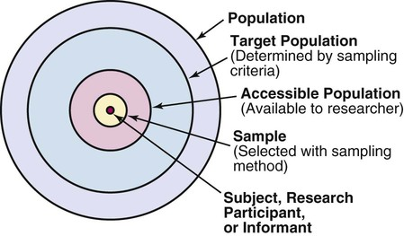

Research Population:
A research population constitute a broad group of people or things, with common, defining characteristics, that are the primary subject of a particular study. A population is the total collection of cases that satisfy certain requirements.

A research population means a well-defined collection of individuals or objects known to have similar characteristics.

For instance, suppose your research aims to delve into the challenges faced by professionals in the healthcare sector during a financial crisis. In this context, the population of interest might include all healthcare professionals registered with the relevant licensing body. This population constitutes the comprehensive group about which you intend to draw inferences. However, despite the ultimate goal of research being to benefit this population, involving every member in the study would be impractical, costly, and time-consuming.
While a census serves as an illustrative example of a whole population study, it's crucial to note that this approach is not always feasible in research endeavours.

Defining and understanding the characteristics of the research population is, therefore, a fundamental step in research design, as it guides the selection of samples, research methods, and the generalizability of findings to the broader population from which the sample is drawn. Accurately defining and describing the research population is essential for ensuring the validity and reliability of research results.

When dealing with the concept of 'population,' two terms often arise: 'target population' and 'accessible population.' The target population refers to the entire group of individuals or objects that a researcher aims to generalize and draw conclusions about. In contrast, the accessible population is the subset within the researcher's reach, from which they can draw their sample.
For instance, if I'm examining assertiveness skills among nurses in the UK, my target population would be all nurses in the UK, representing the group I intend to generalize my findings to. However, for practical reasons, my accessible population may be limited to nurses working in specific hospitals, such as Doncaster and Bassetlaw Teaching Hospitals or a local hospital trust. From this accessible population, I can then draw my sample, which consists of the nurses selected to participate in my study. Now that we talking about sampling, let's move on to this topic and explore more.

What is Sampling?

The aim of research is to benefit the entire population, but involving every member is impractical, costly, and time-consuming. This is where sampling becomes crucial. It plays a vital role in project management, especially when recruiting too many participants is impractical. Given the time, money, and resource constraints of research projects, however, researchers must ensure that the sample size and composition align with the study's objectives to support their findings and conclusions.

Sampling is the process of selecting a portion of the population to represent the entire population. A sample, therefore, is a subset of a population selected to participate in a research study. This is a specific group of people that you will collect data from.

The sample is selected to:
- minimise bias
- represent the characteristics of the population
- allow researchers to draw inferences and make generalisations about the population without examining each unit of the population

Inclusion and Exclusion Criteria:
After defining your sample, the next step is to consider specific details. Three crucial questions arise:
- Who or what constitutes the sample?
- How is the sample selected?
- How many will be chosen?
To clearly define the population, the researcher establishes inclusion and exclusion criteria. Inclusion criteria determine who is included in the study, while exclusion criteria specify who is excluded. Inclusion criteria identify those relevant to the study, while exclusion criteria account for individuals who might introduce bias or deviate from the typical characteristics of the study groups, potentially introducing extraneous variables. These criteria may involve factors like age, gender, ethnicity, diagnosis, geographical location, or the stage of illness.
For instance, in a research paper on adolescent parents—a 15-year longitudinal study of school-age mothers and their children—every schoolgirl who became pregnant in a specific London Health District between 1980 and 1987 was contacted.

Types of Sampling:

There are two types of sampling methods: 'probability' and 'non-probability' sampling.

Probability sampling is considered stronger. The researcher can precisely specify the probability of each population element being included in the sample, instilling greater confidence in its representativeness. Typically, this method involves random subject selection, enabling robust statistical inferences about the entire group. The technique is employed to minimize the risk of selection bias.
Although more expensive and time-consuming, probability sampling is generally considered superior. It is viewed as a much stronger sampling frame overall. Research textbooks often caution that studies using non-probability sampling frames should be approached with great care.

The common types of probability sampling methods are summarised below:

There are multiple Picture/Ways/Tables/Diagramme to present this Sampling.

Non-probability sampling is employed when achieving a probability-based sample is not feasible. However, it is crucial for the researcher and reader to ensure that the sample avoids bias in representing specific population segments disproportionately. In this type of sampling, not every subject has an equal chance of being included in the sample.
Qualitative research often utilizes non-probability sampling, and in this context, a smaller sample size is considered a strength rather than a weakness. It's important to note that non-probability sampling is also used in quantitative research, though it is generally viewed as less favorable than probability sampling methods. The following outlines non-probability/qualitative sampling techniques:

There are multiple Picture/Ways/Tables/Diagramme to present this Sampling.

Sample Size:
Determining the appropriate sample size is a crucial step in research, and various factors influence this decision. There is no one-size-fits-all rule for establishing sample size, but several considerations come into play:
- Type of Design: The nature of the research design impacts the required sample size.
- Sampling Procedures: The method used for sampling plays a role in determining the sample size.
- Formula for Estimation: The specific formula employed to estimate the optimal sample size is a key factor.
- Precision Requirement: The desired degree of precision in the study influences sample size.
- Heterogeneity of Attributes: The diversity of characteristics being investigated affects sample size determination.
- Frequency of Phenomenon Occurrence: Whether the phenomenon is common or rare in the population is a significant consideration.
- Project Cost: The financial implications of employing a particular sampling strategy need to be considered.
It is advisable to determine the sample size before commencing the study, and a general guideline is to aim for the largest sample feasible. Larger samples tend to be more representative of the population, enhancing the reliability of results. Conversely, smaller samples may yield less accurate findings.
In quantitative research, larger sample sizes are typically used compared to qualitative research. Quantitative researchers often employ a statistical procedure called power analysis to estimate the appropriate sample size. For further understanding, a paper by Eng (2003) in the field of radiology provides insights into sample size calculation in quantitative research.
Eng, J. (2003). Sample Size Estimation: How Many Individuals Should Be Studied? 1. Radiology, 227(2), 309-313
In qualitative research, sample size is not predetermined. Due to the extensive analysis of verbal data and the emphasis on intensive participant contact, qualitative research often involves small sample sizes. Participants are added until data saturation is achieved, indicating that no new data emerges during the collection process. Mason's paper (2010) on sample size and saturation in qualitative interviews provides valuable insights into determining appropriate sample sizes in qualitative research.
Mason, M. (2010, August). Sample size and saturation in PhD studies using qualitative interviews. In Forum Qualitative Sozialforschung/Forum: Qualitative Social Research (Vol. 11, No. 3)

Additionally, guidelines for various qualitative approaches can be found in the accompanying table.

Sample size in qualitative research
Type | Sample Size | Focus
Phenomonlogy | 6-10 participants | individual experiences
Grounded theory | 30 - 40 participants (maybe more) | develop a theory
case study | Maybe one person who is followed over time | characteristics of case
Focus Group | 6 - 10 participants per group | facilitate in-depth discussion

Research Participant
A research participant, also known as a human subject, experimentee, trial participant, study participant, or subject, is an individual who willingly takes part in human subject research after providing informed consent to be the subject of the study. A research participant is often a volunteer who consents to participate in the research on equal terms

Identification and Recruitment of Participants.

Identification and recruitment of appropriate participants to the research study can be a big challenge for the researcher. Recruitment refers to a dialogue that takes place between a researcher and a potential participant prior to the initiation of the consent process. It begins with the identification, targeting and enlistment of participants (volunteer patients or controls) for a research study. It involves providing information to the potential participants and generating their interest in the proposed study. There are two main goals of recruitment:
- To recruit a sample that adequately represents the target population
- To recruit sufficient participants to meet the sample size and power requirements of the study

Data collection.
Data collection refers to refers to the process of collecting or gathering data about a particular research question.

Any data collection method should have some basic characteristics and these may include attention to some points as described below.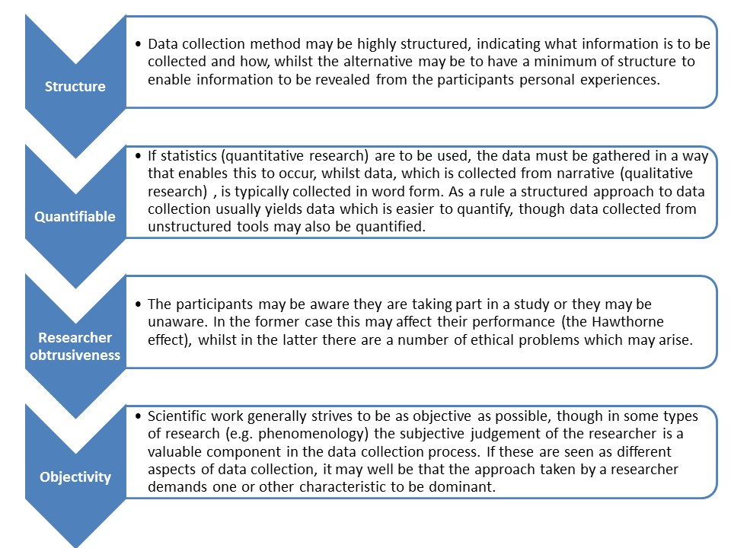

Data collection methods are often dependent on research questions and methodological approaches i.e., qualitative and quantitative research. Researchers can employ a single or a number of data collection methods to collect information.

Both qualitative and quantitative researchers use a combination of methods of data collection.

The main data collection methods used by healthcare researchers include the following
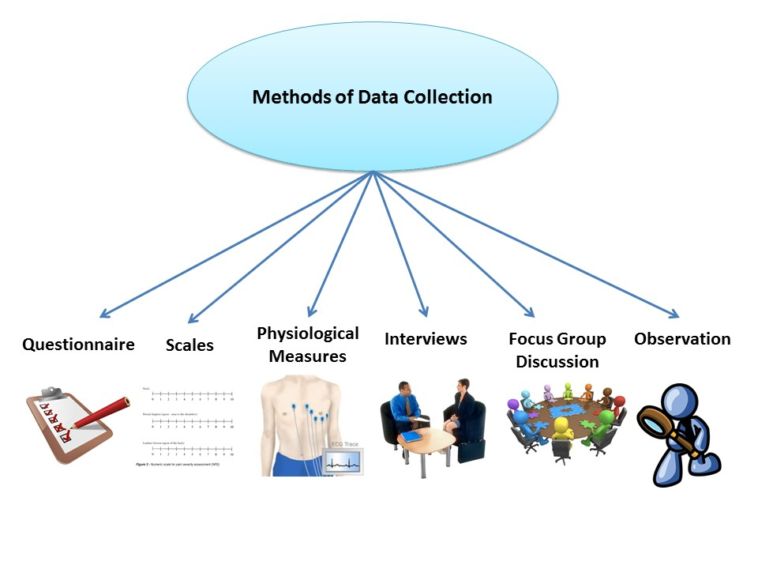

Questionnaire
Data collection via questionnaires involves a variety of instruments falling under the umbrella term "questionnaire." These instruments can take different forms, including:
- Closed responses
- Open responses
- Checklists
- Rating scales
- Open-ended comments
Questionnaires are designed to be both standardized and structured. In quantitative research, they serve various purposes, with a common application in descriptive studies, especially surveys. This is because questionnaires efficiently collect a broad range of information on facts, beliefs, attitudes, and experiences from numerous participants in a relatively quick and cost-effective manner. Questionnaires can consist of a single question type or a combination of different methods, categorized as either:
- Self-reported: Completed by the participant without the researcher's presence.
- Researcher-assisted: The researcher employs the questionnaire to interview the participant.
Despite their seemingly straightforward nature, crafting a questionnaire requires careful consideration. Elements such as selecting question types, formulating questions, structuring the questionnaire, conducting pilot tests, and managing distribution and collection/return processes demand attention to ensure the reliability and validity of the collected data.

General Principles of Questionnaires:
The fundamental principles of questionnaires encompass several key aspects:
- Primary Aim: The primary goal is effective communication with the participant.
- Question Clarity: Questions must be understandable and structured appropriately to facilitate responses.
- Language Importance: Language plays a central role in framing questions to elicit expected responses, known as the 'frame of reference' or context.
- Information Level: The language should align with participants' comprehension levels. Considerations include literacy, ethnic and cultural backgrounds, age, and participants' understanding. Special care is needed when addressing sensitive topics, such as sexuality or abuse, and the use of technical language requires caution. The language should avoid being overly simplistic, patronizing, or utilizing confusing, embarrassing, or upsetting terms.
Questionnaire Design:
- Investigation Scope: The design should delve into the minimum amount of a person's experience necessary to answer the research question.
- Information Collection: It should collect only essential information, including some biographical or demographic details.
- Comprehensive Questions: Questions need careful consideration to ensure comprehensiveness.
- Appropriate Length: The questionnaire should maintain an appropriate length.
Note: While these considerations focus on content, they do not address the questionnaire's appearance, functionality, and layout, including aspects like typography, graphics, instructions, and spacing.
Questionnaire Administration:
Questionnaires, often used for large-scale data collection, can be administered through various means, including pen and paper, web-based platforms, or telephone interviews. The diagram below illustrates the diverse methods through which questionnaires (sometimes referred to as surveys) are conducted.

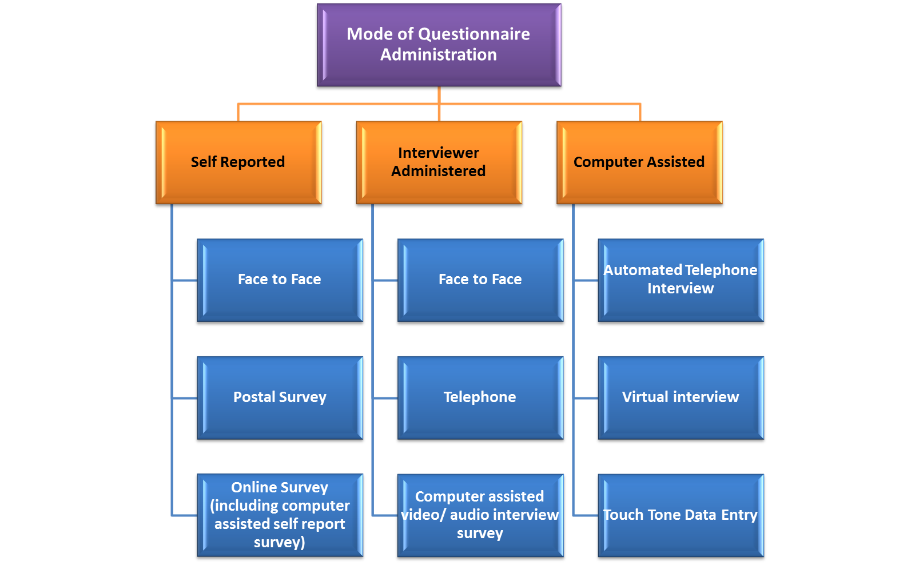

Biophysiological Measures in Healthcare Research:

Healthcare professionals routinely measure biophysiological physical variables, necessitating specialized technical instruments and equipment. These measures can be broadly classified into two types: in vivo measures conducted directly within or on living organisms, and in vitro measures performed outside the body using materials extracted from it (e.g., serum potassium levels). Nursing researchers frequently employ biophysiological measures in their studies, covering various domains:
- Circulatory Function: Heart rate, arterial blood pressure
- Respiratory Function: Respiratory rate, tidal volume, alveolar ventilation
- Neurological Function: Peripheral skin temperature
- Blood Tests: Blood gas analysis, blood pH
- Urine Tests: Urinary cortisol level
- Umbilical Cord Culture: Bacterial colonization rates, Staphylococcus aureus, and Group B Streptococcus

Biophysiological Measures as Data Collection:
- Objective: The equipment used and the individuals interpreting results are likely to be consistent, ensuring objectivity.
- Accuracy, Precision, and Sensitivity: Biophysiological measures are relatively accurate, precise, and sensitive in capturing subtle changes.
- Non-Distorted Measurements: There is a low likelihood of deliberately distorted measurements, enhancing the reliability of the collected data.
- Validity: The instruments employed provide targeted measurements aligned with the study variables, ensuring validity.
- Economic Efficiency: Utilizing biophysiological measures for data collection is economical. When the required equipment and expertise are readily available in a hospital setting, the cost of data collection is reduced.
In summary, leveraging biophysiological measures in healthcare research not only ensures the objectivity, accuracy, and validity of data but also proves to be a cost-effective and efficient approach when conducted within a hospital environment with existing expertise and equipment.

Interviews.

Interviews are a well-established data collection technique and probably the most commonly used data collection method in healthcare research.
Individual interviews are frequently used in healthcare settings to investigate patients' opinions and experiences regarding the provision, delivery, and calibre of care, as well as to solicit suggestions for improvement.

Interviews can be:
- Structured
- Unstructured
- Semi-structured
Structured interviews are commonly used in market research and the aim is to ask all the respondents the same questions uniformly. The wording is planned in advance and each question is asked in the same order and in the same manner. Interviewers are trained to adhere to a protocol. Interviews carried out in this manner are very similar to questionnaires but the problem of poor response rate is significantly reduced as the data is being collected directly at the time.

The problems with this type of interview are that respondents can’t give sophisticated answers or indeed any answer that is not given in the interview schedule. There is a lack of opportunity for free expression and this means some relevant issues may not be covered.

Key points to remember when Interviewing a participant (Interview Tips)

- Plan your interview
- Explain the interview process
- Ask open-ended questions
- Avoid leading questions
- Avoid long questions
- Early questions should be easy to answer
- Be active listener
- Avoid using complex medical terminology or technical jargon or ambigious terms
- Prepare an interview guide (See Figure)
- Share interview guide if necessary - it prepares participants for the interview
- Add as you want
- Audio/Video Record the interview (with permission) - Recording frees you up to concentrate on your interview and also enhances validity and reliability of data collection.
- Confirm time, date and location of interview in advance -

Interview guide:
An interview guide is essentially a structured interview schedule that consists of a limited set of questions accompanied by follow-up prompts to facilitate additional discussion. While developing an interview guide, it is advisable to research the topic in detail and consult with others who have knowledge of the research area. It does not mean involving researchers, often services users and carers are expert in the area and can help develop the interview questions. It is also essential to pilot the interview guide in order to test the questions and obtain some interviewing experience. Keep your interview guide flexible, so that there is a space for participants to bring diverse perspectives into the interview.

Interview Guide Sample (Here)

Appendix 1: Interview guide
Topic. Treatment (elder abuse) of older people in Asian communities living in the UK.
1. Introduction and consent
· Introduce to self and the research
· Clarify the content of the interview
· Explain confidentiality and gain verbal consent
· Length of interview (1 hour with breaks) and recording, and nature of discussions
· Check whether have any question and happy to continue
2. Background (Demographic) data
· Age………………..
· Area/Location……………………
· Educational achievement………………
· Gender………………………………….
· Religion………………………………..
· Ethnicity………………………………..
· Country of Birth…………………………

3. Family dynamics and traditions
· Different culture roles and definitions
· Family and community role in conflicts and care
· Compare the treatment of older people in the country of origin and the UK
· Views about Care homes and institutionalizing of older person

4. Social structure and processes
· Migratory experiences; gains and losses
· Views on traditions, culture, changing norms
· Factors influence on the treatment of older people
5. Understanding of elder mistreatment
· How older people are treated in the community
· If mistreatment, types of mistreatment
· Reasons of mistreatment and who is more likely to experience mistreatment – gender, age
· Any experience personal or others of mistreatment
· Impact of mistreatment
6. Barriers and facilitator of mistreatment
· What are/should be coping mechanisms in the face of abuse
· What are the first and or best channels of support/reporting
· Awareness of support services/help
· What stops in seeking help

Interview probes
Can you tell me more about that?
Can you give me an example?
So you are saying…?
Have you always felt this way?
What is significant about this to you?
How so?
How has your approach changed over time?
And what do you think of that approach?

Focus Group Discussion
In the realm of qualitative research, a Focus Group Discussion (FGD) stands as a dynamic and engaging method, facilitating in-depth conversations among a small, diverse group of participants. Imagine it as a face-to-face interview, orchestrated by a skilled moderator or facilitator, bringing together individuals to delve into their perceptions, perspectives, and opinions about a specific topic. This carefully planned discussion unfolds in a non-threatening and supportive environment, fostering open dialogue and sharing.
Originally crafted for marketing research, the utility of FGDs extends across various domains, including business management, social sciences, and healthcare research. This method transcends the traditional interview format, fostering a collective and shared exploration of social meanings. It is a living interaction, providing an open platform for individuals to express criticism, share negative views, or discuss sensitive topics like domestic violence.
In crafting a Focus Group, the selection of participants is strategic. For discussions on sensitive topics, such as domestic violence, homogenous groups are preferred, where participants share a specific demographic characteristic like race or ethnicity. This homogeneity creates a comfortable and safe space for participants to candidly share their true opinions and experiences.
Typically, a well-orchestrated FGD involves seven to ten participants. Managing a group with more than ten can be challenging, while a group with fewer than seven may not yield the depth and richness desired in the discussion. The session usually spans between 1 and 2 hours, allowing sufficient time for exploration and meaningful dialogue.
In essence, a Focus Group Discussion is not just a method; it's an orchestrated conversation that unveils collective insights, encourages open expression, and enriches the understanding of complex phenomena. Whether you're exploring consumer preferences, organizational dynamics, or sensitive social issues, FGDs offer a unique window into the diverse tapestry of human perspectives.



Advantages, disadvantages and challenges of FGD

Advantages | Disadvantages | Challenges
- Can be structured or unstructured as befits the phenomenon being explored  - Scope to include activities  - Can explore and expand upon complex issues at any stage of the research process (to initiate research or to facilitate reflection on it). Work well in conjunction with other methods  - Allows members to choose to participate in some questions, but not others  - Participant driven | - Criticised as superficial  - Can require lots of preparation and resources  - Moderators may need to continually encourage participation  - Limited opportunity for personal reflection.  - Potential for individual participants to dominate  - May discriminate as participants may not be equally positioned to participate.  - some participants may not feel comfortable sharing views in front of the group. | - Confidentiality of data is limited, as more people are involved.  - Conflict during discussion is a risk  - Maintaining group dynamics is not always manageable.  - Moderators' skill, confidence and experience are key questions in the smooth running of FGD

Key Considerations When Planning Interviews or Focus Group Discussions:
When planning interviews or focus group discussions, it is crucial to carefully consider several key factors:
- Agenda Setting: Confirm whether a clear agenda has been established for the discussion.
- Aims and Objectives: Ensure that the aims and objectives of the interview or discussion are well-defined.
- Methodology Clarity: Clearly outline the method of conducting the interview or discussion to provide participants with a transparent framework.
- Participant Selection Rationale: Clearly articulate the reasons why specific participants were chosen for the interview or focus group.
- Predefined Time Scale: Establish a predefined time scale to manage the duration of the session effectively.
- Data Recipient: Clearly identify who the intended recipient of the collected data is and what purpose it will serve.
- Usage of Data: Understand how the gathered data will be utilized and its implications.
Handling the interview plays a pivotal role in ensuring the participant's comfort, minimizing anxiety and distress, and fostering an environment conducive to obtaining honest answers. While the necessity of rapport between the interviewer and interviewees may be debatable, it is essential for participants to feel at ease to provide relevant information.
In essence, a well-planned and executed interview or focus group discussion considers these elements to enhance the quality and effectiveness of data collection while prioritizing the participant's comfort and the integrity of the information obtained.

Observations
Hadrian


Observation as a data collection strategy holds a prominent position in both qualitative and quantitative research.
Observational research is a data collection method where participants are observed in their natural or designated settings, such as a laboratory, at specific times and days. This approach allows for a deeper understanding of complex situations by going beyond verbal expressions and instead focusing on observing behaviors, actions, and interactions.

This approach is particularly well-suited for studying phenomena like non-verbal communication and tactile skills, offering firsthand access to actual behavior rather than relying solely on reported actions. However, it comes with its drawbacks, including the potential for the presence of an observer to influence the subjects being studied and the risk of observer bias.
Several considerations impact how observation is conducted:
- Structured vs. Unstructured: Structured observation involves multiple observers looking for specific behaviors, incidents, or events. It requires careful piloting and a thorough understanding of relevant variables. On the other hand, unstructured observation lacks predetermined categories or specific criteria, allowing for a more flexible and open-ended exploration.
- Overt vs. Covert: Overt observation involves subjects being aware they are being observed, and they may know the research's purpose. Covert observation, on the other hand, is conducted 'undercover,' with subjects unaware of being examined.
- Participant vs. Non-participant: In participant observation, the observer becomes a member of the group being studied, while in non-participant observation, the observer remains an onlooker. This distinction also extends to extreme cases, such as remote videoing of subjects.
A participant observer can employ records, logs, and field notes, documenting detailed information of what is seen and heard. Precise definition of the behavior to be observed is crucial, often utilizing categories or rating scales. Establishing a scheme for data collection, whether through live observation or video recording, requires careful consideration. Depending on the research aims, data may cover a range of aspects, including individual characteristics, verbal and nonverbal communication, client or practitioner habits, skills and performance, environmental characteristics, and psychological attitudes.
- Individual Characteristics:
  - Example: In a healthcare setting, individual characteristics might involve observing how patients of different age groups and cultural backgrounds engage with healthcare providers during consultations. This could include noting their body language, level of engagement, and comfort with the healthcare environment.
- Verbal and Nonverbal Communication:
  - Example: A study on communication skills in a clinical setting might focus on observing how healthcare practitioners interact with patients. This includes analyzing not only what is said (verbal communication) but also how it is said, including tone, body language, and facial expressions (nonverbal communication).
- Client or Practitioner Habits:
  - Example: For a research project aiming to understand hand hygiene practices in a hospital, observation might involve documenting the habits of both healthcare practitioners and patients. This could include how frequently practitioners sanitize their hands and whether patients adhere to hand hygiene protocols.
- Skills and Performance:
  - Example: In a study evaluating the effectiveness of a training program for medical residents, structured observation could assess their procedural skills during simulated medical procedures. This might involve rating their performance based on predefined criteria, such as accuracy and efficiency.
- Environmental Characteristics:
  - Example: Research on the impact of the physical environment on patient well-being might involve observing how the layout and design of hospital waiting areas influence patient stress levels. This could include noting seating arrangements, lighting, and overall cleanliness.
- Psychological Attitudes:
  - Example: In a mental health research project, the focus might be on observing the psychological attitudes of individuals participating in group therapy sessions. This could involve noting expressions of empathy, engagement, or any signs of discomfort during discussions.
These examples illustrate how observational research can be tailored to various research aims within the healthcare context, providing valuable insights into both individual behaviours and the broader dynamics of healthcare environments.

Chapter Ends Here.

What is Research Population?
Explaining each single itmes
- The population is the entire group that you want to draw conclusions about.
- The sample is the specific group of individuals that you will collect data from.
https://www.scribbr.co.uk/research-methods/sampling/

Sampling frame:
A sampling frame is developed to include all of the possible members of the population who might be eligible for inclusion in the final sample. It will be composed of a list of all of the patients, healthcare professionals, cases or events in the accessible population, established through the use of eligibility criteria.
Those wanting study nurses and midwives could draw on the NMC register, and universities hold lists of students enrolled on nursing courses that can be accessed.

3rd edition auyerd Moule 2017, page 166.
The sampling frame is the list of population members (units) from which the sample is drawn. ideally it should contain a complete listing of every element in the target population, and every element should be included only once.
Bowling 2014, page 199.

Sampling frame
The sampling frame is the actual list of individuals that the sample will be drawn from. Ideally, it should include the entire target population (and nobody who is not part of that population).
https://www.scribbr.co.uk/research-methods/sampling/

Sample size
The number of individuals you should include in your sample depends on various factors, including the size and variability of the population and your research design. There are different sample size calculators and formulas depending on what you want to achieve with statistical analysis.
https://www.scribbr.co.uk/research-methods/sampling/

Nursing researchers undertaking quantitative research will want to determine the size of sample requires so that the study can be powered to ensure any statistical differences between groups in intervention and comparison studies can be shown.
Moule 2017, page 167.
In contrast, qualitative researchers have no specific rule of sample size to work with. smaller samples sizes of 6 to 10 might be used to describe the experience of a population; however when the researcher want to look at variation across the group members, then sample size should be larger. ultimately, the size of sample should be based on the need to obtain sufficient information to address the research questions.

Data collection
Each research design can employ a number of data collection techniques or methods. a case study design, for example, might include documentary analysis, observations, interview and diary collection. Each data collection tool a force the researcher exist to different type of data relevant to addressing the Research question. Moule, page 36.

Why are Inclusion and Exclusion Criteria important is Selection

Part 1
Qualitative Data Collection

Technique | Description
Purposive sampling | Purposive sampling, also known as judgement sampling, involves the researcher using their expertise to select a sample that is most useful to the purposes of the research.  It is often used in qualitative research, where the researcher wants to gain detailed knowledge about a specific phenomenon rather than make statistical inferences, or where the population is very small and specific.  https://www.scribbr.co.uk/research-methods/sampling/  Purposive sampling ( or judgmental sampling) is based on the belief that researchers' knowledge about the population can be used to hand pick the cases (or type of cases) to be included in the sample. Polit 2006, p264.  Purposive of sampling is a deliberate selection of specific individuals, events or settings because of the crucial information they can provide, what cannot be obtained is executively through other channels.  Liamputtong et al. page 22.
Convenience | Convenience sampling is the most common form of nonprobabilistic sampling.  A convenience sample simply includes the individuals who happen to be most accessible to the researcher.  Convenience sampling allows researchers to find individuals who are conveniently available and willing to participate in a study. Liamputtong et al., page 23  This is sampling of subjects for reasons of convenience (e.g., easy to recruit come on near at hand come likely to respond).  Bowling 2014, page 209  A midwife researching breastfeeding practice among new mums, recruits participants accessible to her in practice.  Easy to collect data from accessible participants  This is an easy and inexpensive way to gather initial data  Could be misused method of data collection/sampling.  Often the sample is composed of those who volunteer or self-select, which can lead to concerns that those recruited given their time because they have particular view to present (Moule 2017, page 171)
Snowball | With this approach early sample members are asked to refer others who meet the eligibility criteria. Polit 2006 p262.  Sampling that relies on existing participants to identify acquaintances who fit the inclusion criteria of a study in order to increase the size of the sample. Liamputtong page 109.  This technique is used where no sampling frame exist and it cannot be created: for example, there may be no list of people with the condition of research interest, or they may be unlikely to respond to conventional approaches. Snowball sampling, while not providing representatives samples, Can be effective in the Recruitment of members of vulnerable populations, including members of Small social or cultural groups not easily reached by traditional sampling methods.
Theoretical | Theoretical sampling is a method of sampling that is most often used in grounded Theory studies. It is defined as “the process of data collection for generating Theory whereby the analyst jointly collects, course, and analyze his data and decides what data to collect Next and where to find them in order to develop this theory as it emerges” (p. 36). Polit 2006 page 273.

Type | Description | Example
Interviews | ..a well-established method of data collection and is widely employed in qualitative methodology. Liamputtong page 68  Semi-structured interviews are the most common methods; an interview where where the researchers elicit information from prepared questions, but allow the participants to elaborate on their responses. Liamputtong, page 69. | Key points to remember:  Ask open-ended questions and avoid leading questions  Be active listener  Monitor linguistic choices  Avoid the use of jargon  Pay attention to participants silences  Liamputtong page 71
Focus Groups | Focus group interviews are interviews with groups of about five to 10 people whose opinions and experiences are solicited simultaneously. The advantage of a group format or that it is efficient and can generate a lot of dialogue. Some people however or uncomfortable expressing their views or describing their experiences in front of a group. Polit 2006, page 292.  in focus groups, we're learning includes the logistics of recruitment, or organizing venues in managing group dynamics.  Liamputtong, page 85 | Focus groups should, where possible, consist of homogeneous groups with similar characteristics such as a social standing professional group or education level. Limaputtong page 87.  The focus group method also allows access to research participants who may find individual interviews intimidating or threatening. Liamputtong page 88  Focus groups are particularly useful as a research method when studying under represented in marginalized populations such as a woman and those who are not part of many stream culture. Liamputtong page 88
Observation | The observation method of data collection involves seeing people in a certain setting or place at a specific time and day. Essentially, researchers study the behavior of the individuals or surroundings in which they are analyzing. This can be controlled, spontaneous, or participant-based research.  https://www.iteratorshq.com/blog/data-collection-best-methods-practical-examples/#:~:text=The%20observation%20method%20of%20data,%2C%20or%20participant%2Dbased%20research.  Qualitative researchers collect observational data with a minimum of structure and researcher-imposed constraints. Skillful unstructured observation permits researchers to see the world as the study participants see it, to develop a rich understanding and appreciation of the phenomena of interest, to extract meaning from events and situations, and to grasp the subtleties of cultural variation. Polit 2006, page 305  Observation of behaviors, actions and activities and interaction is a tool for understanding more than what people say about (complex) situations, and can help to comprehend these complex situation more fully. it can be participative or non-participative, structured and quantitative( with a checklist Kama categories to check, rating scale) or unstructured and qualitative ( Direct recording of event and stories is the occur). Does the setting for the observations is usually delivery choosing by the investigator command the sampling technique is purposive. The settings are usually natural, but they can be laboratory setting, is in psychological research.  Bowling 2014, page 372
Life Stories  Life histories and biographical material | Life history or narrative self-disclosure about individual life experiences. with this experience approach researcher also respondents to describe often in chronologic sequence their experience regarding a specific theme either orally or in writing. Polit, 2006, page 292  Life Histories in biographic material report individual life experiences often access through in-depth interviewing.  Diaries, historical data and observations may also inform the development of a biography.  life stories can provide rich data about an individuals experience a particular episodes or a complete life. used to collect biographies from patients, Histories can provide and understanding of life with particular illness and impairments.  ?Bowling 2014  With the life history come on the personal life events of the respondent or explored. the interview requires skilled in order to ensure that the history is an account of person's life including teams in their life that they regard to be important.  Bowling 2014, page 393

Focus group:
A focus group is a group of people, brought together come out to discuss, or focus on specific research issue, or issues, To enhance understanding, using open-ended question. they are focused because the process involves a collective activity .
A good practice for focus groups as having:
- A clear objective
- clear and consistent principles
- a predefined time scale
- good management
- accurate recording of progress events decisions
- a safe environment in which to share thoughts feelings and impressions and being non-threnching
- knowledge from the outside about what will be done with information obtained
Focus group interviews are held with small group of people in the target group of interest.

There are no guidelines about the number of focus groups to aim for. many investigators aim for between 6 and 20, but this is dependent on the complexity of the topic. Groups usually lost between about 1 and 2 hours comma and a comfortable environment is provided with refreshment .
Reference?

In addition,they can be a useful way of researching some sensitive issues such as dissatisfaction with services.
Thorogood 2018, page 147
Focus groups have become a widely used technique in health research for Gathering data to inform need assessment, evaluate services and contract research on group norms.
Thorogood 2018, page 148
Advantage of using group interviews
The strength of group interviews or that they provide some access to shared social meanings, or norms, and how these are enacted.
In one to one interview, it may be more difficult for interviewee to discuss negative views ( especially if the interviewer is a service provider), where is in a meeting with other service users, it can be less threatening for participants if such views come from the group, rather than from one dissatisfied individual.
Thorogood 2018, page 156.

Selecting participants:
The first decision about Who to include in each group relates to what kind of group interview is planned:
- Homogeneous for some demographic or other factors, is for natural group; or
- heterogeneous, as is more typical with traditional focus group.
the advantage of homogeneous group is that they may be ‘safer’ environments for sensitive topics, if all members shared particular experience, whereas heterogeneous group will have advantage if the research is specifically concerned with the range of views on a topic, Or how people negotiate differences of perspective.
Thorogood 2018, page 165.

Key concept 21.1.
What is the focus group method?
The focus group method is the form of group interview in which there are several participants (in addition to thefacilitator); there's emphasis in the questioning on a particularly fairly tightly defined topic; and the accent is upon interaction with the group n joint construction of meaning
Bryman 2016, page 501

The topic guide
A topic guide is a more or less structured interview schedule for the discussion, consisting of a small number of questions come with follow up prompts to use to generate further discussion. the early prompts should be journal, moving on to more specific issue
Box 6.3. Showing interview guide
Thorogood 2018, page 167

Bryman
Figure 20.1
Formulating questions for an interview guide
General research area?>>>specific research questions>>intervie topics>>formulate intervie guide>>review/revise interview questions>>pilot guide>> identify novel issues>>review interview questions>>finalize guide.
Bryman 2016, page 470

Interviews:
Many research questions aim to explore issues such as individual views and believes about service provision, patient experience of care delivery and staff perception of a new way of working. the interview is a data collection approach used by researchers to address such questions. in an interview situation, the researcher as ‘interviewer’ holds the conversation with the purpose, asking the ‘interviewee’ questions with the intent of finding out specific information.
When developing interview questions, it can be useful to involve those with the knowledge of research area in the initial thinking and or piloting of the questions.
Researchers can also involve service users and carers in development of interview questions, or in their review.
Indeveloping the interview guide or schedule, it is useful to include opening questions come on which help relax the participant. these might include explaining the study and verifying the participants understanding of the process. early questions should also be easy to answer - factual data for example.
Moule 2017, page 306, 307.
Interview times come on the method of collecting intermed data and location must be communicated to interviewee in advance.
In some cases, researchers provide the interviewee within the interview questions prior to the interview date to allow for preparation.
Moule 2017, page 309
interviews need not always be recorded; however, a recording can be used to develop a verbatim or Word for word transcript. This is needed if researchers want to include quotes from participants to support analysis.
Moule 2017, page 310.

A full chapter on interview: Bowling 2014, page325-345

while there is inevitably potential for interviewed bias in qualitative interviews, the greater involvement and participation of the interviewer in the interaction aims to promote greater depth, and it is assumed that once the level of communication has reach this depth then respondent will reveal their true inner feelings attitude and behavior.
Bowling 2014, page 395

Qualitative interviewing is usually based on small simple sizes, and the sampling techniques preferred include convenience sampling purposive sampling snowball sampling and theoretical sampling.
Bowling 2014, page 396
A good quality recorder should be used in order to enhance the sound quality of the playback and minimize research material lost due to inadability. the interviewer should still take some notes - for example, keywords and phrases - in order to keep account of the topic that have been covered, is well is the break of to fail recording.
Bowling 2014, page 397.

The interview is probably the most widely used Method of producing data and qualitative health research. in essence, and interview is a conversion conversation that is directed, more or less, towards the researcher’s particular needs for data.
Thorogood 2018. Page 115.

Asking interview questions
Topic. We are interviewing migrant nurses in a project on the problems they face adapting to a new working environment. Our research question is:
Wrong way | Right way
What problems do nurses face when coming to work in this country? | Tell me about how you decided to come to this country to work…  Tell me about when you first arrived to work in this hospital …the first day,  On the hospital ward, tell me about what you’ave found different from [home country]  What has surprised you most about the differences?
Thorogood 2018, page 127.
Planning interview
Access
Location
Introductions
Recording interview
Thorogood 2018, page 137-39

Specific rules when designing questions
- Avoid ambiguous terms in question
- Avoid long questions
- avoid double barrel questions
- avoid very general questions
- avoid leading questions
- avoid questions that are actually asking two questions
- the white questions that include negatives
- avoid technical terms
Bryman 2016, page 254

Tips and skills
why you should record in transcribe interviews
- It helps to correct the natural limitation of your memories and of the intuitive gloves that we might place on what we people say in interview
- it allows more thorough examination of what people say
- it permits repeated examination of interview
- answ the
- therefore help to counter accusation that analysis might have been influenced by researchers value
- it allows the data to be reused in other ways
Bryman 2016, page 479

Assessing the quality of research
Both qualitative and quantitative research approaches have criteria that can be used to evaluate the rigour (authenticity/credibility/strength) of the research. Within the qualitative approach, we use the term trustworthiness, which refers to the quality of qualitative inquiry. a trustworthy research is a research in which researchers have drawn the correct conclusion about the meaning of an event or phenomenon. In health research and practice, trustworthiness means that ‘ defining must be authentic enough to allow practitioners to act upon them with Confidence’ Liamputtong, 2017 page 20

Assessing the Quality of Qualitative Research
Researchers face numerous challenges in conducting research, for example, conceptual clarification, ethics, funding, and methodological issues/challenges. Polit 2006. Nursing research page 40. For practice to be evidence-based, it is important to understand how researchers deal with these challenges Polit 2006. Nursing research page 40.
Research cannot contribute evidence to guide clinical practice if the findings are inaccurate, inconsistent, biased, or fail to adequately represent the experience of the target population.
Polit 2006. Nursing research page 40.

Nurse researchers need to design their studies in such a way that threat to the reliability, validity, and trustworthiness of their studies are minimized, and users of research must evaluate the extent to which they were successful.

Also check Moule 2017, page 181 - 183 regarding credibility, dependability, confirmability and transferability.

 | Description | Components
Credibility | Refers to confidence in the truth of the data and interpretations of them. Polit 2006 page 332.  Credibility refers to the truth or believability of findings. It is relates to the questions gain these findings be regarded as truthful or how believable are the findings. Liamputtong, page 21. | Triangulation: use of multiple sources to draw conclusions about what constitutes the truth. Polit 2006. Nursing research page 40.  Example: data triangulation (data collected from different sources: Interviews, diaries and documents)  Prolonged engagement and persistent observation.  Engagement is the Investment of sufficient time in data collection activities to have an in-depth understanding of the culture language or views of the group understudy and two tests for misinformation. no long engagement may also be essential for building trust and rapid with Informants. Polit page 332.  Credible data collection also involves persistent observation which refers to researchers focus on the aspects of a situation that are relevant to the phenomena being studied. if prolonged engagement provides scope persistent observation provides depth. Polit page 333.  External Checks: Peer debriefing and Member check  Peer debriefing:  Briefing is a session with objective peers to review and explore various expects of inquiry. Polit page 333.  It involves enlisting the help of other researchers, who are experts in the field, to review and provide feedback on the research process and findings.  https://sago.com/en/resources/blog/the-importance-of-establishing-credibility-in-qualitative-research/#:~:text=Strategies%20to%20build%20credibility%20in,%2C%20saturation%2C%20and%20external%20audits.  Members checking:  This approach allows the participants to have a say in the research process, and their feedback is valuable in confirming the accuracy of the research findings.  Member checking is done in various ways, such as sharing transcripts, summaries, or the entire research report with the participants  https://sago.com/en/resources/blog/the-importance-of-establishing-credibility-in-qualitative-research/#:~:text=Strategies%20to%20build%20credibility%20in,%2C%20saturation%2C%20and%20external%20audits.
Dependability | The dependability of qualitative data refers to data stability over time and over conditions. Polit page 335.  Dependability addresses the consistency are congruency of the results. Liamputtong page 21
Confirmability | confirm ability refers to the objectivity or neutrality of the data that is the potential for congruence between two or more independent people about the data's accuracy relevance or meaning. Polit 2006, page 336.  Confirmability Asks if the researcher has allowed his or her values to intrude to a high degree. confirmability is the degree to which findings are determined by respondents and conditions of the inquiry and not by the biases motivations interest or perspectives of inquirer. Liamputtong, 2017 page 21.
Transferability | Extent to which qualitative findings can be transferred to other settings. Polit 2006. Nursing research page 40.  Transferability or applicability relates to weather findings from one study can be transferred to a similar context application of findings to a different situation. it begs the question of to what degree can the study findings be generalized or applied to other individuals or groups, contexts or settings. Liamputtong 2017 page 21. | Thick description: rich and thorough description of research and of observed transactions and processes. Polit 2006. Nursing research page 40.  Thick description. Descriptions that give ample detail and background information so that people action can be understood in the context of the experiences and patterns of meaning that influes them. Liamputtong page 133.
Reflexivity | Researchers’ biases and perspectives can influence the research process and findings in qualitative research, compromising the study’s credibility. Reflexivity is a strategy that aims to address this issue by encouraging you to reflect on your own biases and perspectives and account for them in the research process. This is achieved through keeping a research journal or memo, where you can reflect on your experiences, assumptions, and biases that may impact the research. Being transparent about your preferences and perspectives makes the research process more credible and trustworthy from the outset.  https://sago.com/en/resources/blog/the-importance-of-establishing-credibility-in-qualitative-research/#:~:text=Strategies%20to%20build%20credibility%20in,%2C%20saturation%2C%20and%20external%20audits. | Strategy that makes explicit the researchers deep seated views and judgments that influence and affect the research process. these affect includes researchers assumptions perceptions values believes and interest in relation to research topic of interest. L. pg. 165.

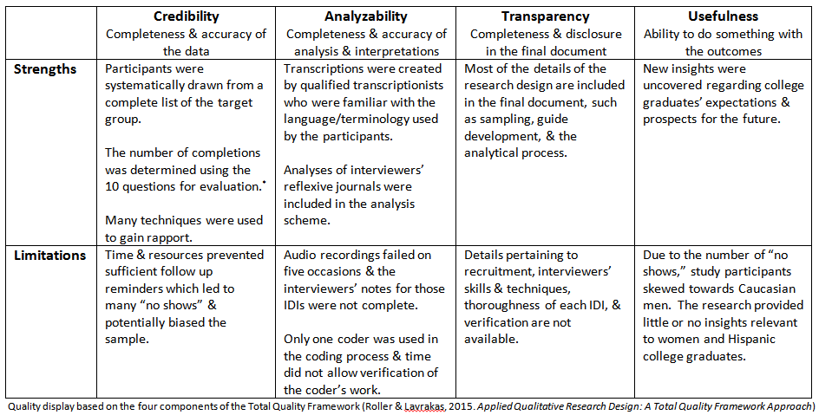

Also check Bryman page 386-88
Credibility, transfirmability, dependability and transferability

Part 2
Quantitative Data Collection

Description
There are two broad types of sampling designs in quantitative research: Probability sampling and non-probability sampling. In nonprobability sampling, researchers select elements by non-random methods. Polit, 2006, page 261.
Probability sampling involves the random selection of elements from the population. Polit et al., 2006, page 264.

Random selection process is one in which each element in the population has an equal independent chance of being selected.

Probability sampling methods. The probability of participants being selected is known in advance. the intent is to generalize the findings for the sample to the population from which it was taken.
Non-probability the probability of a potential research participant being selected is not known in advance. the findings cannot be generalized to a larger group of people.
Liamputtong, page 22

Probability sampling is characterized by the use of random selection to obtain sample members.

Technique | Description
Simple random sampling | A simple random sample is a subset of a statistical population in which each member of the subset has an equal probability of being chosen.https://www.investopedia.com/terms/s/simple-random-sample.asp  A simple random sampling approach to identifying a sample is rigorous, but often time consuming. Moule or Bowling.  At its most basic, names can be pulled out of a hat. alternatively comma computer programs can be designed to sample randomly or to generate random number table to facilitate manual random sampling.  Bowling 2014, page 206.  With the simple random sampling, each unit of the population has an equal probability of inclusion in the simple.  Bryman 2016 page 176
Stratified random sampling | In stratified random sampling the population is divided into homogeneous subsets from which elements are selected at random. Polit 2006, page 265
Cluster random sampling | Cluster random sampling is a probability sampling method where researchers divide a large population into smaller groups known as clusters, and then select randomly among the clusters to form a sample.  Cluster sampling is typically used when the population and the desired sample size are particularly large.  https://www.simplypsychology.org/cluster-sampling.html
Systematic sampling. | Systematic sampling involves the selection of every kth case from some list or group such as every 10th person on a passion list. Polit 2006, page 266.
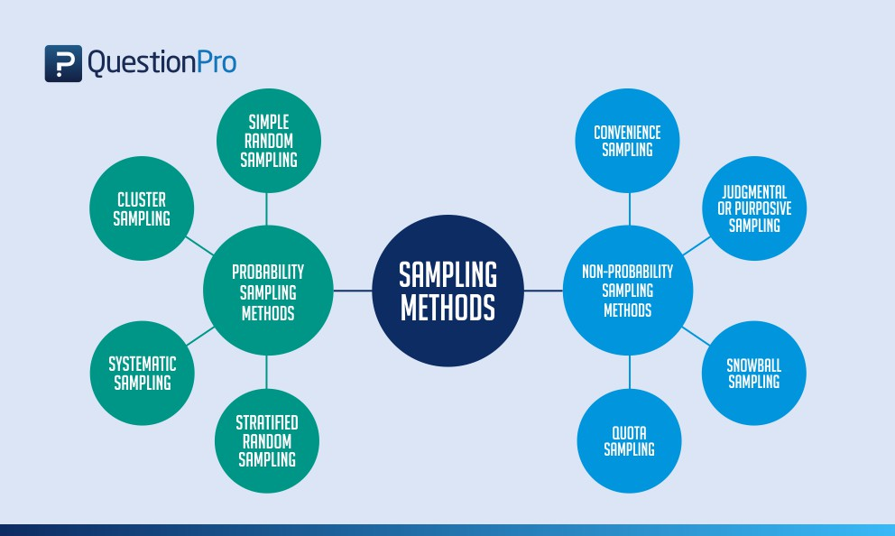
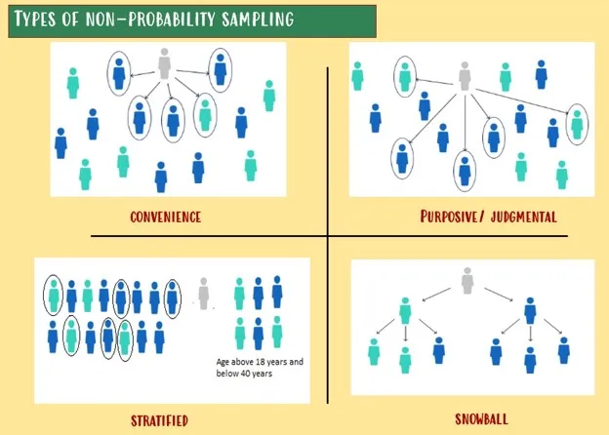
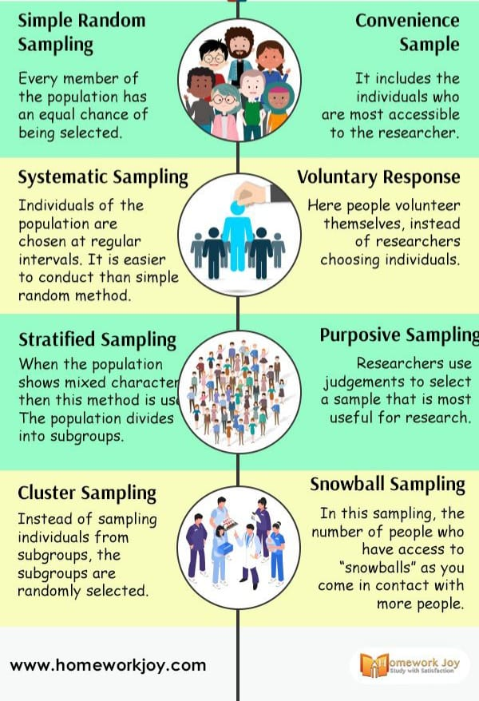

Type | Description
Tissue Samples
Questionnaire Survey
Documents | Documents are socially produced material that can include written records, photographs video and audio recordings. The main types of document used or public records. these can include records of birth, death and marriages, consensus material and the UK electoral register, political and judicial records such as records from court cases and budget or fiscal records and document from government department including crime statistic or educational records.  Within Healthcare commerce searches have access to a number of documents that fall into official and unofficial realms, including patient case notes comma care plans comma and patient letters or Diaries of treatment experience. researchers also draw on literature published online and in journals or textbooks. the analysis of documentary sources can be either quantitative when extracting data from statistical record or qualitative in considering diary narratives.  There are several advantages in the use of documents. Data or generally free from researcher bias, is documents are constructed without researcher input. Additionally they can be convenient to access, there or fewer ethical issues involved and there can be resource saving.  Moule 2017, page 335  Potential limitations>  Incomplet and unusable, as it was not originally collected for research purpose.  There may be inaccuracies, bias or errors in data  Moule 2017, page 336
Interviews

Assessing Quality in Quantitative Research
Only when data is valid and reliable, it can provide valuable insight and evidence for practice.

Nurse researchers working with quantity method have sought to ensure validity and reliability in their method of data collection to maintain the rigour of the study. validity in reliability are related to the data collection methods and tools employed in the research and 2x 10th that the researcher has been able to limit any bias in data collection process. having a valid and reliability collection tool a force credibility to the instrument and subsequent research findings.
Moule 2017, page 176

Validity | Validity is defined as the extent to which a concept is accurately measured in a quantitative study.  https://ebn.bmj.com/content/18/3/66  Validity refers to the extends to which an empirical measure adequately reflects the real meaning of the concept under consideration. Liamputtong, page20.  Establishing the validity of an instrument, or the extent to which an instrument measures what it is intended to measure, is vital. Liampttong page 203  In nursing practice we we use validated measurement tools to record data on a daily basis. such exemples include the use of recording devices to measure a patients blood pressure and pulse.Moule 2017, page 178 |  |  | Content validity  This category looks at whether the instrument adequately covers all the content that it should with respect to the variable. In other words, does the instrument cover the entire domain related to the variable, or construct it was designed to measure?  https://ebn.bmj.com/content/18/3/66  Construct validity  Construct validity refers to whether you can draw inferences about test scores related to the concept being studied. For example, if a person has a high score on a survey that measures anxiety, does this person truly have a high degree of anxiety?
Reliability | The reliability of a quantitative measure is a major criterion for assessing its quality. Reliability is the consistency with which an instrument measures the attributes. Polit, 2006 page 324  Reliability is the consistency and trustworthiness of research findings. Often, it is considered in relation to ‘whether a particular technique applied repeatedly to the same object yields the same results each time. Liamputtong, page 20.  The extent to which a measurement is dependable, stable and consistent when repeated under identical conditions.  Liamputtong page 201.  Vijay nursing practice and number of tools have to be not only valid in what they measure, but also reliable.  Therefore, the instruments used to record blood pressure come up pulse and temperature not only have to take accurate measure of these vital Signs come up but also need to do so every time they are used.  Moule 2017, page 180.
Generalizabilityy | Extent to which study results can be applied to other groups and settings.Polit 2006. Nursing research page 40
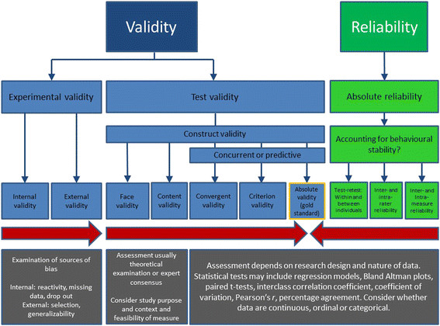

Quantitative data collection is important for several reasons:
- Objectivity: Quantitative data collection provides objective and verifiable information, as the data is collected in a systematic and standardized manner.
- Generalizability: The results from quantitative data collection can be generalized to a larger population, making it an effective way to study large groups of people.
- Precision: Numerical data allows for precise measurement and unit of analysis, providing more accurate results than other data collection forms.
- Hypothesis testing: Quantitative data collection allows for testing hypotheses and theories, leading to a better understanding of the relationships between variables.
- Comparison: Quantitative data collection allows for data comparison and analysis. It can be useful in making decisions and identifying trends or patterns.
- Replicability: The numerical nature of quantitative data makes it easier to replicate research results. It is essential for building knowledge in a particular field.
https://www.questionpro.com/blog/quantitative-data-collection-methods/

Chapter 8 Data Analysis

Data collection refers to the process of gathering information or raw facts from various sources for research or analysis purposes. It is the process of inspecting, cleaning, transforming, and modelling data to discover useful information, draw conclusions, and support decision-making. It involves the application of various techniques and methods to extract meaningful insights from raw data. The goal of data analysis is to uncover patterns, relationships, trends, and other relevant information that can inform decision-making or contribute to the understanding of a particular phenomenon.

Data Analysis in Qualitative Research

Qualitative data analysis is the process of examining non-numerical information, such as text, images, audio, video, or other non-numeric formats, to identify patterns, themes, and insights.
Qualitative Data
Qualitative data are often rich and context-dependent, allowing researchers to explore the complexities and nuances of social phenomena. Here are some common types of data in qualitative research:
- Textual Data: This is the most common form of qualitative data and includes written or transcribed information. It could be in the form of interviews, focus group transcripts, field notes, diaries, documents, or any other text-based material.
- Audio and Video Recordings: Qualitative researchers may use audio or video recordings to capture spoken words, interactions, or behaviours. These recordings can provide additional context and allow for a more in-depth analysis of non-verbal cues.
- Images and Visual Data: Visual data include photographs, drawings, paintings, or any other visual artefacts. These can be used to explore visual representations, symbols, or the cultural aspects of a phenomenon.
- Observations: Qualitative researchers often engage in participant observation or non-participant observation. Observations involve watching and recording behaviours, interactions, and the context of a particular setting.
- Artifacts: Artifacts are physical objects or products that can be analyzed for their cultural or symbolic significance. Examples include tools, clothing, artworks, or any tangible items that provide insights into the researched phenomenon.

- Field Notes: Researchers take field notes during observations or fieldwork to document their impressions, reflections, and details about the research setting. Field notes provide context and help in the analysis process.
- Documents and Texts: Researchers may analyze existing documents, texts, or written records relevant to the research topic. This could include archival material, policy documents, letters, or any written information that sheds light on the phenomenon under study.
- Social Media Data: With the prevalence of social media, researchers may analyze content from platforms like Twitter, Facebook, or Instagram to explore public opinions, interactions, or trends related to a particular topic.
Analysis Process
Unlike quantitative data analysis, which deals with numerical data and statistical methods, qualitative data analysis focuses on understanding the underlying meanings, context, and nuances present in the data. This type of analysis is commonly used in social sciences, humanities, and other fields where the goal is to explore and interpret subjective experiences, perceptions, and behaviours.
Here are key aspects of qualitative data analysis:
- Data Familiarization: Researchers immerse themselves in the raw data to become familiar with the content. This involves reading and re-reading text or examining other forms of qualitative data.
- Coding: Coding involves systematically labeling and categorizing segments of data based on themes, concepts, or patterns. Codes are often generated through an inductive process, allowing themes to emerge directly from the data rather than being predetermined.
- Theme Development: Codes are organized into broader themes that capture the main ideas or patterns within the data. Themes provide a conceptual framework for understanding the content.
- Constant Comparison: Throughout the analysis, researchers continuously compare data segments to identify similarities and differences. This iterative process helps refine codes and develop a deeper understanding of the relationships between themes.
- Triangulation: Researchers may use multiple sources of data or involve multiple researchers in the analysis to enhance the reliability and validity of the findings. Triangulation involves cross-verifying information from different perspectives or sources.
- Memoing: Researchers keep reflective notes or memos throughout the analysis process to document thoughts, insights, and decisions. Memoing helps in maintaining transparency and providing a record of the analytical journey.
- Theoretical Saturation: The analysis continues until theoretical saturation is reached, meaning that new data cease to provide additional insights or perspectives, indicating that a comprehensive understanding of the subject has been achieved.
- Contextualization: Qualitative data analysis emphasizes understanding data within its broader context. Contextual factors, such as cultural, social, or historical influences, are considered to interpret the meaning of the data.
Types of Data Analysis Methods in Qualitative Research:
Qualitative research employs a variety of data analysis methods to derive meaningful insights from non-numerical data. Several common types of data analysis methods in qualitative research include:
Content Analysis:
Content analysis is a systematic and insightful approach to examining qualitative data, allowing researchers to identify patterns, themes, and trends within a body of information. As one embarks on content analysis, it is beneficial to formulate hypotheses or anticipate themes that may surface during the examination of the data. This proactive stance helps guide the analysis process and provides a framework for interpreting findings. To facilitate the organization and interpretation of identified themes, a coding system can be employed. This system might involve assigning colours or numbers to specific themes, creating a structured and easily navigable framework for sorting and grouping content. By employing a coding system, researchers can effectively categorize and analyze data, gaining a deeper understanding of the various perspectives and viewpoints present within the information. This method enhances the ability to explore and comprehend diverse themes, contributing to a more nuanced and comprehensive interpretation of the content under investigation.
Thematic analysis

Thematic analysis is a qualitative research method focused on uncovering, analyzing, and presenting patterns within a dataset. It shares similarities with grounded theory but does not involve theoretical sampling. The approach entails a careful reading and re-reading of the data, emphasizing the coding, sorting, and organization of information into emergent themes that are not predetermined. Qualitative researchers, valuing the expressive power of words, find thematic analysis to be a foundational method for exploring the nuanced meanings embedded in qualitative data. The outlined steps in the thematic analysis process include becoming familiar with the data, transcribing it, and generating initial codes based on repeated readings. These codes are then collated into tentative themes, and the process continues with gathering relevant data for each potential theme. Subsequent steps involve theme revision, checking alignment with codes and the entire dataset, and ongoing refinement to establish clear definitions and names for each theme. The method provides a systematic yet flexible framework for qualitative researchers aiming to reveal and comprehend patterns in their data.

Thematic analysis is a widely used qualitative research method that involves identifying, analyzing, and reporting patterns or themes within a dataset. It is a flexible and systematic approach that allows researchers to explore and make sense of complex phenomena, often in the form of textual, audio, or visual data. Thematic analysis can be applied to various types of qualitative data, including interviews, focus group discussions, surveys, and written or visual materials.
The process of thematic analysis typically involves the following key steps:
- Familiarization with the Data: Researchers start by becoming familiar with the entire dataset. This involves repeatedly reading or reviewing the data to gain a sense of its content and context. This immersion helps researchers develop a holistic understanding of the material.
- Generating Initial Codes: Researchers systematically identify and label interesting features or patterns in the data, creating initial codes. These codes are often short descriptive labels that capture the essence of the data. This phase involves a process known as open coding.
- Searching for Themes: Codes are then grouped together based on similarities to form potential themes. Themes are overarching concepts that encapsulate patterns of meaning within the data. This process is known as axial coding, and it involves looking for relationships and connections between codes.
- Reviewing and Defining Themes: Themes are refined and reviewed through an iterative process. Researchers go back and forth between the data and the emerging themes, ensuring that the themes accurately represent the content and context of the data. This constant comparison helps establish the credibility and trustworthiness of the analysis.
- Defining and Naming Themes: Each theme is clearly defined and named to reflect its meaning. This step involves creating a clear and concise description of what each theme represents in the dataset.
- Writing the Report: Finally, researchers write a detailed report or narrative that includes the identified themes, supported by illustrative examples from the data. This report provides a coherent and meaningful interpretation of the findings.
A working example of Thematic Analysis

Research Question:
To explore the experiences of healthcare providers regarding the challenges and opportunities in delivering mental health services through telehealth during the COVID-19 pandemic.

Data Collection:
Conduct semi-structured interviews with healthcare providers who have been involved in delivering mental health services via telehealth during the COVID-19 pandemic. Record and transcribe the interviews for analysis.

Thematic Analysis Steps:
- Familiarization with the Data:
  - Read through the interview transcripts to become familiar with the content.
  - Take notes on initial thoughts, impressions, and potential patterns.
- Generating Initial Codes:
  - Start by open-coding the data, identifying and labeling interesting features or patterns.
  - Example codes might include "technology challenges," "patient engagement," "changes in therapeutic dynamics," and "telehealth training."
- Searching for Themes:
  - Group related codes into potential themes.
  - Explore how different codes might relate to each other and form patterns.
  - For instance, the codes "technology challenges" and "telehealth training" might be grouped under a broader theme of "barriers to effective telehealth implementation."
- Reviewing Themes:
  - Check and refine themes against the coded extracts and the entire data set.
  - Ensure that themes accurately represent the content and context of the data.
- Defining and Naming Themes:
  - Clearly define each theme and give it a meaningful and representative name.
  - For example, a theme related to the positive aspects of telehealth might be named "Enhanced Accessibility and Reach."
- Writing a Report:
  - Develop a narrative that describes each theme in detail, using supporting quotes from the interviews.
  - Provide an overview of the main findings, highlighting the key themes that emerged.
- Validation:
  - Consider member checking by sharing the findings with participants to ensure the accuracy of the interpretation.

Results:

Theme 1: Barriers to Effective Telehealth Implementation
- Subtheme: Technology Challenges
- Subtheme: Lack of Telehealth Training

Theme 2: Enhanced Accessibility and Reach
- Subtheme: Increased Patient Engagement
- Subtheme: Geographic Reach

Theme 3: Changes in Therapeutic Dynamics
- Subtheme: Challenges in Establishing Rapport
- Subtheme: Opportunities for Flexibility in Session Scheduling

Discussion:
Interpret and discuss the implications of the themes in the context of the research question. Consider the practical implications for healthcare providers, policymakers, and future research.

Grounded Theory Data Analysis
The Grounded Theory data analysis process, often associated with methodologies developed by sociologists Barney Glaser and Anselm Strauss, is an iterative and inductive approach aimed at generating theories grounded in the data. The process typically involves the following key steps:
- Data Collection: The process begins with extensive data collection through methods such as interviews, observations, or document analysis. Data is collected until saturation is reached, meaning that no new information or themes are emerging.
- Open Coding: Researchers start the analysis by open coding, which involves systematically examining the data line by line. They assign initial codes to segments of the data that represent concepts or ideas without imposing preconceived categories. This phase is exploratory and aims to capture a broad range of potential themes.
- Axial Coding: In this phase, researchers organize and connect the open codes to identify relationships and patterns. The focus shifts from individual codes to broader categories, and connections between concepts are explored to form more complex themes.
- Selective Coding: The analysis narrows down to focus on the core categories or themes that emerge as central to the data. Researchers select and refine these core categories, building a more coherent and integrated understanding of the phenomenon under investigation.
- Constant Comparison: Throughout the analysis, researchers continuously compare new data with existing codes and categories. This ongoing comparison helps refine concepts and ensures that the emerging theory is grounded in the data.
- Theoretical Sampling: While not always a part of every grounded theory study, theoretical sampling involves selecting new participants or data sources based on the emerging theory. This process helps researchers further develop and test their theoretical concepts.
- Memoing: Researchers maintain detailed memos throughout the analysis process. These memos capture thoughts, ideas, and reflections on the data and the emerging theory. Memos are crucial for maintaining transparency and providing a record of the analytical journey.
- Saturation: The analysis continues until theoretical saturation is achieved, meaning that the researchers feel confident that the core categories and relationships are well-developed and adequately represent the data.
- Theory Development: The final step involves synthesizing the core categories and relationships into a cohesive theory that explains the phenomenon under study. The resulting theory is grounded in the data and provides a conceptual framework for understanding the observed patterns.
A working example of Grounded Theory

Research Question:
To explore the experience of patients managing chronic illnesses through telemedicine.

Data Collection:
- Interviews: Conduct in-depth interviews with patients who have experience with telemedicine for managing chronic illnesses.
- Observations: Observe telemedicine interactions between patients and healthcare providers.

Initial Coding:
- Open Coding:
  - Begin by reviewing the interview transcripts and observational notes.
  - Code initial concepts and ideas without trying to fit them into pre-existing categories.
  - Example codes might include "technology acceptance," "communication with healthcare provider," "impact on medication adherence," etc.
- Axial Coding:
  - Organize codes into categories based on their relationships.
  - Identify connections and patterns between different codes.
  - Example categories might emerge, such as "patient-provider communication," "technological barriers," or "health outcomes."

Constant Comparison:
- Compare Data:
  - Continuously compare new data with existing codes and categories.
  - Look for similarities and differences to refine categories and codes.
- Theoretical Sampling:
  - Select new participants or gather additional data based on emerging theories and areas where more information is needed.
  - For example, if initial interviews suggest that patient-provider communication is a crucial factor, purposefully sample participants who have experienced challenges or successes in this area.

Theoretical Coding:
- Identify Core Categories:
  - Select core categories that are central to understanding the phenomenon.
  - These might include concepts like "patient empowerment," "technological facilitators," or "healthcare accessibility."
- Develop a Grounded Theory:
  - Generate a theory that explains the relationships between the identified categories.
  - For instance, the theory might propose that effective patient-provider communication, supported by accessible technology, leads to improved patient empowerment and health outcomes in telemedicine.

Writing and Reporting:
- Compose a Narrative:
  - Write a narrative that explains the grounded theory, using quotes and examples from the data to support key points.
- Member Checking:
  - Share the theory with participants to gather their feedback and ensure the findings accurately represent their experiences.

Validation:
- Peer Review:
  - Submit the study for peer review to receive feedback from other researchers.
- Triangulation:
  - Use multiple sources of data (interviews, observations) to strengthen the credibility of the findings.

Colaizzi’s Phenomenological Framework:

In the phenomenological framework, specifically using Colaizzi's approach, the process of data analysis involves a systematic and rigorous exploration of lived experiences. As outlined by Liamputtong on pages 168-169, the steps in Colaizzi's phenomenological analysis are:
- Acquiring a Sense of Each Transcript: The process begins with immersing oneself in the data, gaining a holistic understanding of each transcript. This step involves reading and re-reading the transcripts to develop a comprehensive grasp of the participants' experiences.
- Extracting Significant Statements: Researchers identify and extract significant statements or phrases from the data that capture the essence of the participants' experiences. These statements serve as the raw data for further analysis.
- Formulation of Meanings: The extracted statements are then analyzed to identify underlying meanings and nuances. Researchers delve into the depth of the data, exploring the implicit and explicit meanings conveyed by the participants.
- Organizing Formulated Meanings into Clusters of Themes: The identified meanings are organized into clusters or groups of themes that represent commonalities and patterns across the dataset. This step involves categorizing and structuring the formulated meanings into coherent themes.
- Exhaustively Describing the Investigated Phenomenon: Researchers thoroughly describe and elaborate on each identified theme, providing a rich and exhaustive portrayal of the investigated phenomenon. This step ensures a comprehensive exploration of the depth and breadth of the experiences under study.
- Describing the Fundamental Structure of the Phenomenon: Moving beyond surface-level descriptions, researchers seek to uncover the fundamental structure of the phenomenon. This involves synthesizing the themes and exploring the interconnectedness and core elements that define the essence of the lived experiences.
- Returning to the Participants: The final step is to validate the findings by returning to the participants. Researchers seek feedback to ensure that their interpretations align with the participants' experiences and perspectives. This iterative process contributes to the credibility and trustworthiness of the phenomenological analysis.

A working example Colaizzi’s Phenomological Framework Analysis

Research Question:
To explore the lived experiences of family caregivers providing care to individuals with Alzheimer's disease.

Colaizzi's Phenomenological Framework Analysis Steps:
- Conducting Interviews:
  - Interview family caregivers who are providing care to individuals with Alzheimer's disease.
  - Encourage participants to describe their experiences, emotions, challenges, and meaningful moments.
- Data Transcription:
  - Transcribe the interviews verbatim to have a textual representation of participants' accounts.
- Extracting Significant Statements:
  - Identify significant statements from the transcripts that capture the essence of participants' experiences.
  - For example, a significant statement might be: "I feel overwhelmed trying to balance caregiving with my own life and work."
- Formulating Meanings:
  - Explore the meanings inherent in the significant statements.
  - What does the statement "I feel overwhelmed" mean in the context of caregiving for someone with Alzheimer's disease?
- Clustering Themes:
  - Group similar meanings together to form clusters or themes.
  - Themes might include "Emotional Impact of Caregiving," "Challenges in Balancing Responsibilities," and "Finding Meaning in Caregiving."
- Developing an Exhaustive Description:
  - Create an exhaustive description of the phenomenon, incorporating all identified themes.
  - Describe the phenomenon from the perspective of the caregivers, providing a rich and detailed account.
- Identifying Fundamental Structures:
  - Identify the fundamental structures that underlie the themes and provide a foundation for the phenomenon.
  - This might involve recognizing key elements such as emotional distress, time constraints, and the search for meaning in caregiving.
- Developing a Comprehensive Description:
  - Integrate the exhaustive description and fundamental structures to create a comprehensive understanding of the phenomenon.
- Validation by Participants:
  - Share the findings with participants to validate the accuracy of the interpretation.
  - Ensure that the developed description resonates with the lived experiences of the caregivers.

Results:

Theme 1: Emotional Impact of Caregiving
- Subtheme: Overwhelmed Feelings
- Subtheme: Moments of Joy and Connection

Theme 2: Challenges in Balancing Responsibilities
- Subtheme: Time Constraints
- Subtheme: Impact on Work and Personal Life

Theme 3: Finding Meaning in Caregiving
- Subtheme: Building Deeper Connections
- Subtheme: Personal Growth and Fulfillment

Discussion:
Interpret the findings in the context of existing literature, discuss implications for healthcare practice, and identify potential areas for further research.
Part 2
Data Analysis in Quantitative Research

Quantitative data analysis is a systematic process of interpreting numerical data to discover patterns, relationships, and trends. It involves the use of statistical techniques to analyze and draw meaningful conclusions from data sets. Quantitative analysis is characterized by its objective and empirical nature, as it relies on measurable data that can be expressed in numerical terms. Researchers employ various statistical methods, such as descriptive statistics, inferential statistics, and regression analysis, to examine the relationships between variables and make predictions based on the data. The process often begins with data collection through surveys, experiments, or observations, followed by data cleaning and coding to ensure accuracy and consistency. Subsequently, researchers use mathematical models and statistical tests to uncover patterns, associations, and statistical significance within the data.

In quantitative research, data analysis is a critical phase that involves the systematic examination and interpretation of numerical data to derive meaningful insights and draw conclusions. This process is guided by the research objectives and hypotheses established at the outset of the study. The first step in quantitative data analysis is often data cleaning and preparation, ensuring that the collected data is accurate, consistent, and ready for analysis.
Descriptive statistics play a fundamental role in summarizing and presenting the main features of the data. Measures such as mean, median, mode, and standard deviation provide a concise overview of central tendencies and variability within the dataset. Visualization tools, such as histograms, box plots, and scatter plots, may also be employed to enhance the understanding of data distributions and relationships.
Once the data is characterized descriptively, researchers often move on to inferential statistics. This involves making predictions or inferences about a population based on a sample of data. Hypothesis testing and confidence intervals are common inferential statistical techniques used to assess the significance of observed differences or associations. Regression analysis further explores relationships between variables, allowing researchers to identify and quantify the strength and direction of these associations.
Quantitative data analysis often utilizes statistical software like SPSS, R, or Python to perform complex calculations and analyses efficiently. The goal of this rigorous analytical process is to go beyond mere description, providing researchers with evidence to support or refute hypotheses and contribute to the broader body of knowledge in their field. Ultimately, the results of quantitative data analysis are crucial for informing decision-making processes, policy development, and further research endeavors.

Quantitative Data - Descrptive Statistic
Quantitative data in the context of quantitative research refers to information that is expressed in numerical terms and can be subjected to statistical analysis. This type of data is characterized by its measurable and quantifiable nature, allowing researchers to apply mathematical models and statistical techniques to draw conclusions and make generalizations. Quantitative data can take various forms, including:

- Nominal Categorical Data:
  - Blood Type: Blood types are categorized as A, B, AB, or O. This data is nominal because the categories are distinct and don't have an inherent order.
  - Marital Status: Marital status includes categories like "single," "married," "divorced," and "widowed." These categories are distinct and not ordered.
  - Gender: Categories such as "male," "female," and "other" are nominal because they represent distinct, non-ordered groups.
- Discrete Data:
  - Number of Patients in a Ward: The count of patients in a hospital ward is discrete. It consists of distinct, separate values (whole numbers) and cannot have fractional or intermediate values.
  - Number of Medication Dosages: The number of doses of a medication administered is discrete, as you can't have a fraction of a dose.
- Ordinal Data:
  - Pain Severity Rating: Pain severity rated as "mild," "moderate," or "severe" is ordinal. While there is an order to the categories, the intervals between them may not be uniform.
  - Patient Satisfaction Rating: A satisfaction rating on a scale from "low" to "high" represents ordinal data because there is a meaningful order, but the difference between "low" and "medium" may not be the same as the difference between "medium" and "high."
- Continuous Data:
  - Body Mass Index (BMI): BMI is a continuous variable as it can take any value within a range and can be measured with precision.
  - Blood Pressure: Blood pressure, measured in millimetres of mercury (mmHg), is continuous data because it can take any value within a specific range and is measured with precision.

Descriptive Statistics:
- Measures of Central Tendency:
  - Definition: These statistics (mode, median, mean) help us understand the center or average of a set of values.
  - Example: In a set of exam scores, the mode would be the most common score, the median would be the middle score, and the mean would be the average of all scores.
- Measures of Dispersion:
  - Definition: These statistics (range, standard deviation) provide insights into how spread out or variable the values in a dataset are.
  - Example: In a dataset of income levels, the range would be the difference between the highest and lowest incomes, and the standard deviation would indicate how much incomes vary from the average.
Correlation:
- Correlation Coefficient:
  - Definition: It measures the strength and direction of a linear relationship between two variables.
  - Example: If we're looking at the correlation between exercise frequency and weight loss, a positive correlation suggests that more exercise is associated with more weight loss.
Chi-Square Test:
- Applicability:
  - Definition: It's a statistical test used to determine if there's a significant association between two categorical variables.
  - Example: If we have data on smoking habits and lung disease, a chi-square test can help us understand if there's a significant relationship between the two variables.

Quantitative Data and Inferential Statistics

Inferential Statistics in Healthcare:
Definition:
Inferential statistics, rooted in the laws of probability, serve as a method for drawing conclusions about a population based on data from a sample. It involves various procedures, commonly known as statistical tests, which help healthcare professionals make informed decisions and predictions beyond the observed data.
Statistical Tests in Inferential Statistics:
- T-Test:
  - Definition: A parametric test used to assess the statistical significance of a difference between the means of two groups.
  - Example: In healthcare research, a t-test might be employed to compare the effectiveness of two different treatments on blood pressure. It helps determine if the observed differences are likely due to the treatments and not random chance.
  - Link to Descriptive Statistics: The t-test complements descriptive statistics by examining if observed differences in means are statistically significant.
- Analysis of Variance (ANOVA):
  - Definition: A parametric procedure comparing mean group differences for three or more groups.
  - Example: Healthcare researchers might use ANOVA to assess the impact of various exercise programs on weight loss. It helps determine if there are statistically significant differences in weight loss among different exercise groups.
  - Link to Descriptive Statistics: ANOVA builds on descriptive statistics by comparing means across multiple groups, offering insights into the overall impact of interventions.
- Chi-Squared Test:
  - Definition: A non-parametric procedure testing hypotheses about the proportion of cases falling into different categories in a contingency table.
  - Example: In healthcare, the chi-squared test can be applied to understand the relationship between smoking habits (categories) and the occurrence of respiratory diseases.
  - Link to Descriptive Statistics: This test complements descriptive statistics by assessing the significance of observed categorical relationships.
- Confidence Interval:
  - Definition: An indicator of the representativeness of means, providing a range within which the true population parameter is likely to fall.
  - Example: In healthcare, a confidence interval around the mean blood pressure of a sample may help estimate the range within which the true average blood pressure of the population is likely to be.
  - Link to Descriptive Statistics: While descriptive statistics provide the mean, confidence intervals add a level of certainty around that mean, aiding in generalizability.
- P Value:
  - Definition: A crucial value in inferential statistics representing the probability of obtaining the observed results by chance.
  - Example: In a clinical trial, the p-value helps determine if the observed improvement in patient outcomes with a new treatment is statistically significant.
  - Link to Descriptive Statistics: P values are essential in interpreting findings derived from descriptive statistics, indicating whether observed differences are likely due to true effects or random variability.
In healthcare, these inferential statistical tools help professionals make informed decisions, draw meaningful conclusions from research data, and contribute to evidence-based practice. They complement descriptive statistics by delving deeper into the significance and relationships within the data.

Quality Assessment in Qualitative Research
1.1 Definition of Quality Assessment in Qualitative Research
Quality assessment in qualitative research refers to the systematic and rigorous evaluation of the trustworthiness, credibility, and relevance of qualitative data and findings. It involves a comprehensive examination of the research process, from data collection to analysis and interpretation, to ensure the reliability and validity of the study.
1.2 Importance of Quality Assessment in Healthcare Research
Quality assessment is crucial in healthcare research to ensure the robustness of qualitative findings. It helps healthcare professionals make informed decisions based on reliable evidence, contributing to improved patient outcomes and the advancement of evidence-based practice.
1.3 Key Components of Quality Assessment
1.3.1 Rigor in Data Collection:
Rigor in data collection involves meticulous planning and execution of qualitative data gathering methods. For example, in-depth interviews and focus group discussions should be conducted with standardized protocols to enhance reliability.
1.3.2 Credibility in Data Analysis:
Credibility in data analysis refers to the accuracy and depth of the interpretation. Utilizing multiple coders, conducting member checking, and employing triangulation methods enhance the credibility of qualitative data analysis.
1.3.3 Transferability of Findings:
Transferability relates to the applicability of qualitative findings to other contexts. Providing rich descriptions of the research setting and participants increases the potential transferability of the study results.
1.4 Common Challenges in Quality Assessment
1.4.1 Subjectivity in Qualitative Research:
The inherent subjectivity of qualitative research poses a challenge to quality assessment. Researchers must transparently acknowledge their biases and demonstrate reflexivity to address this issue.
1.4.2 Dependability in Longitudinal Studies:
Maintaining dependability over time, especially in longitudinal studies, can be challenging. Regularly revisiting research protocols and ensuring consistency in data collection and analysis methods is essential.
1.4.3 Ethical Considerations:
Ensuring ethical standards in qualitative research is paramount. Researchers must address issues such as informed consent, confidentiality, and the well-being of participants during both data collection and analysis phases.
1.5 Practical Strategies for Quality Assessment
1.5.1 Utilizing Frameworks and Guidelines:
Adopting established frameworks, such as the Consolidated Criteria for Reporting Qualitative Research (COREQ), provides a structured approach for quality assessment. Researchers should adhere to these guidelines throughout the research process.
1.5.2 Peer Review and Expert Consultation:
Engaging in peer review and seeking expert consultation enhances the rigor and credibility of qualitative research. Collaborative discussions with colleagues and experts in the field contribute to the overall quality of the study.
1.6 Conclusion
In conclusion, quality assessment in qualitative research is indispensable for healthcare professionals seeking to generate reliable and applicable knowledge. This chapter has introduced the foundational concepts, highlighted key components, addressed challenges, and proposed practical strategies to guide healthcare researchers in conducting and evaluating high-quality qualitative studies.
References:
- Creswell, J. W., & Poth, C. N. (2018). Qualitative Inquiry and Research Design: Choosing Among Five Approaches. Sage Publications.
- Tong, A., Sainsbury, P., & Craig, J. (2007). Consolidated criteria for reporting qualitative research (COREQ): a 32-item checklist for interviews and focus groups. International Journal for Quality in Health Care, 19(6), 349-357.

Quality Assessment in Quantitative Research
3.1 Introduction to Quality Assessment in Quantitative Research
Quality assessment in quantitative research involves a systematic evaluation of the reliability, validity, and overall rigor of study design, data collection, analysis, and interpretation. Healthcare professionals must critically appraise quantitative studies to ensure that the evidence generated is trustworthy and applicable to clinical practice.
3.2 Defining Key Terms in Quality Assessment
3.2.1 Reliability:
Reliability in quantitative research refers to the consistency and stability of measurements over time and across different conditions. A reliable study produces consistent results when measurements are repeated. For example, if a blood pressure monitor consistently provides the same readings for a stable patient, it is deemed reliable.
3.2.2 Validity:
Validity pertains to the accuracy and appropriateness of study measurements and outcomes. A valid study measures what it intends to measure and accurately reflects the concepts under investigation. In healthcare, the validity of a diagnostic test is crucial; for instance, a valid screening tool accurately identifies individuals with a specific medical condition.
3.2.3 Rigor in Study Design:
Rigor in study design ensures that the research is conducted with methodological precision. This includes a clear research question, appropriate sampling methods, and a robust study protocol. For instance, a randomized controlled trial (RCT) with a well-defined protocol demonstrates methodological rigor.
3.3 Importance of Quality Assessment in Healthcare Research
Healthcare professionals rely on quantitative evidence to inform clinical decision-making. Quality assessment is essential to ensure that the evidence is trustworthy, minimizing the risk of biased conclusions that could impact patient care and outcomes.
3.4 Key Components of Quality Assessment
3.4.1 Internal Validity:
Internal validity assesses the degree to which a study accurately establishes a cause-and-effect relationship between variables. For example, in a clinical trial, internal validity ensures that any observed effects are genuinely attributable to the intervention being studied and not confounding variables.
3.4.2 External Validity:
External validity, or generalizability, examines the extent to which study findings can be applied to populations beyond the study sample. In healthcare, external validity ensures that research findings are relevant to diverse patient populations and clinical settings.
3.4.3 Statistical Rigor:
Statistical rigor involves the appropriate application of statistical methods to analyze data. Ensuring statistical significance and addressing potential confounding variables are crucial components. For instance, in a cohort study, rigorous statistical methods account for baseline differences between exposed and unexposed groups.
3.5 Challenges in Quality Assessment
3.5.1 Confounding Variables:
Confounding variables can introduce bias, impacting the internal validity of a study. For instance, if a study on the effectiveness of a new medication fails to account for patients' comorbidities, the results may be confounded by these underlying health conditions.
3.5.2 Publication Bias:
Publication bias, the tendency to publish positive results more frequently than negative ones, can skew the overall evidence base. Awareness of publication bias is crucial when interpreting the literature to avoid an overestimation of treatment effects.
3.5.3 Selection Bias:
Selection bias occurs when the study sample is not representative of the target population. For example, if a clinical trial excludes certain patient groups, the study's external validity is compromised.
3.6 Strategies for Quality Assessment
3.6.1 Utilizing Critical Appraisal Tools:
Critical appraisal tools, such as the Joanna Briggs Institute (JBI) Critical Appraisal Checklist for Analytical Cross-Sectional Studies, provide structured guidelines for assessing the quality of quantitative studies. Researchers and healthcare professionals can use these tools to systematically evaluate studies.
3.6.2 Peer Review and Expert Consultation:
Peer review and expert consultation contribute to the robustness of quality assessment. Collaborating with peers and experts in the field ensures that the study design, methods, and statistical analyses undergo rigorous scrutiny.
3.7 Conclusion
In conclusion, quality assessment in quantitative research is fundamental for healthcare professionals seeking to integrate evidence into their practice. This chapter has introduced key terms, emphasized the importance of quality assessment, outlined components, highlighted challenges, and proposed practical strategies to guide healthcare professionals in evaluating the quality of quantitative studies.
References:
- Joanna Briggs Institute. (2018). JBI Critical Appraisal Checklist for Analytical Cross-Sectional Studies.
- Porta, M. (2014). A Dictionary of Epidemiology. Oxford University Press.
- Streiner, D. L., & Norman, G. R. (2015). Health Measurement Scales: A practical guide to their development and use. Oxford University Press.

End here

Moule 2017, apge 37
The approach to data analysis will depend on the type of data that has been collected. quantitative data analysis technique include the analysis of numerical data, using descriptive and inferential statistics. the management of data include working with the data sets come understanding levels of measurement, the application of statistic tests and generation of probability figure.

Types of data.
A research study will include the collection of data on several attributes ( also termed variables) - for example, gender comma blood group, degree of pain, satisfaction with treatment, temperature,, size of legal sir and volume of urine

Data analysis:
The way that researchers make sense of their data. in qualitative research, it means looking for patterns of ideas or themes, whereas in quantitative research data are analyzed by counting various response alternatives.
At first, data analysis is often mechanistic, Looking for recurrent patrons and themes. in the next phase, the analysis is interpretive searching for meaning and conclusions .

Principles regarding qualitative data analysis
Data analysis may seem daunting to the novice qualitative researcher. In fact, data analysis in qualitative research is an ongoing, cyclic process that occurs from the very beginning of the research. researchers need to treat data analysis as an integral component of research design, the literature review, the formation of theory, data collection, the ordering of the data in the writing process. Liamputtong p.422.

As in all forms of qualitative data analysis, the process of the researcher immersing themselves in the data is crucial to truly understanding participants’ perspectives.
Liamputtong page 97

Thematic analysis.
the identification of themes through a careful reading and reading of the data.
Liamputtong Page 98.
themetic analysis techniques our similar to those of grounded Theory, but do not include theoretical sampling.
The process of thermatic analysis involves coding sorting and organizing the data in themes that have not been decided before coding the data.
Liamputtong page 134.

Theme: a grouping of data that emerges from the research and to which the researcher gives a name
Liamputtong page 98.

Qualitative data analysis: An ongoing, cyclical process that occurs from the very beginning of the research.
Qualitative deter analysis involves searching the data for themes that emerged and then become categories for further analysis .
Liamputtong page 134.

Colaizzis’s phenomenological framework in data analysis (Liamputtong, page 168-69
- Acquiring a sense of each transcript
- Extracting significant statements
- Formulation of meanings
- Organising formulated meanings into clusters of themes
- Exhaustively describing the investigated phenomenon
- Describing the fundamental structure of the phenomenon
- Returning to the participants
Two phases of data analysis. Liamputtong page 423.

Phase 1: Preliminary data analysis |  | Phase 2: Post-data collection
 | A process of highlighting emerging issues by keeping track of key information from the data collection process. |  | Explores data at an increasingly sophisticated or deeper level
 | Systematically record identifying facts and features from each participant or case using a ‘fact sheet’ |  | The researcher has a number of options for analysing data depending on the nature of the enquiry and the approach used

Data reduction. L. page 424.
Data reduction occurs when raw data are transcribed and transformed into summaries, initial course and preliminary themes.
The process requires analytic choices to be made throughout, which form The Foundations for deeper levels of analysis .

Data display. Liam. page 424.
Display is an organized, compressed assembly of information that permits conclusion drawing.

Coding. Liam page 424.
Coding is Central to qualitative research and it's typically the starting point for the most forms of qualitative analysis.
It is the first step that allows researchers to move beyond tangible data to make analytic interpretations .
Code. A label or short phrase which symbolically provides a ‘silent essence’ that captures the meaning in the data or the text.
Coding is a labour intensive task that requires many readings of transcripts and other data to complete the progressively more sophisticated levels of coding.
Table 23.1 Basic questions to use as coding strategies

What? | What is the concern here? which course of events is mentioned?
Who? | who are the person involved? what roles do they have? how do they interact?
How? | which aspects of the event or mentioned or omitted?
When? How long? Where? | referring to time, course, and location: when does it happen? how long does it take? where did the incident of her?
How much? How strong? | referring to intensity: How often is the issue emphasized?
Why? | which reasons are provided or can be constructed?
What for? | what is the intention here? what is the purpose?
By which? | referring to means, tactics, and strategies for achieving the aim: what is the main tactic here? how or things accomplished?

Coding.
Coding is a method of conceptualizing research data and classifying them into meaningful and relevant categories for the participants in the study (the unit (s) of analysis).
Bowling 2014, page 349

Components of data analysis: interactive model. Liamputtong page 424.
Data collection (e.g., interviews, observations, researcher’s memos)
Data reduction:
Data display.
Drawing and verifying conclusions

Steps and strategies for coding. Liamputtong page 428
Figure 23.3 A conceptual framework for the practice of coding

Descriptive or open coding | First step in coding in qualitative data analysis, where the aim is to sort and organize the data so that further analysis can take place. | initial coding to sort the data in preparation for furthe analysis
Focused coding | step that follows descriptive or open coding, when researchers begin working with the code themselves in order to start making sense of the data | being working with the cods to start making sense of the data
Axial or interpretive coding | Task of further evaluating the course to determine what needs to be reassembled or reorganized | reassemble and reorganizing the codes for greater abstraction from the data
Selective coding | A level of analysis where researchers can begin formulating propositions by drawing conclusions, making casual connections and developing theoretical constructs. | identification of central or core themes or concepts based on previous stages of coding

Content analysis. Liampuattong page 431
Form of data analysis used for both qualitative and quantitative researchers in which course are identified before searching for their occurrence in the data.
An essential goal for qualitative content analysis requires code to be identified before they are searched for in the data.

Thematic analysis. Liamputtong page 432
The identification of themes through careful reading and we reading of the data .
Qualitative researchers believe that words are more powerful than numbers. Hence contain analysis may not be appropriate for most qualitative research.
thematic analysis is a method for identifying, analyzing and reporting patterns within the data and is a perceived as a foundation method for qualitative analysis .

Figure 23.4. Steps for thematic analysis

Make yourself familiar with your data
Transcribe the data yourself | Read and reread the data and write down your initial impressions and ideas
Start to generate initial codes, as suggested above
Look for themes by collating codes into tentative themes
Gather all data that is related to each potential
Revise the themes you have developed
Check if the themes work in relation to the codes you have extracted and the entire data set | You may also find it useful to develop a thematic ‘map’ of the analysis
Define the name of your themes
It is also important to carry out an ongoing analysis to refine the themes so that clear definitions and names for reach theme can be generated.

Or thematic content analysis
Step1. Familisarizzing yourself with the data
Step 2. Identifying themes
Step 3. Coding the data
Step 4. Organizing codes and themes - cut and paste
Thorogood 2018, page 264-68

.
Data preparation and management
Data management plan
Qualitative studies quickly generate a large corpus of raw data, and perhaps data relating to tht data, such as notes memos and consent forms. A plan for managing these is a useful it the outset of any project, and is a formal requirement for some funding organization and institutions.
Box 10.1 questions for a data management plan.
- Type of data
  - How large is the data set likely to be?
  - in what form will the data be generated in Transformed? example interview transcripts audio files field nodes or photographies
- Storage
  - where we'll data be stored and backed up
  - how will the data set be kept secure and confidential
  - who need access to the data
- Data cataloguing and discovery
  - how will individuals cases/transcripts/documents be identified
  - what information will be recorded about each case
- Archiving and deposit
  - what will happen to the data at the end of the project
  - who owns the data set and as right to use it of the project
  - will Data need preparing for archiving
  - will Data be available for others to use and if so well

Thorogood 2018, page 254-55

Quantitative data analysis
Accurate reliable and meaningful measurement is essential for providing an authoritative basis to explain and support research and to offer recommendations.
Is clinical practice is an iterative process of assessing the need for interaction, applying and intervention comma evaluating its effect and adjusting, continuing or ceasing the intervention, accurate assessment and measurement or equally important in the clinical context.
assessment is the process of gathering quantitative data in general.
measurement will be used when instrument or to meet the requirement for being a measure that is it is capable of measuring the magnitude of the attribute under evaluation using calibrated scale.
Liamputtong page 195
How do we measure? (Liamputtong page 195-96)
Measurement involves the process of description and quantification. It means recording physical or behavioral characteristic by assigning a value to aspects such as the quality quantity frequency or degree of these attributes.
Numerical values are typically used to describe the Frequency or degree of the attributes assessed.
Nominal data occur where objects are people are assigned to name categories according to some criterion, such as male/female. for example, boys = 1, girls = 2.
Examples of nominal scales are dichotomous and descriptive responses (e.g., binary yes/no, descriptors of eye colour such as green, blue, brown) Bowling 2014, page 168
Ordinal data also occur Where objects or people are assigned to categories, but in this case the categories can be rank-ordered on the basis of predetermined level. Common exemples are the likert satisfaction is scales ranging from very dissatisfied =1, dissatisfied =2, neutral =3, satisfied =4 and very satisfied =5.
Interval data also have the property of rink order, and distances or intervals between the units of measurement or equal. for example the thermometer measures temperature in equal interval units called degree.
Ratio data have the same properties is interval data, and have an empirical (absolute) rather than an orbitrary zero.

How are assessment toos developed?. Liam 196
Developing valid and reliable tools demand considerable time, effort and fiscal resources. the study of methods for developing and evaluating assessment tool is referred to as ‘psychometrics’. the goal of psychometric analysis is to establish the extent to which the conceptualization of an attribute, which cannot be measured directly, is represented by the items in the tool.

Descriptive statistics:
Statistical procedures enable researchers to recognize interpret and communicate numerical information. statistics are either descriptive or inferential. descriptive statistics are used to synthesize and describe data. average and percentage are examples of descriptive statistics. Polit page 352.

descriptive statistics. Liamputtong, page 452.
These include measures of central tendency such as means, median (50th percentile) or mode (most frequently) and measures of dispersion (e.g., the standard deviation and the range).

Frequency distribution
Frequency distributions are a method of imposing order on numerical data. A frequency distribution is a systematic arrangement of numerical values from the lowest to the highest together with the count or percentage of the number of times each value was obtained.

Central tendency:

Mode.
The mode is the number that occurs more frequently in a distribution. In the following distribution, the mode is 53.
50 51 51 52 53 53 53 53 53 54 56

Median:
The median is the point in the distribution that divides a score in half.

Mean.
The mean is equal to the sum Of All values divided by the number of participants - what people refer to as the average.

Variability:
Two sets of data with identical means could be quite different with respect to how spread out the data are (i.e., how different people are from one another on an attribute).

Range.
The Range is the highest score minus the lowest score in a distribution.

standard deviation.
The most widely used variability index is the standard deviation

Correlation.
Relationships between two variables are usually described through correlation procedures. the correlation question is: To what extent are two variables related to each other? for example to what degree or anxiety scores and blood pressure measure related?

Median
The median is the midpoint in a distribution of value.
Mode. the mode is the value that occurs most frequently in a distribution
Bryman 2016, page 338
The chi Square test
The car squirt test is applied to contingency tables. it allows to establish how confident we can be that there is a relationship between the two variables in the population .
Bryman 2016, page 347

Inferential statistic (
Inferential statistics which are based on the laws of probability provides a mean for drawing conclusion about a population given data from a sample. Page. Polit 362

Inferential statistic. Liamputtong page. 452
These include various procedures commonly referred to as a statical test

T.test
A common research situation is the comparison of two scores on a dependent variable for groups of people. The procedure used to test the statistical significance of a difference between the means of two groups is the parametric test called the t-test. Polit 370

A t test is a statistical test that is used to compare the means of two groups. It is often used in hypothesis testing to determine whether a process or treatment actually has an effect on the population of interest, or whether two groups are different from one another.
https://www.scribbr.com/statistics/t-test/#:~:text=A%20t%20test%20is%20a,are%20different%20from%20one%20another.

A t-test is used to compare two means with each other come out to establish if there is a statistically significant difference between them. Liamputtong page 455

Analysis of Variance (ANOVA)
Analysis of variance is a parametric procedure used to test mean group differences of three or more groups. Polit 2006, page 371
Analysis of Variance (ANOVA) is a statistical formula used to compare variances across the means (or average) of different groups. A range of scenarios use it to determine if there is any difference between the means of different groups.
For example, to study the effectiveness of different diabetes medications, scientists design and experiment to explore the relationship between the type of medicine and the resulting blood sugar level. The sample population is a set of people. We divide the sample population into multiple groups, and each group receives a particular medicine for a trial period. At the end of the trial period, blood sugar levels are measured for each of the individual participants. Then for each group, the mean blood sugar level is calculated. ANOVA helps to compare these group means to find out if they are statistically different or if they are similar.
https://www.tibco.com/reference-center/what-is-analysis-of-variance-anova#:~:text=Analysis%20of%20Variance%20(ANOVA)%20is,the%20means%20of%20different%20groups.

An analysis of variance (ANOVA) Is used to compare the means of three or more sets of values or scores, to determine if there are statistically significant differences between them. An ANOVA can be used when the data are introver or ratio in type and reasonably normally distributed. Liamputtong page 457.

Chi-Squared Test
The chi-squared (χ²) test is A non-parametric procedure used to test hypotheses about the proportion of cases that fall into various categories as in a contingency table. Page 374 polit 2006.

This is used when the data are nominal in the type and therefore consistent of frequency counts for categories. Liamputtong page 462.

confidence interval. Liamputtong page 472
An important indicator of the representativeness of the means, particularly with respect to a population.

P value. Page 474. Liamputtong.
All inferential tests produce a common value, the p-value, that is crucial in the interpretation of the findings. it is a vital part to examine when reading inferential statistics.

Frequency table.
A frequency table provides the number of people and the percentage belonging to each of the categories for the variable in culture
Example of frequency table
Bryman 2016, page 336

Diagram
Diagrams or among the most frequently used methods of displaying quantitative data . The chief advantage is that they are relatively easy to interpret and understand. if you are working with nominal or ordinal variables, the bar chart and the chart or two of the easiest method to use.
Example of diagrams.
Bryman 2016, page 337

Statistical significance.
Whether or not an outcome is statically significant can be established by using a statistical test to decide whether the outcome is likely to be due to a chance, or to be real. Liamputtong page 452.

Qualitative Data Analysis
Qualitative analysis is a labour-intensive activity that requires creativity conceptual sensitivity and sheer hard work. Polit 2006, page 397.
Data analysis is particularly challenging for qualitative researchers for three reasons.
There is no universal rule for analyzing and summarizing qualitative data
Second there is an Enormous amount of work required
The final challenge comes in reducing the data for reporting purposes
P. 397

The qualitative analysis process.
The analysis of qualitative data is an active and interactive process. Qualitative researchers typically scrutinize their data carefully and deliberately.

Morse and Field identified four cognitive processes that play a role in qualitative analysis:
Comprehending
Sythensizing
Theorizing
Recontextualizing
Page 398-399

Computer aided qualitative analysis
CAQDAS: do i need to and how
QUIRKOS
Thorogood 2018, page 278

Quality Assessment in Research

Research must improve its rigour, or its authenticity, credibility, and strength, in order for a practice to be evidence-based. If the results of the research are inconsistent, biassed, or do not fairly represent the experiences of the target population, they cannot provide evidence to support clinical practice. For practitioners in healthcare settings to act on research findings with confidence, they must be sufficiently authentic.

Quality Assessment in Qualitative Research

Introduction

Quality assessment is a critical aspect of qualitative research, ensuring that the research process and findings are credible, reliable, and trustworthy. Unlike quantitative research, where quality is often assessed through statistical measures, qualitative research quality assessment involves evaluating various aspects of the study to determine its rigor and trustworthiness. This chapter delves into the principles, criteria, and strategies for assessing the quality of qualitative research.

1. Principles of Quality Assessment in Qualitative Research

Quality assessment in qualitative research is guided by several fundamental principles:

1.1. Reflexivity: Researchers should continuously reflect on their role, biases, and potential impact on the research process. Transparency about the researchers' positions and perspectives is essential.

1.2. Credibility: Qualitative research should strive for credibility, meaning that the findings accurately represent the experiences and perspectives of the participants. This involves techniques such as member checking and prolonged engagement.

1.3. Transferability: The research should provide sufficient context and detail for readers to determine the applicability of the findings to other settings or populations.

1.4. Dependability: Dependability refers to the consistency and stability of the research process and findings. Detailed documentation of methods and decision trails enhances dependability.

1.5. Confirmability: Researchers should strive for objectivity in their interpretations and avoid personal biases. Clear documentation of data, decisions, and analytical steps is essential.

2. Criteria for Assessing Quality

To assess the quality of qualitative research, several criteria are commonly used:

2.1. Trustworthiness: Trustworthiness encompasses credibility, transferability, dependability, and confirmability. Researchers should demonstrate that their findings are trustworthy and can be relied upon.

2.2. Transparency: The research process should be transparent, enabling readers to understand how data were collected, analyzed, and interpreted. Transparency enhances the credibility and confirmability of the study.

2.3. Saturation: Researchers should demonstrate that data saturation has been achieved, meaning that no new information or themes emerge from additional data collection. This indicates that the study has reached a point of data richness.

2.4. Member Checking: Member checking involves returning to participants with preliminary findings to ensure that their experiences have been accurately represented. This enhances credibility and the accuracy of findings.

2.5. Triangulation: Triangulation involves using multiple data sources, methods, or researchers to cross-verify findings. This approach increases the dependability and confirmability of the study.

2.6. Thick Description: Thick description refers to the practice of providing rich, detailed descriptions of the research context, participants, and findings. It enhances transferability by enabling readers to assess the applicability of the findings to other situations.

3. Strategies for Quality Assessment

Quality assessment in qualitative research can be facilitated through the following strategies:

3.1. Peer Review: Involve peer researchers or experts in the field to review the research process, data analysis, and findings. Their feedback can provide valuable insights into improving the quality of the study.

3.2. Audit Trails: Maintain detailed records of the research process, including data collection, coding, and analysis. These audit trails enhance the dependability and confirmability of the study.

3.3. Researcher Reflexivity: Regularly engage in reflexivity by critically examining your own biases, values, and perspectives. Transparency about your positionality is important for enhancing the credibility of the study.

3.4. Coding Consistency: Ensure coding consistency among researchers by using coding frameworks and discussing interpretations to minimize subjectivity and enhance confirmability.

3.5. Validation Workshops: Organize validation workshops with participants or stakeholders to review and validate the research findings. Their input can contribute to the credibility and transferability of the study.

Conclusion

Quality assessment in qualitative research is essential to ensure the trustworthiness and rigor of the study. Adhering to the principles of reflexivity, credibility, transferability, dependability, and confirmability, and using criteria like saturation, member checking, triangulation, and thick description, researchers can produce high-quality qualitative research that contributes meaningfully to knowledge and practice. Continuous reflection, transparency, and methodological rigor are key elements in maintaining the integrity of qualitative research.

Chapter 9 Evidence Based Practice

Introduction
Evidence-Based Practice (EBP) is a cornerstone in modern healthcare, guiding practitioners to make decisions grounded in the best available, current, valid, and relevant evidence. Dr. David Sackett, a pioneer in EBP, defined it as the "conscientious, explicit, and judicious use of current best evidence in making decisions about the care of the individual patient." This practice integrates individual clinical expertise with external clinical evidence, emphasizing the inclusion of patients' concerns, expectations, and values [Bowling, 2014, p.158]. The importance of EBP lies in its potential to reduce inconsistency in healthcare practices, enhance efficiency, and increase effectiveness.

Why Evidence-Based Practice?
- Promoting Inquiry and Critical Thinking: EBP instills an attitude of inquiry among health professionals. It encourages them to question and evaluate their practices, fostering continuous improvement and innovation.
- Ensuring Effective Resource Utilization: Finite health resources are used wisely through EBP. This approach ensures that decisions about funding health services are informed by relevant evidence, maximizing the impact of available resources [Research Methods in Health].
- Enhancing Quality of Care: By integrating the best available evidence, EBP contributes to the delivery of high-quality, patient-centered care. This is crucial in improving health outcomes and patient satisfaction.

Why EBP in picture:
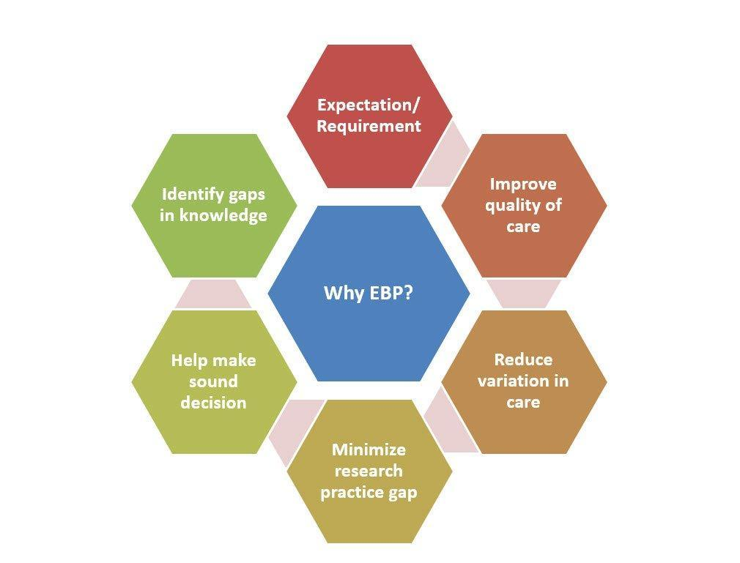

Five Steps of Evidence-Based Practice

EBP Steps | Knowledge and Skills required
- ASK an answerable clinical question | Recognise a knowledge gap and formulate a structured question that defines the problem, the intervention and the outcomes of interest
- ACQUIRE the best available evidence | Know evidence sources and types, and search databases
- APPRAISE the evidence | Critically appraise the evidence to determine its validity and clinical importance
- APPLY the evidence | Integrate the evidence with clinical expertise and patient preference
- ASSESS the process | Reflect on Steps 1-4 and identify ways to improve efficiency
Table from the book: Research methods in health (copied as it is)
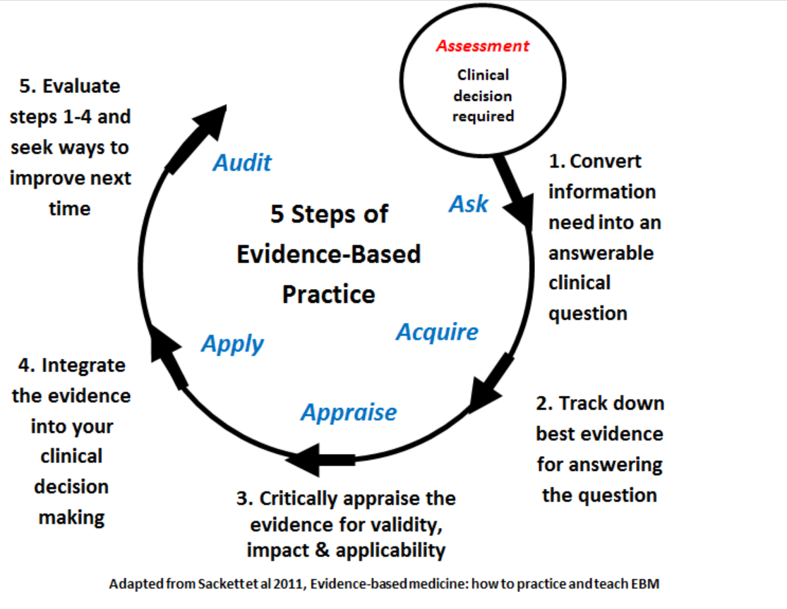
Source: https://canberra.libguides.com/evidence

1. ASK - Formulating an Answerable Clinical Question
Asking a specific and focused question is essential. The PICO framework (Population, Intervention, Comparison, Outcome) is widely used to structure questions. Other tools like PICOT, SPICE, and ECLIPSE cater to different research problems. For example, a question could be, "Do patients undergoing lumbar punctures need four hours' bed rest to minimize the risk of post-lumbar puncture headaches?".

2. ACQUIRE - Obtaining the Best Available Evidence
Not all research is equally valuable. Clinically useful research satisfies criteria such as addressing a real and important problem, adding substantially to existing knowledge, having a pragmatic design, measuring patient-relevant outcomes, providing good value for money, being feasible and acceptable in the real world, and making study data available for verification [How to Implement Evidence-Based Healthcare, p.15].

2.1 Evidence Hierarchy:
The hierarchy of evidence is a system used in evidence-based practices to rank the relative strength of results obtained from scientific research. The diagram typically takes the shape of a pyramid, with the highest quality evidence at the top and the lowest at the bottom. Here's a general outline for a hierarchy of evidence diagram:
- Systematic Reviews and Meta-Analyses: At the top of the pyramid. These studies synthesize data from multiple studies.
- Randomized Controlled Trials (RCTs): Below systematic reviews. These studies involve randomly allocating participants into experimental and control groups.
- Cohort Studies: Observational studies where participants with a certain condition or treatment are followed over time and compared with a similar group who are not affected by the condition under investigation.
- Case-Control Studies: Observational studies where two groups differing in outcome are identified and compared on the basis of some supposed causal attribute.
- Cross-Sectional Surveys/Studies: Observational studies that analyze data from a population, or a representative subset, at a specific point in time.
- Case Reports and Series: Reports on the treatment of individual patients or a report on a single patient.
- Expert Opinion: At the bottom of the pyramid. Includes editorials, expert opinions, and commentary.
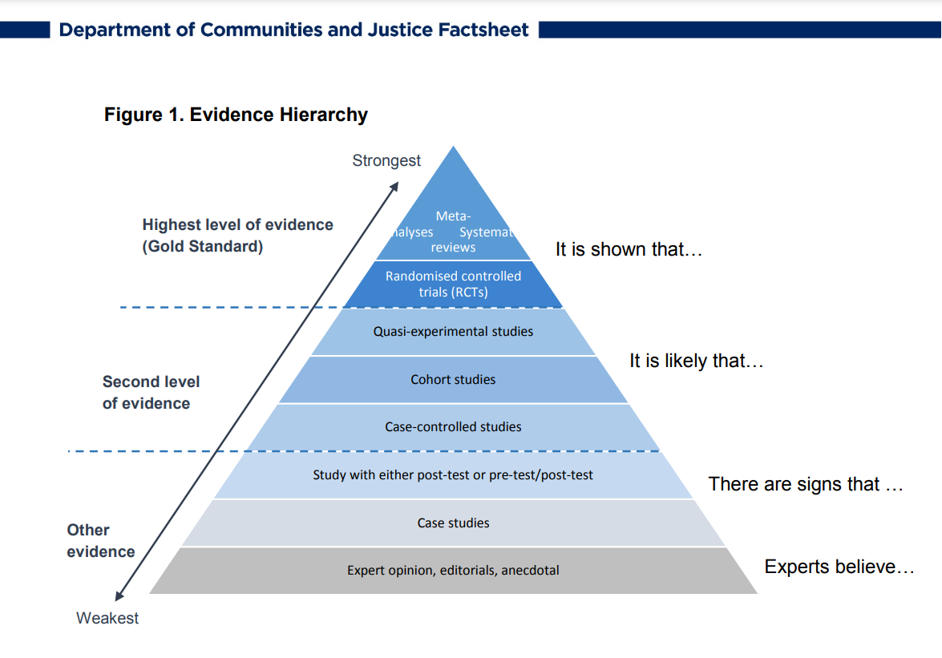

3. APPRAISE - Critically Evaluating the Evidence
Critical appraisal involves assessing the validity, impact, and applicability of the evidence. Determining if the study addresses a clear question, evaluating the validity of methods used, and assessing the relevance and importance of findings are crucial steps [Canberra LibGuides].

4. APPLY - Integrating Evidence with Clinical Expertise and Patient Preference
Successful EBP involves integrating evidence with clinical expertise and considering patient preferences. This step ensures that the best available evidence aligns with the unique circumstances and values of individual patients.

5. ASSESS - Reflecting on the Process
Reflection on the EBP process is vital. Practitioners should assess the efficiency of each step and identify opportunities for improvement, ensuring a continuous cycle of learning and refinement.

Factors Influencing Evidence-Based Practice
Several factors influence the successful implementation of EBP:
- Cost Implications: EBP may incur costs related to changes in service delivery. A well-defined budget, including staff costs, resources, and equipment, is crucial.
- Time: Developing a timeline for various project activities ensures timely completion.
- Resources: Identifying and arranging necessary resources is essential for successful implementation.
- Outcome Measures: Identifying short and long-term indicators of success and ways to collect relevant data are critical.
- Support Groups: Identifying individuals or groups that support the implementation of change is crucial for overcoming resistance.
- Strategies for Change: Implementing EBP requires strategies such as creating awareness, building knowledge, promoting action, and pursuing integration and sustainability.

Assessing/Evaluating the Process
Once implemented, the new practice or change should be evaluated. Evaluation helps determine the acceptance, rejection, or modification of the practice. It also provides insights into the effectiveness of the implementation process, identifies training needs, and informs future cycles of EBP.

In conclusion, Evidence-Based Practice is a dynamic and iterative process that combines the best available evidence with clinical expertise and patient values. By following the five steps and considering key factors influencing EBP, healthcare practitioners can enhance the quality and effectiveness of patient care.
References:
- Bowling, A. (2014). Research Methods in Health: Investigating Health and Health Services. McGraw-Hill Education.
- How to Implement Evidence-Based Healthcare, page 15.
- Canberra LibGuides - Evidence.
- Chartered Society of Physiotherapy.

Chapter end

EPB old chapter material
Evidence-based practice in health care. A process that requires the practitioner to find empirical evidence about the effectiveness or efficiency of different treatment options and then determine the relevance of the evidence to a particular client’s situation. Liamputtong, page 294.

EBP reduces inconsistency in practice and increases efficiency and effectiveness, and has thus been accepted by government and funding bodies as essential to better health care (Research Methods in Health).

EBP promotes an attitude of inquiry in health professionals and starts us thinking about: Why am I doing this in this way? Is there evidence that can guide me to do this in a more effective way? As health professionals, part of providing a professional service is ensuring that our practice is informed by the best available evidence. EBP also plays a role in ensuring that finite health resources are used wisely and that relevant evidence is considered when decisions are made about funding health services.4

Asking an answerable clinical question
Asking a specific and focused question is a challenging task. To make this easy, there are various frameworks that have been developed to help practitioners develop a specific, focused and answerable question. The most widely used framework, in this respect, is PICO. However, there are multiple other tools that can be used depending on the research problem, for example, PICOT (Population/Problem, Interventions, Control/Comparison, Outcome, Time), SPICE (Settings, Perspective, Intervention, Comparison, Evaluation), ECLIPSE (Expectations, Client Group, Location, Impact, Professionals, Service),
Example: Do patients undergoing lumbar punctures need four hours’ bed rest to minimise the risk of post-lumber puncture headaches?

P | I | C | O
Population  Patient  Problem | Intervention or Exposure | Comparison | Outcome
Adult patients undergoing lumbar puncture | Four hours’ bed rest | No bed rest | No headache
#

Acquiring the best available evidence

From the book (how to implement evidence-based Healthcare) page 15
For all these reasons, and as John I recently argued, research is very often not actually useful to clinicians. A clinically useful research study satisfies the criteria listed in box 2.1
Box 2.1. What is a clinically useful research study?
A clinically useful research study satisfies the following criteria
- It was designed to address a real and important problem
- It adds substantially and systematically to what we already know
- Its design was pragmatic
- It measured outcomes that matter to patients
- The intervention is good value for money
- The intervention is feasible and acceptable in the real world
- The study data are available for verification

From the book (RMiH)
Since time is a barrier to EPB for many practitioners (Scurlock et al. ), some system is needed to identify which papers should be read, or what evidence is most important or credible.
How much confidence you can have in the results of the research will depend at least in part on the research design.

An evidence hierarchy is a useful tool to help decision-makers quickly identify the best available research evidence of 'what works' in their field (Ref 4)

Good sources for acquiring Evidence

Which electronic databases to choose?
There are many electronic databases available for you to search for literature. A good place to start is to search either in the general medical database such as a PubMed m-based Cochrane or Medline or the general allied health database such as CINAHL, Amed or Psychinfo.

 |  | 
 |  | 
 |  |  | 
 |  | 

Appraising the evidence

From: https://canberra.libguides.com/evidence

Is not all Published Research of Good Quality?
Not all research is of sufficient quality to inform clinical decision making. Therefore you need to critically appraise evidence before using it to inform your clinical decision making. The three major aspects of evidence that you need to critically appraise are:
- Validity - can you trust it?
- Impact - are the results clinically important?
- Applicability - can you apply it to your patient?

Critical appraisal is a systematic process, a central process of evidence-based practice, which helps the reader to determine:
- If the study presented in the research paper addresses a clear and focus question?
- If the methods used to answer the question were valid
- Are the results/ findings of the study valid, informative and important?
- Can these findings be applied in a practice setting?

Applying the evidence

Implementation of evidence-based practice is most important and equally challenging.

? Table List of barriers to EBP
Following is the list of barriers that may hamper implementation of EBP and therefore, these should be considered while planning any implementation strategies

• Unawareness of research
• Lack of evidence
• Evidence is not easily available
• Conflicting evidence
• Lack of time to read evidence or implement new ideas
• Lack of facilities or resources
• Lack of staff experienced in EBP
• Lack of training in EBP
• EBP insufficiently supported by staff and management
• Evidence is not generalizable to own setting
• Evidence is not incorporated into clinical practice
• EBP negatively impacts medical skills and freedom
• Evidence is written in a foreign language
• Lack of authority to change practice
• Statistics or research, is unintelligible
• Implications for practice are unclear

It is worth exploring how barriers can be tackled when planning change.

Factor influencing EPB
These can be put in a table or box or presented differently
Associated cost
EPB has a cost implication as any new practice or a change in practice may require changes in how a service is delivered, and therefore, there are costs associated with it. The kind of questions that you may need to ask yourself include
- What are the financial implications of the interventions proposes
- How much money is organisation willing to spend on the intervention proposed
- A clearly articulated and itemised budget detailing every aspect of the required cost related to human and material resources should be developed. You may need to think of staff cost, stationary, electronic or technological equipment, meeting arrangement and catering cost etc.
Time
  - Developing a timeline that specifies a time for various activities associated with the project should be developed.
  - Such timeline helps in ensuring on time completion of various activities associated with the project.
Resources

  - Identification of resources helps in the prior arrangement of resources and specification of financial requirements for the project

Deciding on outcome measure
  - It is important to identify and decide measures of success, which will help in identifying and determining the success of the change implemented. Both short term indicators (which can be achieved within 6 months) and long term indicators (which may be achieved in the longer period) need to be specified.
  - It is also essential to identify ways to collect data about indicators of success

Identify support groups
  - Change cannot be implemented without getting appropriate support and acceptance from the target audience. Therefore, it is important to identify people who like and support your idea and can support you in implementing change. These people can be champions, managers, those who have an interest in the subject etc
Identify strategies to implement change
  - Creating awareness and interest
  - Building knowledge and commitment
  - Promoting action and adaptation
  - Pursue integration and sustainability

Assess/Evaluate the Process

Once implemented, changed or new practice should be evaluated to see if the practice is accepted, rejected or need some modification to suit the needs of a specific setting. Evaluation helps in exploring and comparing the effects of evaluation with baseline (before the implementation of new intervention) or with other areas of practice where intervention is not implemented. Evaluation may also provide useful information about the process of implementation and strategies that worked and those which did not work. It may also help in identification of staff training and development needs with regards to the new practice. Evaluation may help identification and recognition or new issues that may need to be explored in the next cycle f EBP.

What is evidence-based practice?
Pp. 467. Figure 18.2 Stetler Modle of Research Utilization to facilitate evidence-based Practice.

?Evidence-based practice or Healthcare (Book)
Evidence, value and resources; a triangle where evidence is ignored
Evidence-based practice
Evidence-based decision-making (asking the right questions)
Evidence-based healthcare
Three Stages of evidence-based healthcare
- Producing evidence
- Making evidence available
- Using evidence

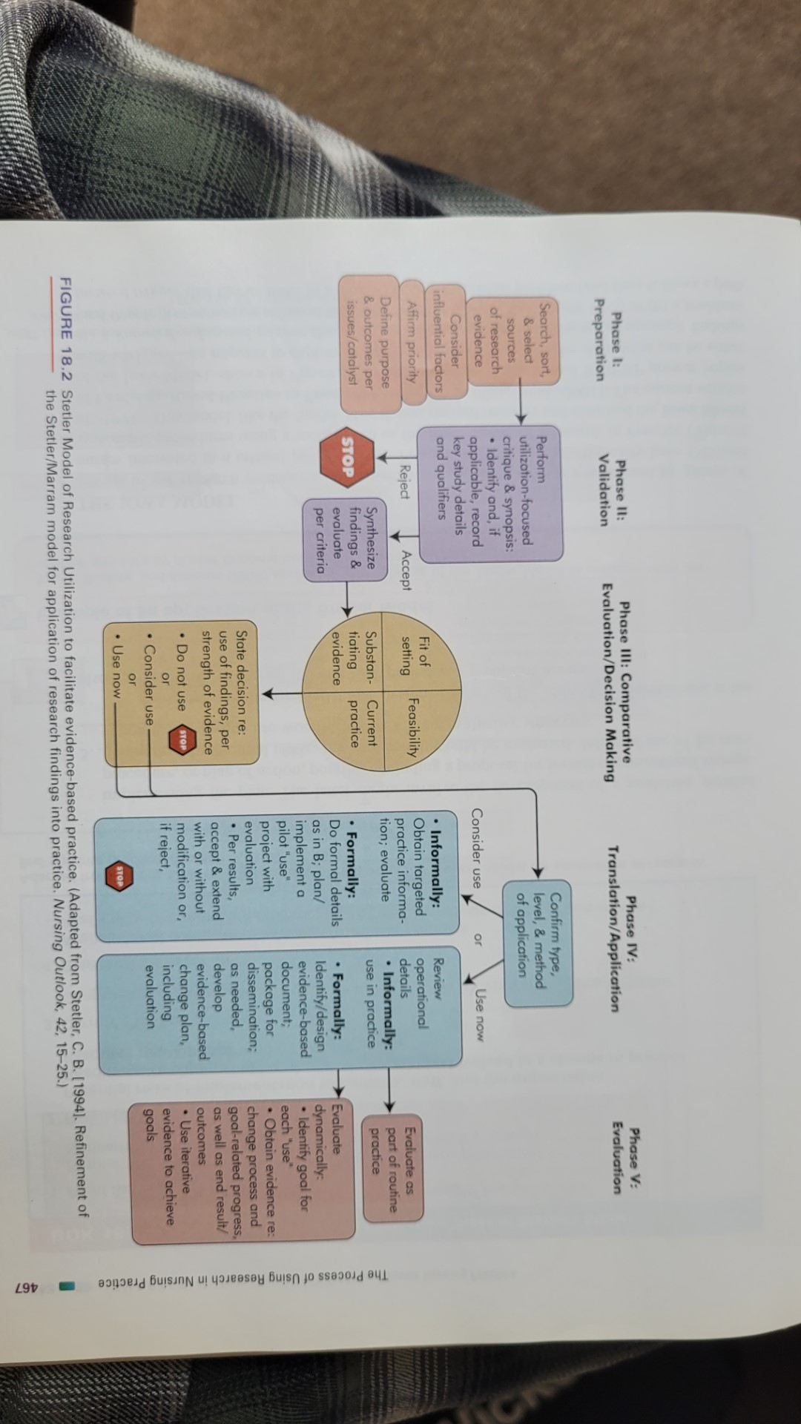
BOOK 3rd nursing Research pm
What is evidence-based practice?
making decisions about the type of nursing care to give to service users is not easy. It may mean making choices between a number of alternative actions that involve treatment choices provision of services or efficiency.
Evidence best practice promotes quality and cost-effective outcomes of Healthcare with SD suggesting it is practice space on the best available evidence of patient preference and clinical judgement

Evidence based practice is seen as comprising five explicit steps
- Identify a problem from practice and turn it into a specific question
- Find the best available evidence that relates to the specific question usually through a taro and systematic search of the literature
- Critically appraise the evidence validity usefulness and methodological rigour
- Identify and use the current best evidence and together with the patient or clients preferences and the practitioner's expertise and experience, apply it to the situation
- Evaluate the effect on the patient outlined and reflect on the nurses own performance

Clinical audit:
Process that provides a systematic framework for establishing care standards based on best evidence. It can identify areas of care that require improvement.
Clinical order is about clinical effectiveness, since the evidence against which current practice is measured is what has been established as being effective for the research evidence published in the literature.
Liamputtong page 303.

Audit
Audit is directed at the maintenance and achievement of quality in Healthcare.
Audit aims to improve patient outcome, to develop a more cost-effective use of resources and to have an educational function for health professionals.
Audit can be carried out internally by organizations, members of a discipline, individuals who systematically review their work or that of their teams, or external bodies.The process of audit involves multiple methods, such as document searching and analysis, analysis of retained data, clinical case reviews and presentation in team meetings. it can also include the collection of information by focus groups or patients or by questionnaire, for example, patient satisfaction, patient-assessed outcome.
Bowling 2014, page 7, 8, 9.

Appendix
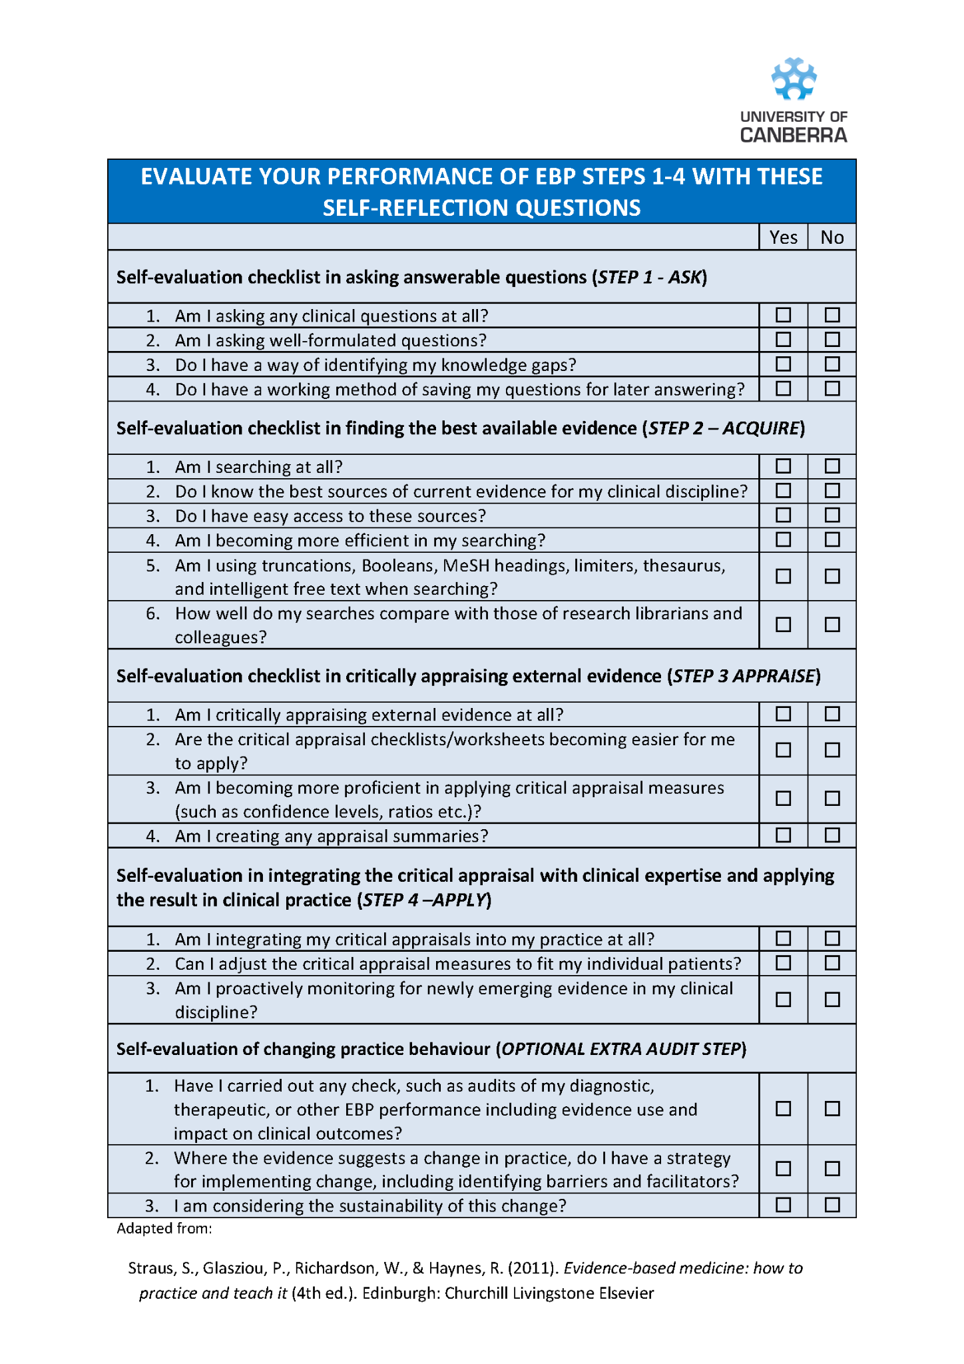

References

3.Dawes M, Summerskill W, Glasziou P et al 2005 Sicily statement on evidence-based practice BMC Medical Education 5(1) 1-7
4. https://www.facs.nsw.gov.au/__data/assets/pdf_file/0007/789163/What-is-an-Evidence-Hierarchy.pdf

Chapter 10: Developing a Research Proposal in Healthcare

Introduction
A research proposal is a vital document that outlines the plan for a research project. It is particularly crucial in the healthcare field, where research can lead to significant advancements in patient care, medical procedures, and healthcare policy. This chapter aims to guide healthcare professionals in developing a research proposal, highlighting its importance, structure, and critical factors to consider.

Understanding a Research Proposal

Definition and Purpose
A research proposal is a detailed plan of a proposed study designed to answer specific research questions. It serves multiple purposes:

1.1. Justifying the Need for the Research
- Addressing Critical Healthcare Issues: Justifying the need for research begins with identifying and articulating a significant problem or gap in current healthcare knowledge or practice. This could be a prevalent health issue, a gap in effective treatment options, or an operational challenge within healthcare systems. The proposal should demonstrate how the research will contribute to solving these problems, thereby benefiting patient care, healthcare policy, or medical knowledge. For example, a study might seek to improve treatment protocols for a chronic disease, test the efficacy of a new surgical technique, or evaluate the impact of healthcare policies on patient outcomes.
- Advancing Medical Knowledge and Practice: Research is essential for the continuous advancement of medical knowledge and healthcare practices. A well-justified proposal shows how the study will add to the existing body of knowledge, either by exploring new territory, challenging current understanding, or providing deeper insights into known issues. The aim is to ensure that healthcare practices are based on the latest and most robust evidence, ultimately leading to improved health outcomes.
- Responding to Changing Healthcare Needs: Healthcare needs and challenges evolve continuously due to factors like demographic shifts, emerging diseases, technological advancements, and changing social contexts. Research proposals need to justify their relevance by demonstrating an understanding of these dynamic needs and proposing ways to address them. This responsiveness not only keeps the healthcare sector adaptive and forward-thinking but also ensures that resources are directed toward the most pressing and contemporary issues.

1.2.Guiding the Research Process
- Providing a Structured Framework: A research proposal acts as a roadmap for the entire research process, laying out a structured approach to investigating the research question. This structure includes defining the scope of the study, specifying research objectives, and detailing the methodology. By having a clear plan, researchers can maintain focus and direction, ensuring that the study remains on track and aligned with its objectives.
- Facilitating Consistency and Rigor: The proposal sets out the methods for data collection and analysis, which are crucial for maintaining the integrity and rigor of the research. By pre-defining these methods, researchers can avoid biases and ensure that the study is conducted systematically and consistently. This is especially important in healthcare research, where the accuracy and reliability of findings can directly impact patient care and treatment outcomes.
- Enabling Continuous Assessment and Adaptation: Throughout the research process, the proposal serves as a reference point against which progress can be measured and decisions can be evaluated. It allows researchers to assess whether the study is adhering to its initial objectives and methodology, and if necessary, make informed adjustments. This ongoing evaluation is critical for maintaining the quality and relevance of the research.

1.3. Securing Funding and Approvals
- Demonstrating Value to Funders: Most research projects in healthcare require funding. A compelling research proposal is essential to convince funding bodies of the value and feasibility of the study. It must clearly articulate the significance of the research question, the soundness of the methodology, and the potential impact of the findings. By doing so, it increases the likelihood of securing the necessary financial support.
- Facilitating Ethical and Institutional Approvals: Healthcare research often involves sensitive ethical issues, particularly when dealing with human subjects. A research proposal must include a thorough consideration of these ethical aspects, outlining how participants will be protected and how data will be managed. This is crucial for obtaining approval from ethics committees and institutional review boards, which is a prerequisite for conducting the research.
- Aligning with Strategic Priorities: Funding bodies and institutions often have specific strategic priorities, such as focusing on certain diseases, populations, or healthcare challenges. A well-crafted proposal will align its objectives with these priorities, demonstrating how the research contributes to the broader goals of the funding bodies or institutions. This alignment not only helps in securing funding but also ensures that the research is relevant and beneficial to broader healthcare agendas.

Key Components
A typical research proposal includes:
- Title: Clear and concise, reflecting the study's focus.
- Abstract: A brief summary of the proposal.
- Introduction: Contextualizes the research problem and its significance.
- Literature Review: Summarizes existing research and identifies gaps.
- Research Questions/Hypothesis: Specific, measurable, and achievable questions or hypotheses.
- Methodology: Detailed plan of how the research will be conducted, including design, sample, data collection, and analysis methods.
- Ethical Considerations: Addresses how ethical issues will be managed.
- Budget and Timeline: Outlines the resources required and the project timeline.
- References: Cites all sources of information.
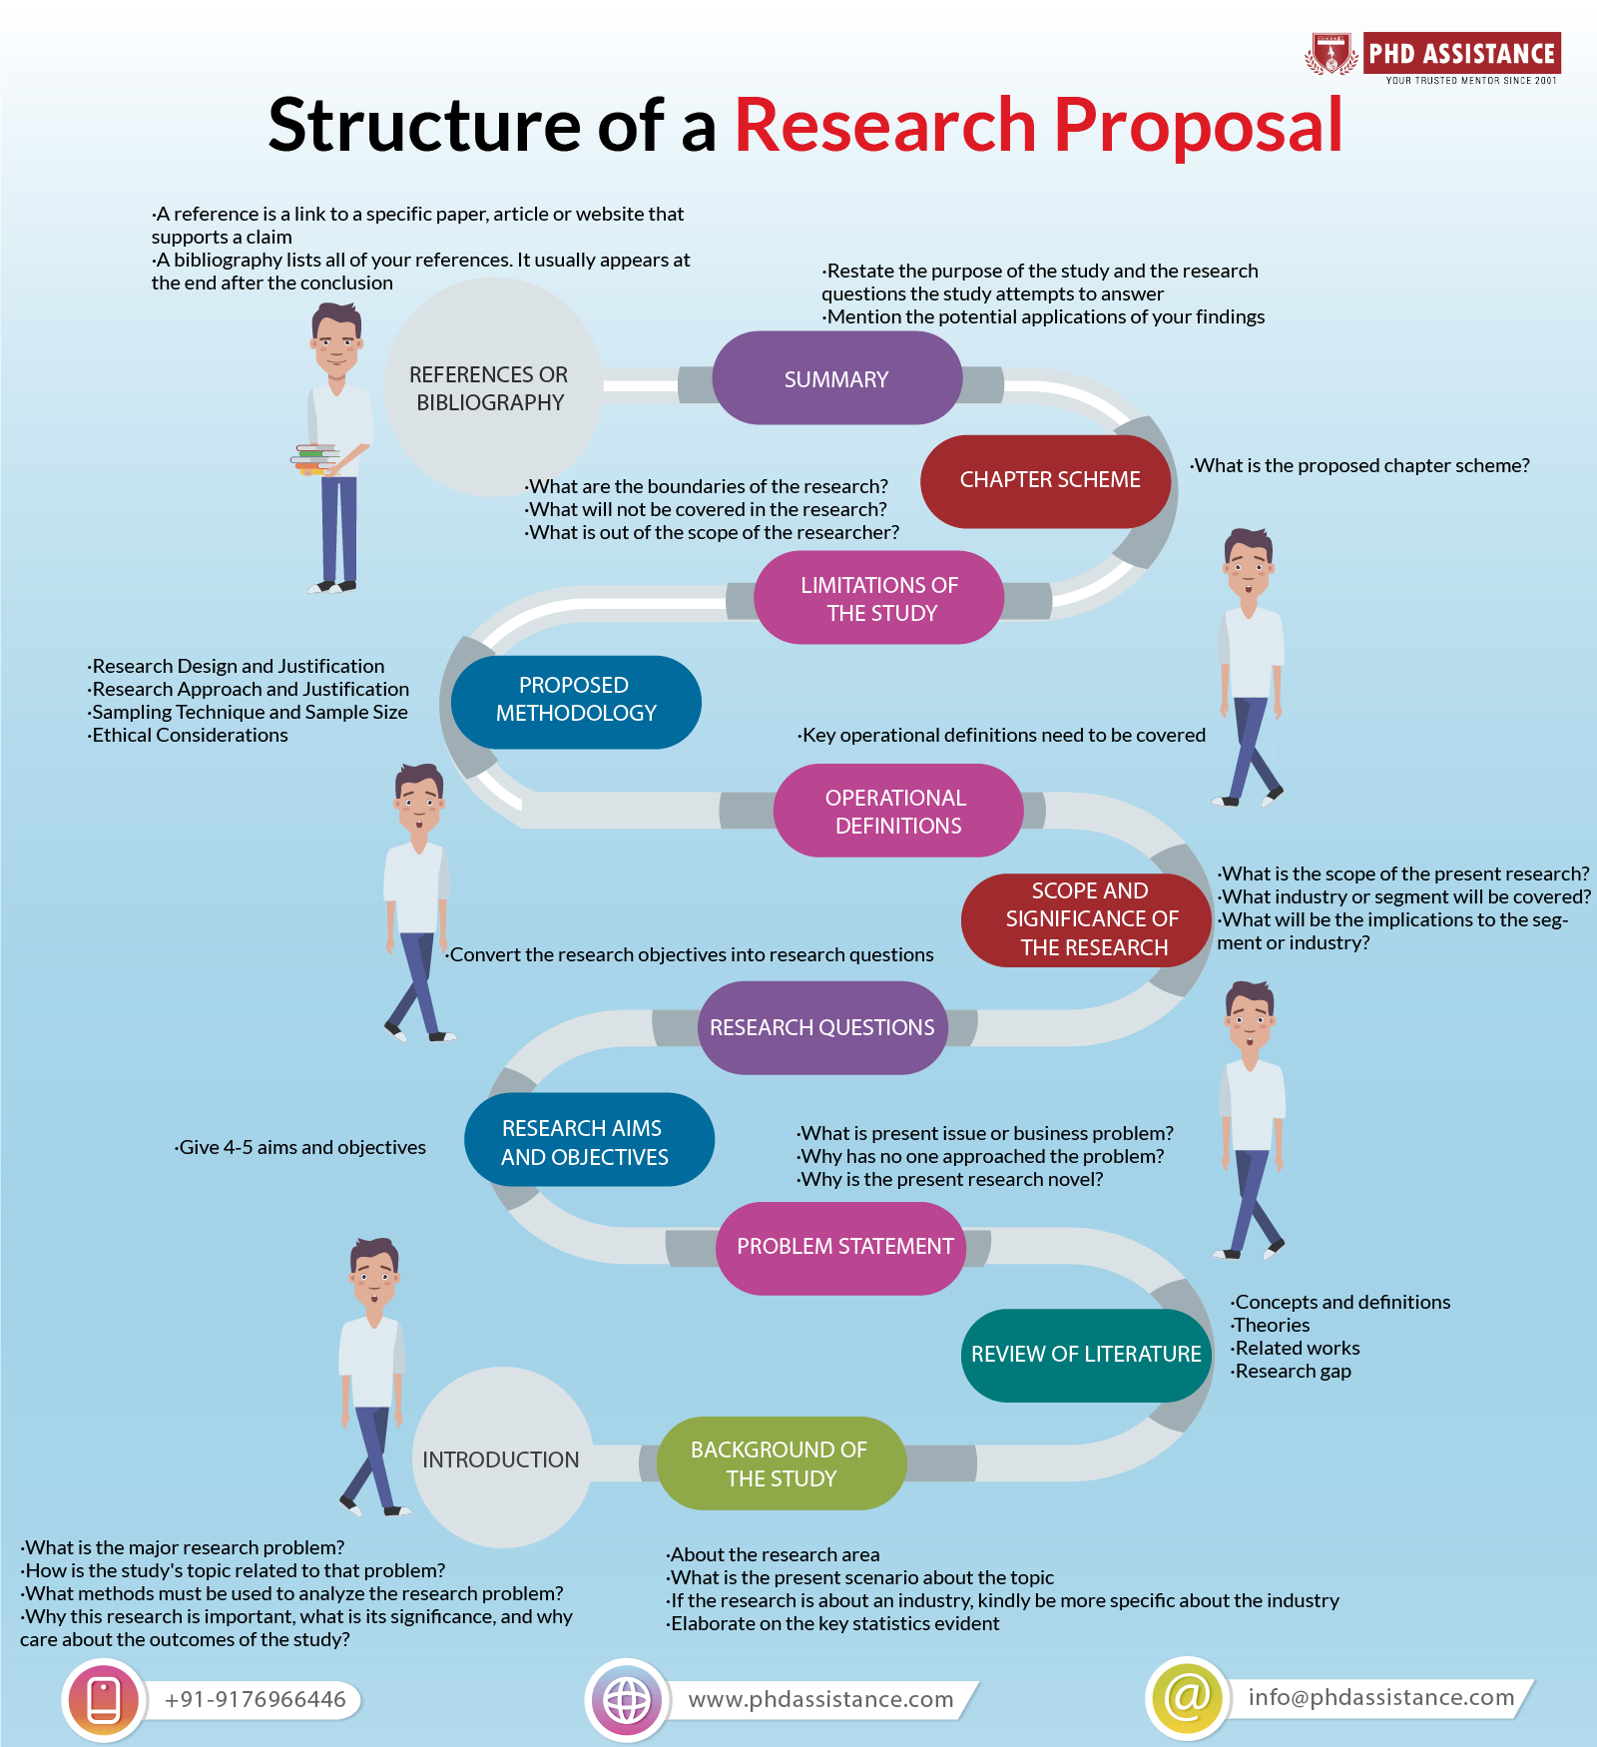

Developing a Research Proposal

Identifying the Research Problem
Start with a clear and focused research problem. It should be relevant to healthcare, addressing a gap in knowledge or a specific healthcare challenge.

Conducting a Literature Review
A thorough literature review is essential. It helps in understanding the current state of research and in identifying gaps that your study could fill.

Formulating Research Questions or Hypotheses
Develop research questions or hypotheses that are specific, measurable, achievable, relevant, and time-bound (SMART).

Designing the Methodology
The methodology should be robust and appropriate for the research questions. Consider:
- Research Design: Qualitative, quantitative, or mixed-methods.
- Sampling: How participants will be selected.
- Data Collection: Tools and techniques for gathering data.
- Data Analysis: Methods for analyzing the collected data.

Ethical Considerations
Given the sensitivity of healthcare research, ethical considerations are paramount. Ensure compliance with ethical standards and obtain necessary approvals.

Budgeting and Timelines
Develop a realistic budget and timeline, considering all phases of the research.

Factors to Consider
- Relevance to Healthcare: Ensure the study addresses significant healthcare issues.
- Feasibility: Assess the practicality of the research in terms of time, resources, and expertise.
- Ethical Implications: Consider the ethical impact, particularly regarding patient confidentiality and consent.
- Funding Opportunities: Explore potential funding sources and tailor the proposal to meet their requirements.
- Interdisciplinary Collaboration: Consider collaborating with other healthcare professionals, statisticians, or researchers.

Conclusion
Developing a research proposal in healthcare requires a systematic approach, ensuring that the study is well-planned, relevant, ethical, and feasible. By following the outlined steps and considerations, healthcare professionals can contribute significantly to advancing healthcare research and practice.

Chapter end

